Name: Date:

Student Exploration: Linear Inequalities in Two Variables

Vocabulary: boundary, half-plane, inequality, linear inequality

Prior Knowledge Questions (Do these BEFORE using the Gizmo.)
Karisa collects candles and mugs. She only has one shelf to display them on. The maximum number of items that will fit on the shelf is 10. (The candles and mugs are about the same size.)

- Tell whether each of the following combinations will fit on the shelf.

- 3 candles and 5 mugs

- 10 candles and 0 mugs

- 6 candles and 5 mugs

- 4 candles and 9 mugs

- An inequality compares two quantities or expressions that are not equal. Write an inequality for how many candles (c) and mugs (m) the shelf can hold. Use a “less than” (<), “less than or equal to” (≤), “greater than” (>), or “greater than or equal to” (≥) symbol in your answer.

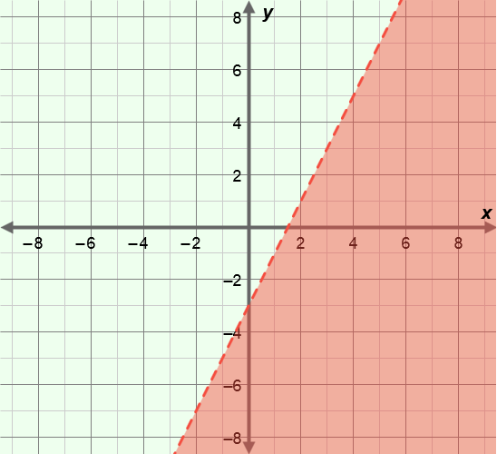
Gizmo Warm-up
The statement you wrote above is a linear inequality. In the Linear Inequalities in Two Variables Gizmo, you will graph linear inequalities. The graphs of linear inequalities consist of a dashed or solid line, and a shaded region.
- Be sure the “less than” button ( ) is selected.

- Drag the m slider. How does the graph change?

- Drag the b slider. How does the graph change?

- Select the “less than or equal to” button ( ). How does the graph change?

- Select the “greater than or equal to” button ( ). How does the graph change?

Activity A:  Solutions of inequalities | Get the Gizmo ready:  - Be sure Show solution test is turned off. | 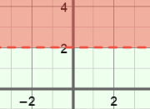

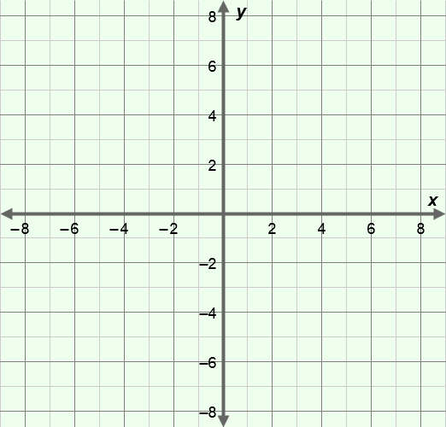
- Set m to 0 and b to 2, and select the “equal to” button ( ) to graph y = 2. (To quickly set the values of m and b, select the number in the text field, type in a new value, and hit Enter.)

  - Sketch the graph on the grid to the right.

  - Where are the points with a y-value greater than 2 located on your graph?

Sketch a few of these points on the graph.

- Select the “greater than” button ( ) to graph y > 2.

- Compare this graph to the graph of y = 2. How are the graphs different?

The graph of y = 2 is the boundary, and the shaded area is a half-plane.

- Select Show solution test. Drag the point and watch the inequality under the check box as you do. When is the point (x, y) a solution to the inequality?

- What does the shaded area of the graph represent?

- Select the “greater than or equal to” button to graph y ≥ 2.

- Are the points on the boundary line solutions to y ≥ 2?
- How does changing the sign from > to ≥ change the solution of an inequality?

(Activity A continued on next page)
Activity A (continued from previous page)

- Graph y > 2x + 4 in the Gizmo.
- How will the graph look if you click ?

Check your answer in the Gizmo.
- How will the graph look if you click ?

Check your answer in the Gizmo.

- Write the coordinates of two points you think will make y ≤ 2x + 4 true but not
y < 2x + 4. Then turn on Show solution test to check your answer in the Gizmo.

( , ) ( , )

- Why are the coordinates you wrote above solutions to y ≤ 2x + 4 but not y < 2x + 4?

- Consider the graph of y < –3x – 5.

- What is the equation of the boundary of this inequality?

- Will the boundary line be solid or dashed?

- Which side of the boundary line do you think will be shaded?

Check your answer in the Gizmo.

- Determine if each of the following are solutions to the inequality y ≤ 5x – 2. Show your work in the space below each problem. Then check your answers in the Gizmo.

- (5, 0)

- (–2, 6)

Activity B:  Using inequalities | Get the Gizmo ready:  - Be sure Show solution test is turned on. | 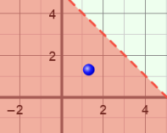

- Graph the following inequalities on the grids below. Then check your graphs in the Gizmo.

- y ≥ –x + 6

- y < 4x – 8

- For each item below, write an inequality that contains the given point(s) in its solution. Then check your answers in the Gizmo.

- The point (0, 0) and all points on the boundary line y = –2x + 1.

- The point (–5, 1)

