Vocabulary: Linear Inequalities in Two Variables

Vocabulary

- Boundary – a line or curve separating one part of a plane from another.
- The boundary in the graph below is the line with the equation y = 5x + 5.
- A boundary that is a line divides a plane into two half-planes.

- Half-plane – a region in a plane consisting of all points on one side of a boundary.
- Every line divides the plane it lies in into two half-planes.

- Inequality – a statement that compares two quantities or expressions that are not equal.
- For example, 8 > 2, and also 5 < 2 • 3.
- An inequality contains one of these signs: < (less than), ≤ (less than or equal to), > (greater than), or ≥ (greater than or equal to).

- Linear inequality – an inequality whose graph is a half-plane with a linear boundary.
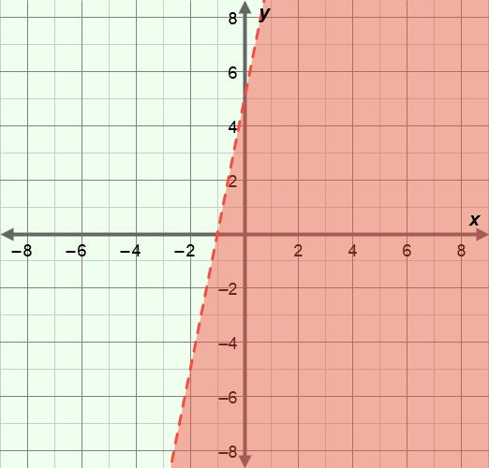
- The linear inequality graphed to the right is
y < 5x + 5.
- The shaded part of the graph contains all points that are solutions to this inequality.
- The boundary is the line with the equation y = 5x + 5, and is dashed because the inequality symbol used (<) does not include the “equal to” part.

