Name: Date:

Student Exploration: Linear Programming

Vocabulary: constraints, feasible region, linear programming, objective function, optimize

Prior Knowledge Questions (Do these BEFORE using the Gizmo.)
Rachael babysits for two families. The Smiths pay $5 per hour and the Millers pay $6 per hour. Write an inequality to describe each situation. (Use x for Smith hours and y for Miller hours.)

- Rachael can’t work a negative number of hours for:

- the Smiths.
- the Millers.

- The Millers never ask Rachael to babysit more than 4 hours a week.

- The maximum number of hours Rachael can babysit each week is 8.

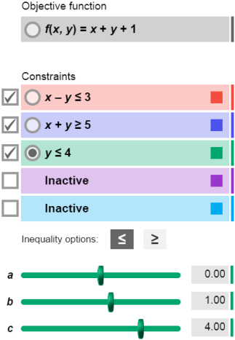
Gizmo Warm-up
Rachael wants to maximize the money she makes given her limitations, or constraints. You can use a system of linear inequalities to model these constraints. In the Linear Programming Gizmo, you can graph these constraints, and then use them to maximize (or minimize) the value of the objective function.

To activate any of the Constraints, click the box to its left. To vary the values of a, b, or c in the objective function or in a constraint, select the button to its left and drag the sliders, or type a new value in the text box to the right of the slider and hit Enter. Change the inequality signs by clicking the buttons above the sliders.

With the CONTROLS tab chosen, activate the first three Constraints. Set the constraints to
x – y ≤ 3, x + y ≥ 5, and y ≤ 4. Make sure the Objective function is set to f(x, y) = x + y + 1.

- Move the cursor to each vertex of the triangle formed by the constraints.

- What are the coordinates of each vertex?

- What is the value of f(x, y) at each vertex?

- Move the cursor around the purple shaded area. The value of f(x, y) is given below the

graph. Does any point have a value higher than the greatest value above?

Activity A:  Finding the maximum | Get the Gizmo ready:  - Activate the fourth Constraint. | 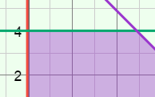

- Recall that Rachael babysits for the Smiths and for the Millers. The Smiths pay her $5 per hour and the Millers pay $6 per hour.

  - Write an expression to describe how much money Rachael can make babysitting for the Smiths and Millers. Let x be the number of hours she babysits for the Smiths and y be the number of hours she babysits for the Millers.

f(x, y) = In the Gizmo, set this as the Objective function.

  - Find the value of the objective function at
(2, 3). Show your work in the space to the right.

f(2, 3) =

  - Move the cursor to (2, 3) to check. What does the value of f(2, 3) mean?

- It is impossible for Rachael to babysit negative hours for either the Smiths or the Millers.

Write two inequalities for these constraints.

Graph these inequalities in the Gizmo as the first and second constraints. The shaded region shown in the Gizmo is said to be unbounded because it has infinite area.

- The Millers can’t hire Rachael for more than 4 hours a week. Rachael’s total hours cannot be greater than 8 hours per week.

Write two inequalities for these constraints.

Graph these inequalities in the Gizmo as the third and fourth constraints.

- Notice the graph is no longer unbounded. The shaded part is called the feasible region.

- Do you expect all points in the feasible region to satisfy all of the constraints?
Why or why not?
- Do you expect any point outside the feasible region to satisfy the constraints?

Why or why not?

(Activity A continued on next page)
Activity A (continued from previous page)

- Move the cursor around the feasible region.

- Give the coordinates of the points where the value of the objective function is the largest and the smallest.

Largest: Smallest:

- Where are the points you gave above located relative to the feasible region?

- What is the most money Rachael can make babysitting, and how can she do it?

You just used linear programming to optimize (find the maximum or minimum of) the objective function for this problem.

- The Smiths decide to give Rachael a raise to $7 per hour. However, they can only hire her for 6 hours a week.

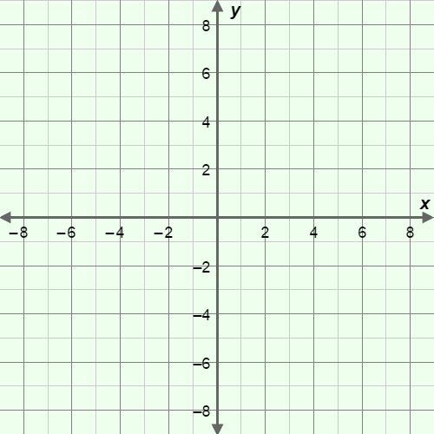
- Use the Gizmo to model these changes. You will have to activate another constraint.

- Sketch the graph on the grid to the right.

- What is the objective function?

- What is the value of the objective function at each vertex in the feasible region?

- Move the cursor around the feasible region in the Gizmo. At what point is the value of the objective function the largest?
- What is the maximum Rachael can earn with these constraints?

- To maximize her earnings, what weekly schedule should Rachael follow?

Activity B:  Using linear programming | Get the Gizmo ready:  - Select the CONTROLS tab. | 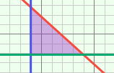

A small sporting goods factory can produce either basketballs or footballs. It can only produce one type of ball each hour. The factory also has the following constraints.
- The factory produces 6 basketballs or 4 footballs per hour.
- The factory is open 8 hours per day.
- The number of footballs produced in a day cannot be more than twice the number of basketballs.

- Use x for the hours spent making basketballs and y for the hours spent making footballs.

  - Write two inequalities to show that the hours spent making basketballs and footballs cannot be negative. Graph these constraints in the Gizmo.

  - Next, write an inequality expressing how many hours the factory can make balls each day. Graph this constraint in the Gizmo.
  - Write equations to state the relationship between the number of balls produced in a day and the variables x and y. Use b for the number of basketballs and f for footballs.

b = f =

  - Write an inequality describing the relationship between the number of basketballs (b) and the number of footballs (f) produced per day. Then substitute the expressions you wrote above to rewrite the inequality in terms of x and y.

  - Rearrange the inequality from above so that x and y are on the same side, and simplify if possible. Show your work to the right. When you are finished, graph this constraint in the Gizmo.

- The factory makes $2 profit on each basketball and $4 profit on each football. Write an objective function to express the profit the factory earns. First write the function in terms of b and f. Then use substitution to write the function in terms of x and y.

f(b, f) = f(x, y) =

(Activity B continued on next page)
Activity B (continued from previous page)
- Set the Objective function in the Gizmo and be sure all of the constraints are graphed.

- Sketch the resulting feasible region on the grid to the right. Your feasible region should have three vertices. What are the coordinates of these vertices?

- What is the value of the objective function at each vertex?

- How many hours each day should the factory produce basketballs?

- How many hours each day should the factory produce footballs?

- What is the maximum profit the factory can earn each day?

- Matt decides to start a workout program. He has time to exercise up to 7 hours per week. He burns 700 calories per hour lifting weights and 1000 calories per hour on the treadmill. Matt wants his weightlifting time (x) to be at least 40% of his treadmill time (y).

- Write a function for the number of calories Matt burns per week from exercise.

f(x, y) =

Set this as the Objective function in the Gizmo. (Hint: Divide each coefficient by 100 so you can set it in the Gizmo.)

- List the four constraints on Matt’s workouts and graph them in the Gizmo.

- How many calories (maximum) can Matt burn in a week from exercise?

(Hint: Remember to multiply the result given in the Gizmo by 100.)

- How many hours of weights and treadmill will allow Matt to burn this many calories?

