Vocabulary: Linear Programming

Vocabulary

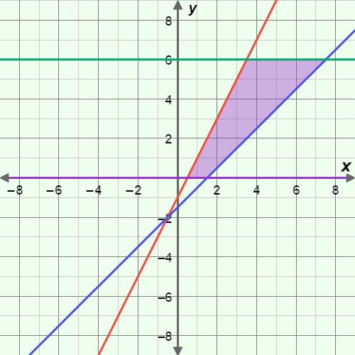
- Constraints – a system of linear inequalities whose graph forms the feasible region for an objective function.
- The constraints of the feasible region in the graph to the right are:
2x – y ≥ 1
x – y ≤ 1.5
y ≤ 6
y ≥ 0

- Feasible region – the set of coordinates that satisfy all constraints to an objective function.
- The purple shaded area in the graph to the right is a feasible region.
- The feasible region shown in the graph has finite area so it is said to be bounded.
- A feasible region with infinite area is said to be unbounded.

- Linear programming – the process of finding the maximum or minimum of a linear objective function for a region defined by linear inequalities.

- Objective function – the function to be optimized in linear programming.

- Optimize – to find the maximum or minimum value of a function.
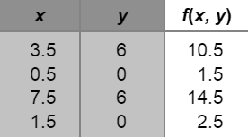
- The maximum or minimum of a linear objective function will always occur at a vertex of the feasible region.
- Suppose the objective function f(x, y) = x + y + 1 has the constraints graphed above. To optimize the function, evaluate it for the coordinates of each vertex of the feasible region (see table to the right).

The maximum value is 14.5, at (7.5, 6), and the minimum value is 1.5, at (0.5, 0).

