Name: Date:

**Student Exploration: Logarithmic Functions: Translating and Scaling**

**Vocabulary:** asymptote, base, domain, logarithmic function, scale (a function),   
transform (a function), translate (a function)

**Prior Knowledge Questions** (Do these BEFORE using the Gizmo.)

1. The function *y* = 3*x* is an exponential function, because the variable is in the exponent. The value (in this function, the 3) raised to the exponent is called the **base** of the function.
2. For *y* = 3*x*, what is the output (*y*) when the input (*x*) is 2?
3. What is *y* when *x* is 5?
4. The inverse of *y* = 3*x* is the **logarithmic function** *y* = log3(*x*). Recall that the logarithmic form (*y* = log3(*x*)) can always be converted to exponential form (3*y* = *x*) if it helps.
5. For *y* = log3(*x*), what does the *input* (*x*) have to be to get an *output* (*y*) of 2?
6. For *y* = log3(*x*), what is *x* when *y* is 5?

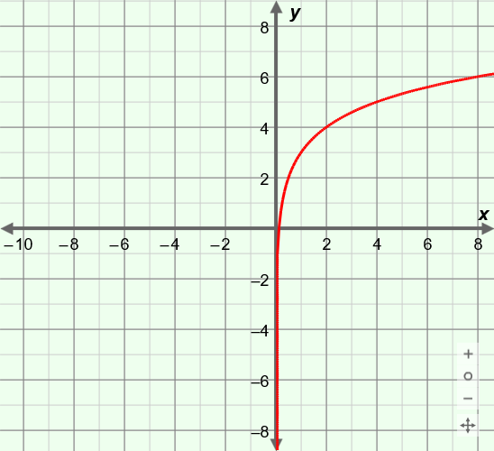

**Gizmo Warm-up**

The general form of a logarithmic function is *y* = *a* log*b c*(*x* – *h*) + *k*. In the *Logarithmic Functions: Translating and Scaling* Gizmo, you can vary the values of *a*, *c*, *h*, and *k* to see how they alter, or **transform**, the graph of *y* = log*b*(*x*).

On the **CONTROLS** tab, be sure ***a*** is set to 1, ***b*** to 2, ***c*** to 1, ***h*** to 0, and ***k*** to 0. (To quickly set the value of a slider, type the number into the text box and press **Enter**.) The function graphed in the Gizmo should be *y* = log2(*x*).

1. Vary ***h*** by dragging the slider. What happens to the graph?

1. Drag the ***k*** slider back and forth. How does the graph change as you vary *k*?

|  |  |  |
| --- | --- | --- |
| **Activity A:**  **Effects of *h* and *k* on the graph** | Get the Gizmo ready:   * On the **CONTROLS** tab, set ***a*** to 1, ***b*** to 2, ***c*** to 1, ***h*** to 0, and ***k*** to 0. |  |

1. The function you have graphed in the Gizmo should be *y* = log2(*x*).
2. Give the coordinates of two “key points” on the graph of *y* = log2(*x*) (the points that have *y*-values of 0 and 1). ( , 0) and ( , 1) Select **Show probe** to check.
3. Set ***k*** to 3 to graph the function *y* = log2(*x*) + 3. What are the coordinates of these two key points now? ( , ) ( , )
4. How did adding 3 to log2(*x*) change the coordinates of those points?

1. How did adding 3 **translate** (shift) the graph as a whole?

1. Vary ***k*** and ***b*** to see how *k* affects logarithmic functions with different bases. In general, what two key points are always on the graph of *y* = log*b*(*x*) + *k*?

(1, ) and (*b*, )

1. Graph *y* = log2(*x*) again in the Gizmo. Then set ***h*** to 3 to graph the function *y* = log2(*x* – 3).
2. Where are the key points (formerly (1, 0) and (2, 1)) now? ( , ) and ( , )
3. How did subtracting 3 from *x* shift the graph of *y* = log2(*x*)?

Explain why this makes sense.

1. Vary ***h*** and ***b*** to see how *h* affects logarithmic functions with different bases. In general, what two key points are always on the graph of *y* = log*b*(*x* – *h*)?

( , 0) and ( , 1)

1. In general, how do you know which direction *h* will move a graph?

**(Activity A continued on next page)**

**Activity A (continued from previous page)**

1. Experiment more with different values of ***h***, ***k***, and ***b***. In general, what two key points are always on the graph of *y* = log*b*(*x* – *h*) + *k*? ( , ) ( , )
2. Now graph *y* = log8(*x*) in the Gizmo. Turn on **Show asymptote**. The light blue vertical dotted line is the **asymptote**. It marks the edge of the **domain**, which is the set of all *x*-values for which the function is defined.
3. How do you think *h* and *k* affect the asymptote and domain of *y* = log8(*x*)? Explain.

1. Vary ***h*** and ***k*** in the Gizmo to check your answer. What do you find?

1. Vary ***b***, ***h***, and ***k*** to test many different logarithmic functions. In general, what are the asymptote and domain of *y* = log*b*(*x* – *h*) + *k*?

Asymptote: Domain:

1. State the coordinates of two key points on the graphs of the following functions. Check your answer in the Gizmo.
2. *y* = log2(*x* – 5)

1. *y* = log6(*x*) + 2

1. *y* = log3(*x* + 4) – 6

1. What logarithmic functions are graphed here? Check your answers in the Gizmo.

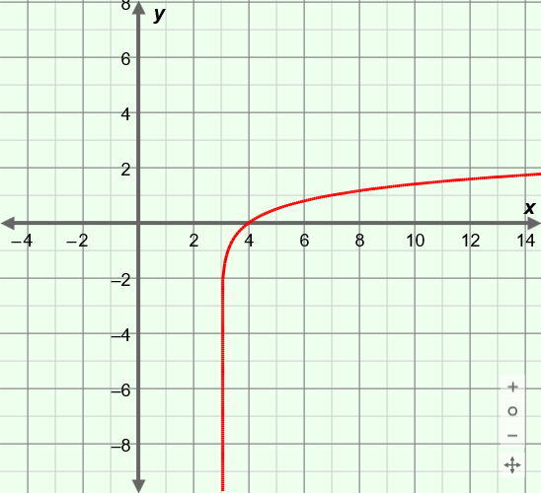

**(4, 0)**

**(7, 1)**

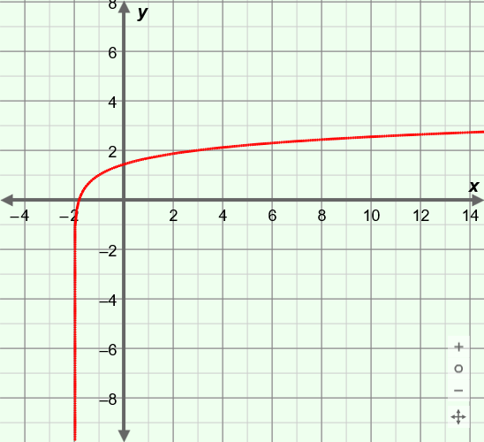

**(–1, 1)**

**(3, 2)**

|  |  |  |
| --- | --- | --- |
| **Activity B:**  **Effects of *a* and *c* on the graph** | Get the Gizmo ready:   * On the **CONTROLS** tab, select **Show probe** and turn off **Show asymptote**. * Set ***a*** to 1, ***b*** to 8, ***c*** to 1, ***h*** to 0, and ***k*** to 0. |  |

1. The function you have graphed in the Gizmo should be *y* = log8(*x*).
   1. What are the coordinates of two “key points” (the points with *y*-values of 0 and 1) on this graph? ( , 0) and ( , 1) Use the probe to check your answers.
   2. Use the slider to vary the value of ***a***. What happens to these two points?

* 1. When *a* is negative, what happens to the graph?

* 1. Vary ***a*** and ***b*** to check how *a* affects logarithmic functions with other bases. You should see that the value of *a* **scales** (stretches or shrinks) the graph vertically.

In general, what two key points are always on the graph of *y* = *a* log*b*(*x*)?

( , ) and ( , )

* 1. Select **Show asymptote**. Vary ***a*** and ***b***. How does *a* affect the asymptote and domain?

1. Graph the function *y* = log5(*x*) in the Gizmo.
2. What is the solution to log5(*x*) = 0? To log5(*x*) = 1?
3. Based on that, what two points lie on the graph of *y* = log5(*x*)?
4. What is the solution to log5 2(*x*) = 0? To log5 2(*x*) = 1?
5. So, what two points must lie on the graph of *y* = log5 2(*x*)?
6. Graph *y* = log5 2(*x*) in the Gizmo. Use the probe to verify the points you found. Overall, how did the graph of *y* = log5(*x*) change when *c* changed from 1 to 2?

**(Activity B continued on next page)**

**Activity B (continued from previous page)**

1. Vary ***c*** and ***b*** to check how *c* affects logarithmic functions with other bases. You should see that *c* scales the graph horizontally.

What two key points are always on the graph of *y* = log*b* *c*(*x*)?

1. Graph *y* = log2(*x*) in the Gizmo. Turn on **Show asymptote**.
2. How do you think *a* and *c* will affect the asymptote and domain of *y* = log2(*x*)?

Check your answer in the Gizmo.

1. Vary ***a*** and ***c*** in the Gizmo to check your answer. What do you find?

1. Vary ***a***, ***b***, and ***c***, to see many different logarithmic functions. In general, what are the asymptote and domain of *y* = *a* log*b* *c*(*x*)?

Asymptote: Domain:

1. State the coordinates of two key points on the graphs of the following functions. Check your answers in the Gizmo.
2. *y* = 6 log3(*x*)

1. *y* = log6 2(*x*)

1. *y* = –5 log9 2(*x*)

1. What logarithmic functions are graphed here? Check your answers in the Gizmo.

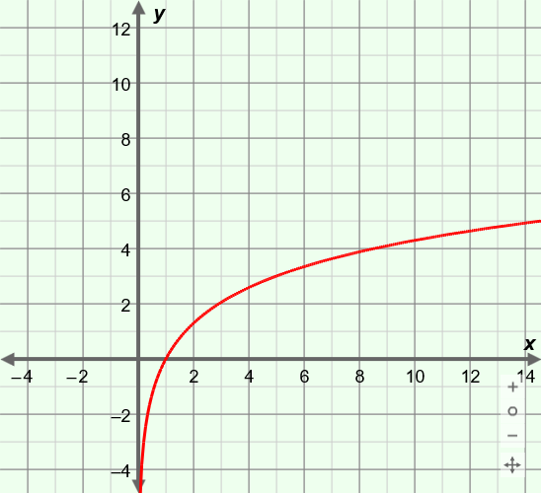

**(5, 3)**

**(1, 0)**

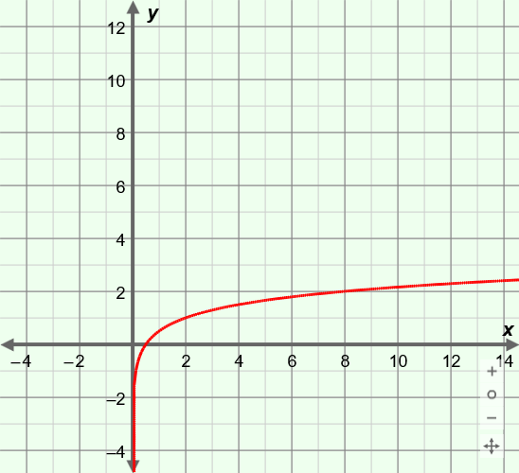

**(0.5, 0)**

**(2, 1)**

|  |  |  |
| --- | --- | --- |
| **Activity C:**  **Practice scaling and translating functions** | Get the Gizmo ready:   * On the **CONTROLS** tab, turn off **Show probe** and **Show asymptote**. |  |

1. Before using the Gizmo, consider the graph shown here.

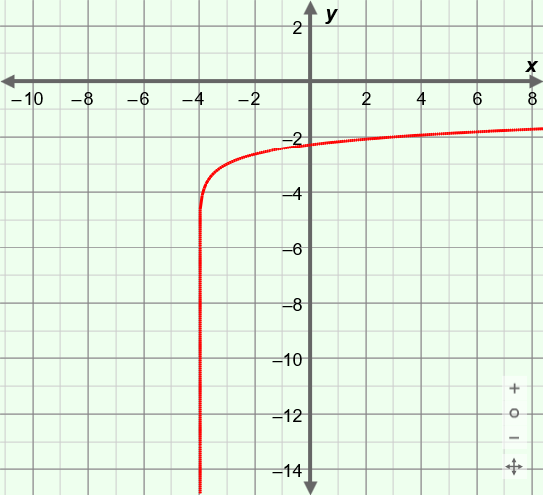

**(–3, –3)**

**(3, –2)**

1. How has the function *y* = log7(*x*) been transformed to create the graph shown?

1. What is the value of *h*? Of *k*?
2. What logarithmic function does the graph show?

Use the Gizmo to check your answers.

1. State the coordinates of two key points on the graphs of the following functions. (Hint: Work from the "inside out.")
2. *y* = 7 log3(*x*)
3. *y* = –log8(*x* + 2) + 5
4. *y* = log4 2(*x*) – 6

Graph these functions in the Gizmo to check your answers.

1. What logarithmic functions are graphed here? Check your answers in the Gizmo.

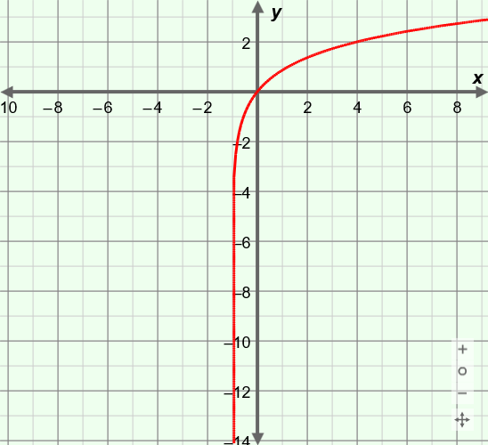

**(0, 0)**

**(4, 2)**

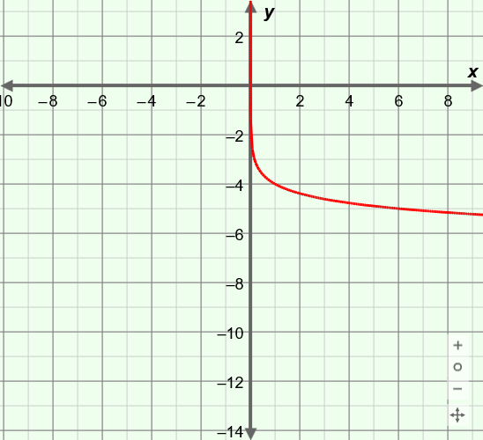

**(1, –4)**

**(6, –5)**