Vocabulary: Magnetic Induction

Vocabulary

- Current – the flow of electrical charge.
  - In a metal wire, current is the flow of negatively charged particles (electrons).
  - Current is measured in amperes (A).
  - In equations, the symbol for current is I.

- Induced magnetic field – a magnetic field that surrounds a current in a circuit.

- Magnetic field – a region in space that surrounds a magnet or moving charged particle.
  - Magnets and moving charges within the magnetic field experience a force.
  - Magnetic field lines show the direction magnetic objects such as iron filings or compass needles will align to.
  - Magnetic forces are greatest where the magnetic field lines are closest together.
  - The symbol for the strength of a magnetic field is B. It is typically measured in gauss (G).

- Pythagorean Theorem – a law that states that the square of the length of a right triangle’s hypotenuse (c) is equal to the sum of the squares of the lengths of the two legs (a and b): a² + b² = c².
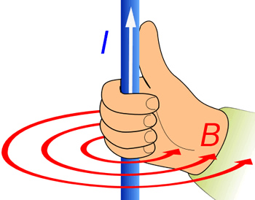

Right-hand rule

- Right-hand rule – a way to visualize the magnetic field produced by an electric current.
  - The thumb points in the direction of conventional (positive) current, while the fingers show the direction of the magnetic field.

