Vocabulary: Mascot Election

Vocabulary
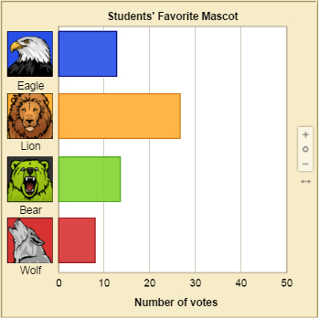

Bar graph

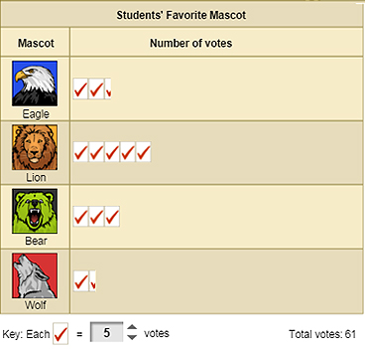

Pictograph

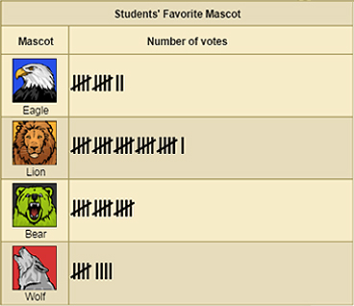

Tally chart

- Bar graph – a graph in which bars are used to represent data.
  - Bars can be vertical or horizontal. The graph at right has horizontal bars.
  - The scale of the bar graph should be adjusted so that all bars are clearly visible.

- Frequency – how often an event occurred.

- Frequency table – a table that shows how often each result occurred.

- Horizontal axis – a number line that runs left to right below a graph.

- Pictograph – a form of bar graph in which the bars are replaced by rows or columns of symbols.
  - Each symbol represents a certain number of real objects.
  - For example, in the pictograph shown, each symbol represents 5 votes.

- Scale – the amount represented by each unit in a graph.
  - On a bar graph, the scale is the amount represented by each unit of the vertical axis.
  - On a pictograph, the scale is the amount represented by each symbol.

- Tally chart – a table that uses tally marks to record data.
  - Each vertical tally mark (|) represents one.
  - Tally marks are grouped into sets of five, like this: ||||.

