Name: Date:

Student Exploration: Mean, Median, and Mode

Vocabulary: average, line plot, mean, median, mode, outlier, range

Prior Knowledge Questions (Do these BEFORE using the Gizmo.)
Bill has 1 marble, Jill has 1 marble, Sally has 2 marbles, Wendy has 3 marbles, and Sean has 8 marbles. They argue about what the average number of marbles is.

- Wendy thinks the average is 3. What do you think her reasoning is?

- Sally thinks the average is 2. What do you think her reasoning is?

- Bill and Jill think that the average number of marbles is 1. What you think their reasoning is?

Gizmo Warm-up
There are actually several ways of finding the “average” of a group of numbers. Most of the time, when people talk about average, they are referring to the mean. However, average could also refer to the median or mode of a data set.

These three types of “average” are explored in the Mean, Median, and Mode Gizmo. To begin, create a data set by dragging the gray dots to the line plot. Drag dots to 1, 1, 2, 3, and 8.

- Check that Find mean is selected. Drag the balance point slider until the frogs are balanced. What is the balance point of this data set?

- Select Find median. Click the arrow buttons ( and ) until the pans are balanced. What is the middle value of this data set?

- Select Find mode. Drag the bar down until it hits the highest stack of frogs. Which stack of frogs is the highest?
Activity A:  Mean | Get the Gizmo ready:  - Click Clear and select Find mean.  - Drag dots to 3 and 9 on the line plot.

- The most common measurement of average is the mean. One way to think about the mean is to imagine all of the objects in a data set pooled together, and then divided evenly.

- Check that there are frogs at 3 and 9 on the seesaw. Turn on Calculate mean. How is the mean calculated?
In general, the mean () is found by adding all the values in the data set, then dividing by the number of items (n). This is shown by the formula below:
=

- Use the balance point slider to balance the frogs. How does the balance point relate to the mean?
- Turn off Calculate mean. Move the point at 3 to 1. What is the mean now? Show your calculation to the right, and then check your answer by finding the new balance point.

=

- Be sure Calculate mean is off. Click Clear, and then use the points on the line plot to generate the following data set: 1, 3, 6, 6, 8, 9, 9.

- Calculate the mean of this data set. Show your work to the right.

=

- Turn on Calculate mean to check your calculation. Correct your value if necessary.

- Set the balance point to the mean. What happens?

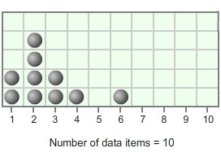
- Mrs. Flynn asked each student in her class how many children were in their family. The results are shown to the right. Find the mean, and then check your answer using the Gizmo.

=

Activity B:  Median | Get the Gizmo ready:  - Click Clear and select Find median.  - Drag dots to 3, 4, and 5 on the line plot.

- The median of a data set is its middle value. In the Gizmo, this is modeled by placing the frogs on a balance. Check that the data set consists of 3, 4, and 5. Click the arrow buttons until the frogs are balanced.

- What is the middle value in the data set you modeled?

- Turn on Calculate median. Is this the same value as that of the middle frog?

- On the line plot, drag the point on 5 to 10. Does this change the median?

Explain.

- Now place a fourth point on the data set at 6. The data set should now be 3, 4, 6, 10. Click the arrow buttons until the pans are balanced again.

- Carefully read the text below Calculate median. How do you find the median of a data set that has an even number of items?

- What is the median of the data set 3, 4, 6, 10?

- Turn off Calculate median. Click Clear, and then use the points on the line plot to generate the following data set: 1, 1, 2, 7, 9, 10. Use the arrow buttons to balance the pans.

What is the median of this data set? Turn on Calculate median to check.

- Find the median of the data set: 8, 5, 8, 2, 4, 9, 8, 5. (Hint: You will need to write the numbers in order first.) Check your answer with the Gizmo.

Median:

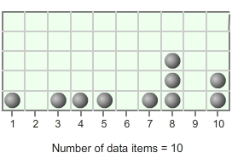
- Mrs. Flynn asked each student in her class how many cousins they had. The results are shown at right. Find the median number of cousins, and then check using the Gizmo.

Median:

Activity C:  Mode and range | Get the Gizmo ready:  - Click Clear and select Find mode.  - Create the following data set: 1, 3, 3, 3, 4, 5, 5, 9.

- Move the red and yellow bar down until it hits the tallest stack of frogs.

- Which stack of frogs did the bar hit first?

You have just found the mode, the most frequent value (or values) in the data set.

- The range of a data set is the difference between the highest and lowest values. What is the range of this data set?
- Add another point at 5. What happens?

As you see, a data set can have more than one mode.

- Turn off Calculate mode. Move the point at 1 and the point at 9 to 4. The data set should now be 3, 3, 3, 4, 4, 4, 5, 5, 5. Does this data set have a mode? Explain why or why not.
Check your answer by turning on Calculate mode.

- Turn off Calculate mode. Click Clear, and then use the points on the line plot to generate the following data set: 3, 4, 4, 4, 5, 5, 7, 7, 7.

- How many modes does this data set contain?

- What is/are the mode(s) of this data set?

- Turn on Calculate mode to check your answer. Correct your value if necessary.

- What is the range of this data set?

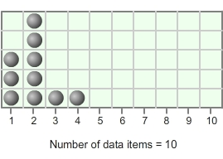
- Mrs. Flynn asked each student in her class how many cars their family owned. The results are shown at right.

- What is the mode of this data set?

- What is the range of this data set?

Extension:  Comparing mean, median, and mode | Get the Gizmo ready:  - Click Clear and select Find mean.  - Create the following data set: 1, 2, 2, 4, 4, 4, 6, 6, 7. | 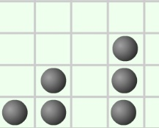

For some data sets the mean, median, and mode are similar. For other data sets they may be very different. How these values differ can give clues about the shape of the data set.

- In the Gizmo, look at the overall “shape” of the data set. Consider the symmetry of the data, or how much the left side and right side of the data set look like mirror images of each other.

- Does the left half of the data set look similar to the right half?

Because the two sides are like mirror images, this data set can be described as symmetrical.

- What are the mean, median, and mode of this data set?

Mean: Median: Mode:

- In a symmetrical data set like this one, what do you observe about the mean, median, and mode?

- Click Clear. Create the following data set: 1, 1, 1, 1, 3, 4, 10.

- Would you describe this data set as symmetrical? Explain.

- Which value do you think will be greatest, the mean, median, or mode?

- What are the mean, median, and mode of this data set?

Mean: Median: Mode:

- When one value in a data set is very different from the rest, it is called an outlier.

Which value appears to be an outlier in this data set?

- Which value do outliers seem to affect most, the mean, median or mode?

Explain.

(Extension continued on next page)
Extension (continued from previous page)
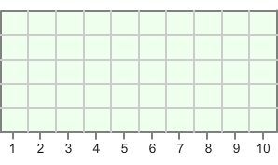
- Using the Gizmo, create a data set in which the mean is between the median and the mode. Illustrate your data set by filling in the line plot to the right. List the mean, median, and mode of your data set below.

Mean: Median: Mode:

- Morgan received the following grades on her math tests: 98, 94, 97, 94, 95 and 41. (She was sick on the day of the last test.)

- Do you think the mean is above or below the median in this data set?

Explain how you know.

- Which test score is an outlier?

- What are the mean, median, and mode of this data set?

Mean: Median: Mode:

- Challenge: The graph below shows the distribution of household income in the United States in 2010.
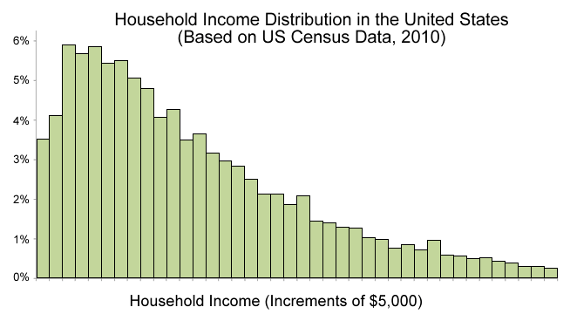
- What do you think is the order of the mean, median, and mode of this data set, from lowest to highest?
- Explain how you know.

