Vocabulary: Mean, Median, and Mode

dictionary2

**Vocabulary**

* Average – a number that typifies a set of numbers.
  + The average of a set of numbers can be the mean, median, mode, or another value. Usually average is used to indicate the mean.

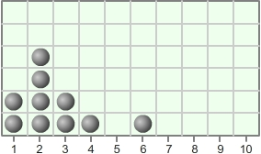

* Line plot – a graph in which each item of data is represented by a dot above a number line.
  + For example, the line plot at right represents the following data set: 1, 1, 2, 2, 2, 2, 3, 3, 4, 6.
  + Line plots are also known as *dot plots*.
* Mean – the sum of all the values in a data set divided by the number of values.
  + For example, the mean of the data set 2, 3, 5, 6 is  =  = 4.
* Median – the middle value in a set of numbers.
  + Before finding the median, all data should be in order from least to greatest.
  + If there is an odd number of values, the median is the middle number.
    - For example, the median of the data set 2, 3, 5, 6, 8 is 5.
  + If there is an even number of values, the median is the mean of the middle two values.
    - For example, the median of the data set 3, 5, 6, 8 is  =  = 5.5.
* Mode – the most common value in a data set.
  + For example, the mode of the data set 4, 4, 5, 7, 10 is 4 because 4 is the most common value.
* Outlier – a value that is significantly different from the other values in a data set.
  + For example, in the data set 1, 1, 2, 3, 10, the number 10 may be considered an outlier.
* Range – the difference between the greatest and least value in a data set.
  + For example, the range of the data set 4, 4, 5, 7, 10 is 10 – 4 = 6.