Name: Date:

**Student Exploration:** **Modeling Fractions**

**Vocabulary:** denominator, difference, equivalent, fraction, least common denominator, numerator

**Prior Knowledge Questions** (Do these BEFORE using the Gizmo.)

1. Suppose you were splitting a candy bar equally between yourself and two friends. Where would you cut the bar? (Show your cuts on the diagram below.)

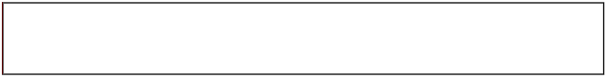

1. Now suppose you were splitting the candy bar with just one friend, but she wanted *twice* as much candy as you. How would you split up the candy bar this time?



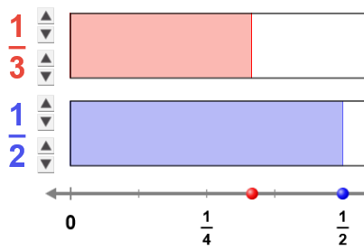**Gizmo Warm-up**

A **fraction** shows the relationship between a part and a whole. The *Modeling Fractions* Gizmo represents fractions with area models. In each model, the whole is represented by the large rectangle, and the part is represented by the red or blue shaded portion.

1. The **numerator** is the top number in a fraction. Click the arrows to change the numerator of the top (red) fraction.

How does changing the numerator affect the model? _______________________________

_________________________________________________________________________

1. The **denominator** is the bottom number in a fraction. Click the arrows to change the denominator of the bottom (blue) fraction.

How does changing the denominator affect the model? _____________________________

_________________________________________________________________________

|  |  |  |
| --- | --- | --- |
| **Activity A:**  **Fraction parts** | Get the Gizmo ready:   * Click **Clear** to set both fractions to . | 1006SE3 |

If you and your friends were dividing up a candy bar, each friend would get a fraction of the bar. The denominator of the fraction is how many equal parts you divide the bar into. The numerator is the number of those equal parts that a person gets.

1. In the Gizmo, set the denominator of the top (red) model to 4. In the space below, shade the models to show , , , and . Use the Gizmo to guide your work.









1. How does increasing the numerator affect the value of the fraction? ___________________

_________________________________________________________________________

1. In the Gizmo, set the numerator of the bottom (blue) model to 1. In the space below, shade the models to show , , , and .

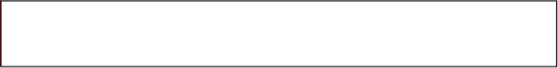







1. How does increasing the denominator affect the value of the fraction? _________________

_________________________________________________________________________

1. Place a < (“is less than”) or > (“is greater than”) sign between each pair of fractions to indicate which is greater. Use the Gizmo to check your answers.

       

|  |  |  |
| --- | --- | --- |
| **Activity B:**  **Equivalent fractions** | Get the Gizmo ready:   * Click **Clear** to set both fractions to . | 1006SE4 |

1. You cut a candy bar into two equal pieces, and eat one. Your friend cuts his candy bar into four equal pieces, and eats two pieces. Who ate more candy? _______________________

Why do you think so? _______________________________________________________

1. Model this situation in the Gizmo by setting the top model to  and the bottom model to .

What do you notice? ________________________________________________________

Because they represent the same amount,  and  are equal or **equivalent** fractions.

1. Experiment with the Gizmo to find other equivalent fractions. Find a fraction that is equivalent to each of the following fractions. (The first is done for you.)

 =   =  =  =

1. Without using the Gizmo, how can you find a fraction that is equivalent to ? _________________________________________________________________________
2. Given a starting fraction such as , how can you create an equivalent fraction with a *smaller* denominator? _______________________________________________________
3. Challenge: Create fractions equivalent to each of the following. (Hint: You may not be able to model some of these in the Gizmo.)

 =  =  =  =

|  |  |  |
| --- | --- | --- |
| **Activity C:**  **Comparing fractions** | Get the Gizmo ready:   * Click **Clear** to set both fractions to . |  |

1. You eat  of a candy bar, and your friend eats  of a bar. Who ate more? _____________

Without using the Gizmo, why is it hard to compare these fractions? ___________________

_________________________________________________________________________

1. Model  and . Which fraction is greater? ________ Who ate more candy? _________
2. It is hard to compare fractions when they have different denominators, but it is easy to compare fractions with the same denominator. The **least common denominator** (LCD) of a pair of fractions is the smallest whole number that is a multiple of both denominators.

Turn on **Compare fractions using LCD** and look at the resulting display:

* 1. What is the LCD of  and ? _____
  2. What fraction has a denominator of 8 and is equivalent to ?

1. You might wonder how much more candy you ate than your friend. The **difference** between two numbers is how much one number is greater than the other.

What is the difference between  and ? Turn on **Show difference** to check.

1. Practice: Answer the questions below. Use the LCD of each pair to help. Use the Gizmo to check your answers.

Which fraction is greater  or ? Which is greater,  or ?

Find the difference:  –  = Find the difference:  –  =