Name: Date:

Student Exploration: Modeling Whole Numbers and Decimals

Vocabulary: base-10 blocks, base-10 system, decimal, decimal point, whole number

Prior Knowledge Questions (Do these BEFORE using the Gizmo.)

- Sally has 2 hundred-dollar bills, 6 ten-dollar bills, and 7 ones.

How much money does Sally have? ____________________________________________

- Buck has 91 one-dollar bills in his wallet. The wallet is so fat it barely fits into his pocket.

What is a better way to carry 91 dollars? ________________________________________

- Morgan has 214 pennies in her purse. She makes a jingling sound as she walks.

What is a better way to carry 214 cents? ________________________________________

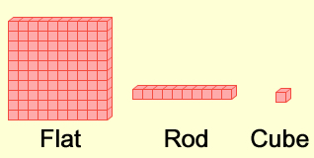
Gizmo Warm-up
Most people in the world use a base-10 system. Each place in this system represents 10 times as much as the next place to the right. For example, 345 means 3 hundreds + 4 tens + 5 ones.

The Modeling Whole Numbers and Decimals Gizmo uses base-10 blocks to represent numbers. There are three types of blocks: flats, rods, and cubes.

- Drag one flat, one rod, and one cube onto the yellow mat.

  - How many cubes are in a rod? _____

  - How many rods are in a flat? _____

  - How many cubes are in a flat? _____

- Click Clear. Drag a flat into the Tens area. What happens? __________________________

- Now drag a rod into the Ones area. What happens? _______________________________

Activity A:  Modeling whole numbers | Get the Gizmo ready:  - Click Clear.  - Under Set block values, check that 100, 10, 1 is selected. | 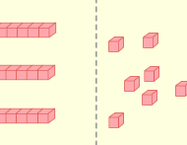

Numbers with no fractional or decimal part are called whole numbers. With the base-10 blocks shown in the Gizmo, you can model whole numbers up to 1000.

- Drag 2 flats into the Hundreds area, 3 rods into the Tens area, and 5 cubes into the Ones area of the yellow mat. What number have you modeled? ___________________________
Check your answer by turning on Show value.

- Drag one of the flats into the Tens area, and drag one of the rods into the Ones area.

  - How many total flats, rods, and cubes do you have now?

Flats: _____ Rods: _____ Cubes: _____

  - Has the number being modeled changed? _____

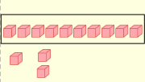
- Click and drag your cursor to select 10 cubes, as shown at right. Drag these cubes into the Tens area.

What happens?

- Use the same method to drag 10 rods into the Hundreds area. What happens? _________

_________________________________________________________________________

- Click Clear. Model 134 in as many different ways as you can. Describe what you did below:

_________________________________________________________________________

_________________________________________________________________________

_________________________________________________________________________

- Wilson has 210 dollars, all in one-dollar bills. He needs a briefcase just to carry his money around. How could Wilson carry his money with the fewest number of bills?

_________________________________________________________________________

Activity B:  Modeling decimals | Get the Gizmo ready:  - Click Clear.  - Under Set block values, select 1, 0.1, 0.01. | 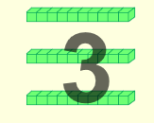

Decimals are numbers written in the base-10 number system. Often, though, the term “decimal” is used to mean a number with a decimal point separating the units place and the tenths place.

- With block values of 1, 0.1, 0.01 selected, look at the labels next to the flat, rod, and cube at the top of the Gizmo.

  - What is the value of one cube? ___________________

  - What is the value of one rod? ___________________

  - What is the value of one flat? ___________________

- The flats, rods, and cubes can be converted from one form to another.

  - Drag a flat into the tenths area. How many tenths are in one whole? _____

  - Drag a rod into the hundredths area. How many hundredths are in one tenth? ____

  - Click Clear. How many hundredths do you think are in one whole? _____

Use the Gizmo to check your answer.

- Turn on Show values on mat. Drag flats, rods, and cubes onto the mat until you have created the number 3.18. How many flats, rods, and cubes did you use?

Flats: _____ Rods: _____ Cubes: _____

- Model 3.18 in at least two other ways. Describe how you did it in the space below.

_________________________________________________________________________

_________________________________________________________________________

_________________________________________________________________________

- Shontay has 4 dollar bills. She wants to play a video game that only takes dimes. How many dimes can she get for her dollars? How many pennies? Explain.

_________________________________________________________________________

_________________________________________________________________________

Activity C:  Other models | Get the Gizmo ready:  - Click Clear. Turn off Show values on mat and Show value.  - Under Set block values, select 10, 1, 0.1. | 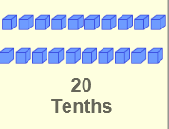

Base-10 blocks can be used to represent any set of places in the base-10 system.

- With block values set to 10, 1, 0.1, look at the labels next to the flat, rod and cube at the top.

  - In this set, what is the value of one cube? ___________________

  - What is the value of one rod? ___________________

  - What is the value of one flat? ___________________

- In the space, draw flats, rods, and cubes to model 25.3. Use the Gizmo to check your work.

- Click Clear, and set the block values to 0.1, 0.01, 0.001. Sketch a model of the number 0.147, and then use the Gizmo to check your work.
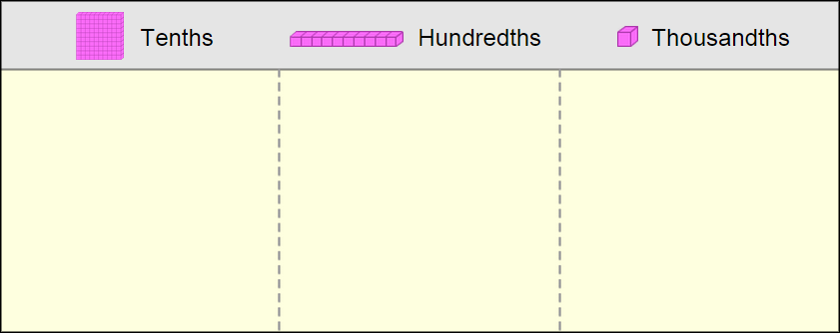

- Turn Show values on mat and Show value off. Play the following game with a partner:
  - Model a number by dragging flats, rods, and cubes onto the mat.
  - Have your partner guess what the number is, and then turn on Show value to check.
  - Switch roles and play again! Play as many rounds as you like.

