Name: Date:

Student Exploration: Molecule Builder

Vocabulary: chemical bond, chemical formula, covalent bond, double covalent bond, cyclic molecule, hydrocarbon, ionic bond, isomers, Lewis structure, molecule, organic compound

Prior Knowledge Questions (Do these BEFORE using the Gizmo.)
Look at the water molecule shown below. In the molecule, chemical bonds are shown as lines between the atoms.
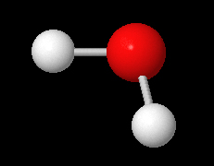
- The red atom in the middle is oxygen. How many bonds does the oxygen atom have?

- The two white atoms are hydrogens. How many bonds does one hydrogen atom have?

- The chemical formula of water is H₂O. In this formula, what do you think the “2” between the H and O refers to?
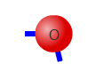
Gizmo Warm-up
In the Molecule Builder Gizmo, drag an oxygen atom into the white simulation area. The short blue lines extending from the atom represent possible chemical bonds.

- How many bonds can oxygen form?

- Drag a hydrogen atom into the area. How many bonds can hydrogen form?

- Drag the hydrogen atom on top of the oxygen atom. What happens?

The black line represents a chemical bond between the hydrogen and oxygen atoms.

- Bond another hydrogen atom to the other side of the oxygen atom. Now, enter the formula “H2O” into the Type the formula below box. Congratulations! You have created a water molecule. Select Show 3D structure to see what the molecule looks like in 3D.

Activity A:  Simple molecules | Get the Gizmo ready:  - Check that the Free build mode is selected.  - If necessary, double-click on the trash can icon to clear the simulation area. | 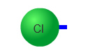

Introduction: Not every group of bonded atoms is a molecule. In a molecule, the chemical bonds connecting atoms are covalent bonds. In a covalent bond, bonded atoms share pairs of electrons. (In an ionic bond, electrons are transferred from one atom to another.)

Question: What is the structure and chemical formula of simple molecules?

- Explore: On your own, experiment by dragging different atoms into the simulation screen and bond them together. When you have completed a molecule, try typing its formula into the “Type formula” box. See if you can figure out how to write formulas for simple molecules.

When you enter the correct formula for a molecule you built, it appears in the Completed molecules area. Which molecules have you completed so far?

- List: Drag each element into the area. How many bonds can each element form?

Carbon: ___ | Nitrogen: ___ | Chlorine: ___ | Sulfur: ___ | Hydrogen: ___ | Oxygen: ___

Which element forms the greatest number of bonds?

- Create: Clear the simulation area, then drag two oxygen atoms into the area.

- Create a bond between the two oxygen atoms. How many bonds does each atom have remaining?
- Click on the bond. What happens?

This is a double covalent bond. In this bond, two pairs of electrons are shared.

- Enter the formula O₂ into the box, then view the 3D molecule. Notice the subscript “2” follows the element it describes, in this case oxygen.

- Create: Clear the screen, then drag out two nitrogen atoms. Bond them together to form a complete N₂ molecule. What type of bond do you think you formed?
Enter the formula into the area, then view the 3D nitrogen gas molecule. Nitrogen molecules contain triple bonds, so they share three pairs of electrons.

(Activity A continued on next page)
Activity A (continued from previous page)

- Practice: Write the formula for each molecule shown below. Then, check your work by creating the molecule in the Gizmo and writing the formula. (Don’t worry too much about the order of elements in the formula for now.)
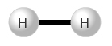 | 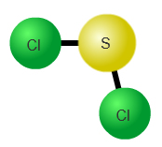 | 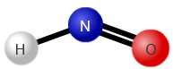
Formula: _____ | Formula: _____ | Formula: _____

- Practice: Under Mode, select Build from formula. Check that Simple molecules are selected. Turn on Show Lewis structure. A Lewis structure is a diagram that shows the 2D structure of the molecule.

Each time you complete a molecule, click Check. List the full name of each molecule below. Select Show 3D structure to view what the molecule really looks like in three dimensions.

Cl₂: O₂: N₂: H₂O:

NH₃: CO₂: CH₄: C₃H₈:

- Extend: Molecules that contain C-H bonds are called organic compounds. Most organic compounds are produced by living things. Look at the Lewis structure of the organic compound propane, C₃H₈. Based on the structure of propane in the Gizmo, what do you think is the structure of butane, C₄H₁₀? Draw a picture below, then see if you are correct using the Free build mode of the Gizmo.

C₄H₁₀

Methane, propane, and butane are all examples of hydrocarbons. As the name implies, hydrocarbons are made of hydrogen and carbon. Many fuels are hydrocarbons.

- Infer: Of the elements you can see in this Gizmo, which element would you choose to form the inner structure, or “skeleton,” of a complicated molecule? Explain your choice.

Activity B:  Cyclic molecules | Get the Gizmo ready:  - Select Build from formula.  - Select Cyclic molecules and check that C₃H₆ is selected. (If not, click the Prev. button.) | 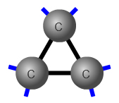

Goal: Build ring-shaped molecules.

- Create: The challenge molecule should be C₃H₆. Drag three carbon atoms into the simulation area, then bond them into a straight row. Be sure to use single bonds.

- Click Make cyclic. What happens?

A cyclic molecule has a ring structure.

- Complete the molecule using the hydrogen atoms. (Turn on Show Lewis structure if necessary.) Click Check and Show 3D structure.

What is the name of the molecule you created?

- Practice: Use the Lewis structures as a guide to complete the next three cyclic molecules. List the name of each molecule you create.

C₃H₄: C₅H₈: S₈:

Which molecule does not contain any carbon?

- Challenge: Click Next and create the most complex molecule in the Gizmo, C₆H₁₂O₆. Start with a horizontal line that contains five carbons and one oxygen. Then click Make cyclic.

Use the Lewis structure to complete the molecule. (Note: In this structure, OH is shorthand for a hydrogen atom connected to an oxygen, like O-H.) Click Check and Show 3D structure when the molecule is complete.

What is the name of this molecule?

Glucose is a basic sugar used as an energy source by living things. Glucose molecules can be linked together to form complex sugars and carbohydrates.

- Think and discuss: Most of the molecules in living things contain rings of carbon and oxygen. Why do you think carbon is such an important element in forming these molecules?

Extension activity:  Isomers | Get the Gizmo ready:  - Select Build from formula.  - Select Isomers. Check that the challenge molecule is C₄H₆, or butyne. | 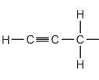

Introduction: Sometimes compounds have the same chemical formula but different structures. These alternate structures are called isomers.

Goal: Create multiple versions of the same compound.

- Create: Check that the challenge molecule is C₄H₆, or butyne. Turn on Show Lewis structure. Create the first isomer of butyne, click Check, and view the molecule in 3D. Sketch the Lewis structure in the left box below.

Click the right arrow to see the Lewis structure of isomer 2. Build this molecule and click Check, then sketch the Lewis structure in the right box. Circle at least one place where the two isomers are different.
Butyne (isomer 1)
Butyne (isomer 2)

- Practice: Using the Lewis structures as a guide, create the remaining isomers. If you like, you can take screenshots of the isomers you create and paste them below. (To do this, click the camera icon () and paste the resulting screenshot either into this document or into a blank document to print out and turn in with this sheet.)
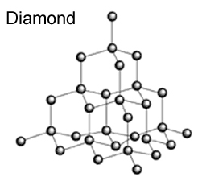

- Go beyond: Allotropes are elements that have different structures. For example, graphite and diamond are two allotropes of pure carbon. You can see their crystal structures at right.

- Look carefully at the highlighted carbon atoms.

How many bonds does each form?

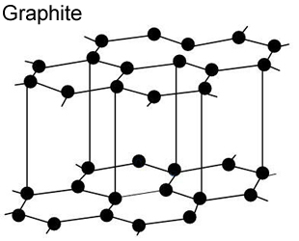
- Diamonds are very hard, while graphite is the soft black substance in a pencil lead. Based on their structures, why do you think diamonds are much harder than graphite?

