Vocabulary: Moonrise, Moonset, and Phases

Vocabulary
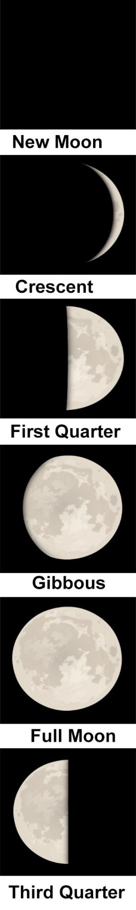
- Horizon – the line along which the sky appears to meet the land or sea.

- Moon phase – the appearance of the Moon, as seen by an observer on Earth.
  - Moon phases occur because different amounts of the illuminated half of the Moon are visible as the Moon orbits Earth.
  - The order of Moon phases is New Moon, Waxing Crescent, First Quarter, Waxing Gibbous, Full Moon, Waning Gibbous, Third Quarter, and Waning Crescent. Many of these phases are shown at right.
  - The full cycle of Moon phases takes 29.5 days to complete.

- Moonrise – the time at which the Moon appears above the eastern horizon.

- Moonset – the time at which the Moon disappears below the western horizon.

