Name: Date:

Student Exploration: Multiplying Decimals

Vocabulary: area, estimate, partial product, product

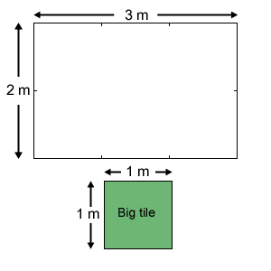
Prior Knowledge Questions (Do these BEFORE using the Gizmo.)

At the Big Green Tiles flooring store, your job is to figure out how many tiles will be needed to cover a floor. Mrs. Harmon’s bathroom floor (shown at right) measures 2 meters by 3 meters. Each big green tile measures 1 meter on each side.

- An estimate is rough calculation or educated guess. How many tiles do you think will be needed to cover the floor?

______________________________________________

- How did you make this estimate? ______________________________________________

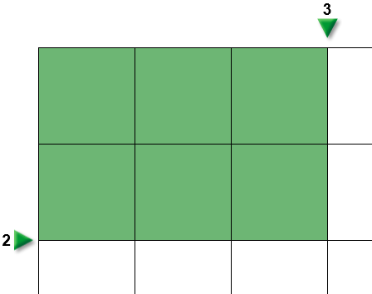
Gizmo Warm-up
The Multiplying Decimals (Area Model) Gizmo shows a floor that is being tiled with big green tiles. Drag the arrows to change the length or width of the floor. Check that Mrs. Harmon’s floor (2 × 3) is modeled in the Gizmo.

- How many rows of green tiles do you see? _________

How many columns of green tiles do you see? _________

- How many tiles cover a 2-by-3 floor? _________ What does 2 × 3 equal? _________

The answer to 2 × 3 is called the product of 2 and 3.

- The number of square units (such as tiles) in a figure is its area. If you know the length and width of a rectangle, how can you find the area?

_________________________________________________________________________

- How many tiles will cover a floor that measures 3 meters by 4 meters? _________

Use the Gizmo to check your answer. Were you correct? _________

Activity A:  Mr. Lee’s floor | Get the Gizmo ready:  - Select Estimate.  - Next to rows (lower left), select Halves. | 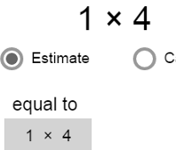

Mr. Lee wants the floor of his utility closet to be tiled. He can’t quite remember the dimensions, but he thinks it measures 1 meter by 4 meters.

- Use the arrows to set the floor dimensions to 1 × 4.

  - How many rows of tiles are there? __________ Columns? __________

  - What is the area of the closet floor? __________

- Mr. Lee changes his mind. Now he thinks the closet measures 2 meters by 4 meters. Adjust the floor in the Gizmo so that its dimensions are 2 × 4.

  - How many rows of tiles are there? __________ Columns? __________

  - What is the area of the floor? __________

- Finally you decide to measure Mr. Lee’s floor yourself. It measures 1.5 meters by 4 meters. Check that Estimate is still selected, and adjust the floor in the Gizmo to these dimensions.

  - How many whole tiles do you see? __________

  - How many half tiles do you see? __________

  - If you put the halves together, how many whole tiles could you make? ___________
  - What is the total area of the floor? __________

- Select Calculate. The green and turquoise areas are parts of the whole product, called partial products. Check that Show partial products is on, and turn on Show sum of partial products.

  - What are the partial products in this problem? __________ and __________

  - How many tiles will you need to cover Mr. Lee’s floor? __________

- Find each product to determine how many tiles are needed for each floor. When possible, use the Gizmo to check answers. (The last two are challenges.)

0.5 × 4 = ______ 1 × 4 = ______ 1.5 × 4 = ______ 2 × 4 = ______ 2.5 × 4 = ______

3 × 4 = ______ 3.5 × 4 = ______ 4 × 4 = ______ 4.5 × 4 = ______ 5 × 4 = ______

Activity B:  Miss Thibault’s floor | Get the Gizmo ready:  - Turn off Show partial products.  - Select Estimate, and turn off Show estimation.  - Next to rows, select Tenths. | 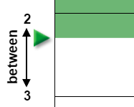

Miss Thibault wants the floor of her bathroom to be tiled. She measured the floor very precisely, and the floor measures 2.3 meters by 2 meters.

- With Estimate selected, use the arrows to set the dimensions of the floor to 2.3 × 2.

  - The product of 2.3 × 2 is greater than what number? __________

  - The product of 2.3 × 2 is less than what number? __________

  - Look closely at the model. What is your best estimate of the product? __________

- Select Calculate. Move your cursor over each of the partial products.

What does 2 × 2 equal? __________ What does 0.3 × 2 equal? __________

What does 2.3 × 2 equal? __________
(Turn on Show partial products and Show sum of partial products to check.)

Mr. and Mrs. Rosewall want the floor of their kitchen to be tiled. The floor measures 2.7 meters by 3 meters. First they want an estimate.

- Switch to the Estimate mode. Set the floor to 2.7 × 3, and look closely.

What is your best guess for the number of tiles it will take to cover their floor? __________

- Without switching to the Calculate mode, find the two partial products that add up to the product (2.7 × 3). Record your calculations below in the spaces below.

First partial product: _____ × _____ = __________

Second partial product: _____ × _____ = __________

Sum of partial products: __________

- Select Calculate, and turn on Show partial products and Show sum of partial products.

What does 2.7 × 3 equal? __________ Was your calculation correct? __________

On your own: Practice multiplying whole numbers by decimals. Use the Gizmo as needed.
Activity C:  Mr. Sedlowski’s floor | Get the Gizmo ready:  - Turn off Show partial products and Show sum of partial products.  - Select Estimate, and check that Tenths is selected. | 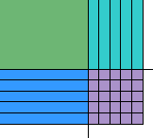

Mr. Sedlowski wants the floor of his workshop tiled with Big Green Tiles brand tiles. His floor measures 2.5 meters by 2.5 meters.

- Set the floor to 2.5 × 2.5. Look carefully at the tiles, and try to determine exactly how many tiles will be needed. Write your estimate here: __________

- Click Calculate. Check that Show partial products is off.

How many partial products are there when you multiply two decimals? __________

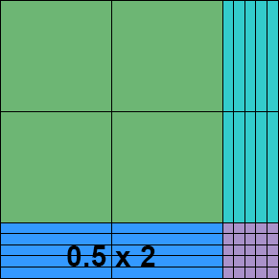
- Move your cursor over each of the partial products to see which part of the diagram they represent. On the diagram at right, label each partial product. (One has been done for you.)

  - Calculate each partial product, and list these values in the spaces below:

__________ __________ __________ __________

Turn on Show partial products to check your work.

  - Add up the partial products to find the product: ______________________________

  - Turn on Show sum of partial products. Were you correct? __________

- Select Estimate. Mr. Sedlowski liked his tiles so much he now wants to tile the floor of his garage, which measures 3.4 m by 3.8 m. Make an estimate, and then calculate the product.

Estimate: __________

First partial product: ______ × ______ = __________

Second partial product: ______ × ______ = __________

Third partial product: ______ × ______ = __________

Fourth partial product: ______ × ______ = __________

Sum of partial products: __________

Click Calculate to check your answer. Were you correct? __________

