Name: Date:

**Student Exploration:** **Multiplying Exponential Expressions**

**Vocabulary:** base, exponent, expression

**Prior Knowledge Questions** (Do these BEFORE using the Gizmo.)

1. What is a shorter, simpler way to express each of the following expressions?
2. *x* + *x* + *x* = __________
3. *x* • *x* • *x* = __________
4. How could you write the expression below in a shorter, simpler way?

(*x* • *x* • *x*) + (*x* • *x* • *x*) + (*x* • *x* • *x*) =

**Gizmo Overview**

In the *Multiplying Exponential Expressions* Gizmo, you multiply **expressions** with exponents, step-by-step. An **exponent** is a number, written to the right of and just above a number or expression (called the **base**), that indicates how many times the base is multiplied by itself.

Here’s how the Gizmo looks at first:

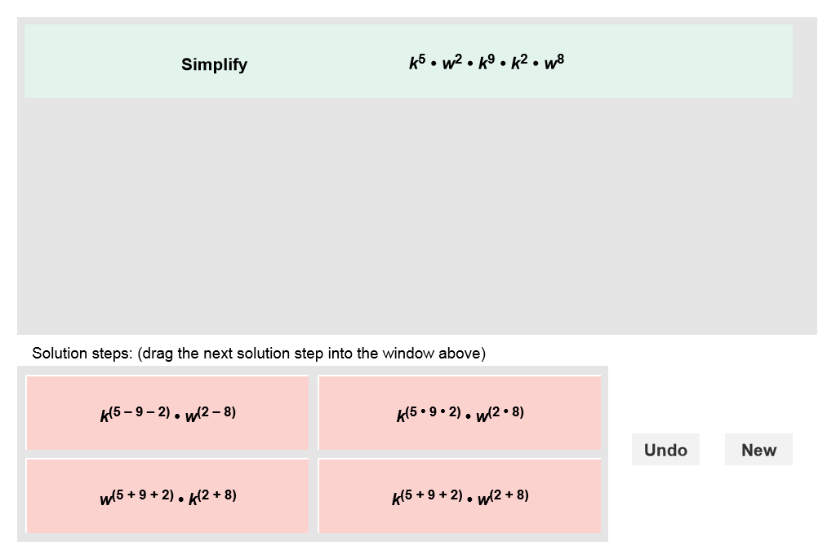

The expression for you to simplify is here.

The tiles give you four choices for the next step. Choose the one you think is correct and drag it into the white area above.

Click **Undo** to undo your last choice.

Click **New** to go to a different problem.

Read your feedback in the Gizmo. (No feedback is given for correct answers.)

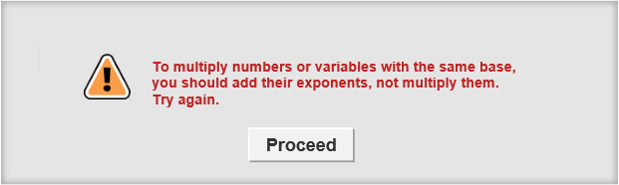

Click **Proceed** to go to the next step.

Continue until the expression is simplified. Then click **New** for a new problem to work on.

|  |  |  |
| --- | --- | --- |
| **Activity:**  **Simplifying products** | Get the Gizmo ready:   * You should see the expression 63 • 64. If not, click **Refresh** in your browser. | 343SE4 |

1. 343SE3When you begin, you should see the expression shown to the right at the top of the Gizmo.
2. First, write 63 • 64 as the product of repeated factors below.

63 • 64 =

1. How many factors of 6 did you write, total? _____________
2. What mathematical operation can you perform on the exponents 3 and 4 to get the number of 6’s being multiplied in 63 • 64?
3. In the Gizmo, choose the correct step. If your choice is incorrect, read the given feedback and try again. What is the answer? _____________
4. Write a rule that explains how to multiply exponential expressions with like bases.

1. Express that general rule as a formula: *xa* • *xb* = _____________
2. 343SE5Click **New**. You should now see the expression shown at the right in the Gizmo.
3. In the expression –8*w*5*y*3 • 2*w*4*y*7, what three pairs of factors can be combined or simplified?

_______ and _______ _______ and _______ _______ and _______

1. In the Gizmo, choose the first correct step. How does writing the expression like this help you simplify the expression?
2. Choose the last correct step. What is the final simplified answer?
3. Click **New**. Work through more problems in the Gizmo. Be sure to read feedback as you do.

**(Activity continued on next page)**

**Activity (continued from previous page)**

1. Simplify each expression below. Write all your steps in the space below each problem.
2. 34 • 32
3. 2*m*6 • 4*m*4
4. *x*8 • *y*7 • *y*6
5. 5*y*2*z* • –3*y*4*z*8
6. *a*9 • *b*3 • *a* • *b*2
7. –4*c*9 • 7*c*6
8. 10*m*7*n* • 5*mn*9
9. –6*x*4*y*5 • –2*xy*7*z*3