Name: ______________________________________ Date: ________________________

**Student Exploration:** **Multiplying Mixed Numbers**

**Vocabulary:** mixed number, product

**Prior Knowledge Questions** (Do these BEFORE using the Gizmo.)

1. Suppose Ricardo has  feet of string. How many  foot pieces can he make?

Explain.

1. How many  foot pieces can he make? __________ Explain.

**Gizmo Overview**

In the *Multiplying Mixed Numbers* Gizmo, you will multiply **mixed numbers** (a whole number combined with a fraction), step-by-step. Here’s how the Gizmo looks at first:

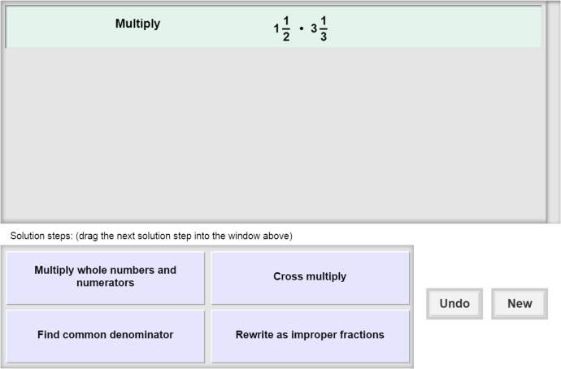The expression for you to multiply is here.

Click **Undo** to undo your last choice.

The tiles give you four choices for the next step. Choose the one you think is correct and drag it into the white area above.

Click **New** to go to a different problem.

Read your feedback in the Gizmo after each answer. Red light = incorrect. Green light = correct.

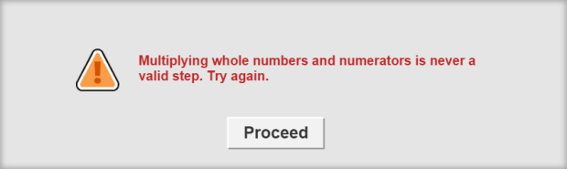

Click **Proceed** to go on to the next step.

Continue until you find the **product** (the result of multiplication). Then click **New** for a new problem to work on.

|  |  |  |
| --- | --- | --- |
| **Activity:**  **Finding the product** | Get the Gizmo ready:   * You should see the expression  • . If not, click **Refresh** in your browser. | 227SE4 |

1. 227SE5When you begin, you should see the expression shown to the right at the top of the Gizmo.
2. Choose the description that you think goes with the correct first step. If your choice is incorrect, read the given feedback and try again. What is the correct first step?

1. The expression shown should now be  • . Do you need to find a common denominator to find the product of two fractions? ____________ Why or why not?

1. What is the next step?
2. Continue to choose the correct steps until you get to the final answer. Fill in the equation at the right to show the product.  •  = __________

227SE6

1. Click **New**. You should now see the expression shown to the right in the Gizmo.
2. What is the correct first step, in words?
3. Fill in the improper fractions that the given mixed numbers are equivalent to.

•

1. Fill in the equation at the right to show the product.  •  =
2. Click **New**. Work through more problems in the Gizmo. Be sure to read the feedback in the Gizmo along the way.

**(Activity continued on next page)**

**Activity (continued from previous page)**

1. Find each product below. Write all your steps in the space below each problem.
2.  • 
3. 5 • 
4.  • 
5.  • 