Vocabulary: Multiplying with Decimals

Vocabulary
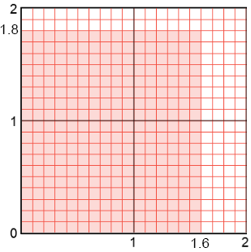
- Area model – a model that uses the area of a figure to represent a quantity.
  - For example, the shading in the area model to the right represents the product of 1.6 and 1.8.

- Product – the result of multiplication.
  - For example, the product of 1.5 and 3 is 4.5, because 1.5 • 3 = 4.5.

