Name: ______________________________________ Date: ________________________

Student Exploration: Mystery Powder Analysis

Vocabulary: Biuret solution, iodine solution, litmus paper, vinegar

Prior Knowledge Questions (Do these BEFORE using the Gizmo.)
A white powder is found spilled on the kitchen floor of a crime scene. A similar powder is found on the shoes of a suspect in the crime.

- What are some powders that you might find on the kitchen floor? _____________________

_________________________________________________________________________

- How could you tell if the powder was salt, sugar, flour, or baking soda? ________________

_________________________________________________________________________

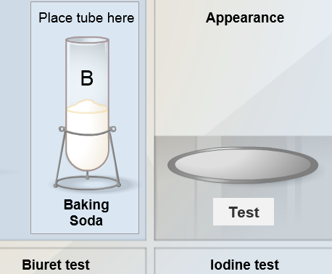
Gizmo Warm-up
The Mystery Powder Analysis Gizmo allows you to use a variety of tests to identify unknown substances. To start, drag the Baking soda test tube into the “Place tube here” area.

- Under Appearance, click Test. Is baking soda a fine powder (no visible grains), or is it coarse (visible grains)?

_____________________________________________

- Litmus paper is an indicator of acids and bases. Under Litmus test, click Test. Which of the following results occurred? (Circle the answer.)
A. Both strips red (acid) C. One red, one blue strip (neutral)
B. Both strips blue (base)

- Some substances react with vinegar to produce carbon dioxide, visible as bubbles.

Under Vinegar test, click Test. Does the vinegar bubble? ________________________

- The blue Biuret solution turns bright purple in the presence of proteins. Iodine solution turns dark purple in the presence of starch. Try each of these tests.

Does baking soda contain protein? ______ Does baking soda contain starch? ______

Activity A:  Known substances | Get the Gizmo ready:  - Click Reset.  - Be sure the Known substances are selected. | 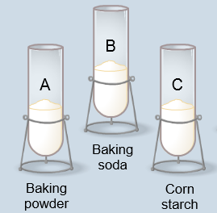

Question: What are the properties of baking powder, baking soda, corn starch, gelatin, and salt?

- Collect data: Use the Gizmo to test the five known substances. Fill in the results below.

Substance | Appearance (coarse or fine?) | Litmus (acid or base?) | Vinegar (bubbles?) | Biuret (protein?) | Iodine (starch?)
Baking powder
Baking soda
Corn starch
Gelatin
Salt

- Analyze: Look at the results of your tests.

- Which substance(s) are acids? __________________________________________

- Which substance(s) are bases? _________________________________________

- Which substance(s) react with vinegar? ___________________________________

- Which substance(s) contain protein? ______________________________________

- Which substance(s) contain starch? ______________________________________

- Apply: Suppose you find a mystery powder. It is coarse in appearance, has a neutral pH, and does not react with vinegar, Biuret solution, or iodine.

Of the five substances listed here, which is it most likely to be? _______________________

- Challenge: Baking powder is a combination of three substances. One is an acid salt, and the other two are other “known” substances in the Gizmo. What are these two substances?

_________________________________________________________________________
Activity B:  Unknown substances | Get the Gizmo ready:  - Click Reset.  - Under Select a sample, choose Unknown.  - Check that the Standard mystery set is displayed. (If not, click Refresh or Reload on your browser.) | 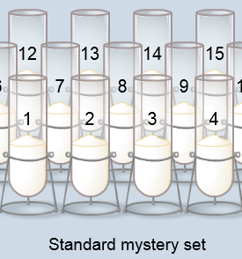

Question: How can you identify unknown substances?

- Identify: Test tubes 1-5 are all contain single substances. Run the five tests on these powders, and identify the substance in each tube.

Sample | Appearance | Litmus | Vinegar | Biuret | Iodine | Substance
1
2
3
4
5

- Identify: Test tubes 6-10 all contain mixtures of two substances. Run the five tests on these powders, and identify the TWO substances in each tube.

Sample | Appearance | Litmus | Vinegar | Biuret | Iodine | Substances
6
7
8
9
10

- Analyze: In the two-substance mixtures you have investigated so far, are there any situations where there is more than one correct answer? Explain.

_________________________________________________________________________

_________________________________________________________________________

(Activity B continued on next page)
Activity B (continued from previous page)

- Challenge: Test tubes 11-15 all contain mixtures of three substances. Run the five tests on these powders, and identify the THREE substances in each tube. (Note: Sometimes there will be more than one possible answer.)

Sample | Appearance | Litmus | Vinegar | Biuret | Iodine | Substances
11
12
13
14
15

- Analyze: Based on your experiences, answer the following.

- Why is it hard to tell if a mixture contains salt? ______________________________

___________________________________________________________________

___________________________________________________________________

- How can you tell if a sample contains baking soda and cornstarch or baking powder?

___________________________________________________________________

___________________________________________________________________

- On your own: For further practice, click New sample. In this set, the contents of every tube is randomized. You may even find new substances you haven’t seen before. Record your observations and make hypotheses about the contents of each tube. Good luck!

