Name: ______________________________________ Date: ________________________

Student Exploration: Ocean Tides

Vocabulary: gravity, high tide, low tide, neap tide, range, spring tide, tides

Prior Knowledge Questions (Do these BEFORE using the Gizmo.)

- A boy builds a sand castle near the ocean. When he returns several hours later, the castle is gone. What do you think happened?

_________________________________________________________________________

- A boat sails into a bay and drops anchor. Several hours later, it is surrounded by mud. What happened?

_________________________________________________________________________

Gizmo Warm-up: What is a tide?

In the Gizmo, the pane on the left shows the position of the Earth and Moon. The Sun is far off in space to the left. The person standing on Earth represents the location of the fisherman shown at right.

- Click Play () and observe the ocean depth for several days. What do you notice?

_________________________________________________________________________

The rise and fall of water that you see are called tides.
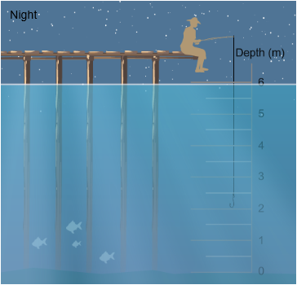

- Turn on Show value. Click Pause () when the water is at its highest level, or high tide. What is the water depth at high tide?

_________________________________________

- Click Play, and then Pause when the water is at its lowest level (low tide). What is the water depth at low tide?

_________________________________________

Activity A:  The Moon and tides | Get the Gizmo Ready:  - Click Reset (). | 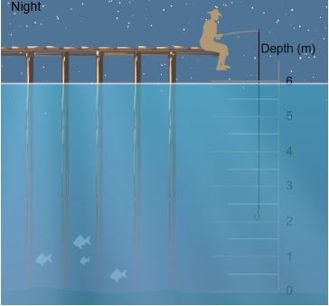

Question: What causes the tides?

- Observe: Click Play and observe for several days. Try to find a connection between the tides shown at right and the position of the observer shown at left.

What do you notice? ________________________________________________________

_________________________________________________________________________

2. Form a hypothesis: What do you think causes tides? _______________________________

_________________________________________________________________________

3. Observe: Click Play, and Pause the simulation at several consecutive high tides. Each time, look at where the observer on Earth is pointing. Do you see a pattern? What is it?

_________________________________________________________________________

- Observe: Observe several low tides. Where does the observer point during the low tides?

_________________________________________________________________________

- Extend: Turn on Show tidal bands. The tidal bands show the depth of water at different places (not to scale). Notice the two bulges that show high tide. Click Fast forward ().

  - In what directions do the bulges always point? ______________________________

  - How does the Moon seem to affect the tidal bulges? _________________________

___________________________________________________________________

6. Think and discuss: The Moon’s gravity pulls on Earth. How does the Moon’s gravity affect the oceans closest to the Moon? _______________________________________________
_________________________________________________________________________

_________________________________________________________________________

Activity B:  The Sun and tides | Get the Gizmo Ready:  - Click Reset ().  - Make sure Show tidal bands is on. | 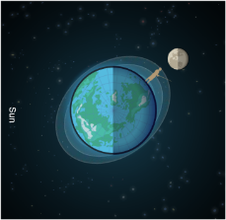

Question: How does the Sun affect tides?

- Observe: Click Fast forward. Observe the shape of the tidal bands. How does the shape change as the simulation plays? _______________________________________________

- Gather data: Click Reset. Use the Gizmo to fill in the table, recording one high and one low tide each day. Calculate the range, the difference between high and low tide, for each day.

Day | Depth at high tide | Depth at low tide | Range  (high tide – low tide)
0
1
2
3
4
5
6

- Investigate: Tides with the largest range from high tide to low tide are called spring tides. Click Reset to observe the positions of the Sun, Earth and Moon during a spring tide. Then Fast forward to another spring tide. (Look for the label in the upper right corner.)

What do you notice about the positions of the Sun, Moon and Earth during spring tides?

_________________________________________________________________________

- Investigate: Tides with the smallest range from high tide to low tide are called neap tides. Click Fast forward, and use the label to help find two periods of neap tides.

What do you notice about the positions of the Sun, Moon, and Earth during neap tides?

_________________________________________________________________________

- Conclude: How does the Sun affect tides? _______________________________________

_________________________________________________________________________

