Name: Date:

Student Exploration: Modeling One-Step Equations

Vocabulary: equation, solution, zero pair

Prior Knowledge Questions (Do these BEFORE using the Gizmo.)
Suppose you want to buy a new t-shirt for $15. So far, you have saved $9 from your allowance.

- Write an equation to model the situation. Let x be the amount you need.

- How much more money do you need? Explain.

Gizmo Overview
An equation can be used to model real-life situations. An equation is a mathematical sentence that states that two expressions are equal. In the Modeling One-Step Equations Gizmo, you will solve an equation using tiles to isolate the variable. The solution is the value or values that make the equation true. The Gizmo provides you with step-by-step instructions.

Here’s how the Gizmo looks at first. The equation for you to solve is given at the top left.
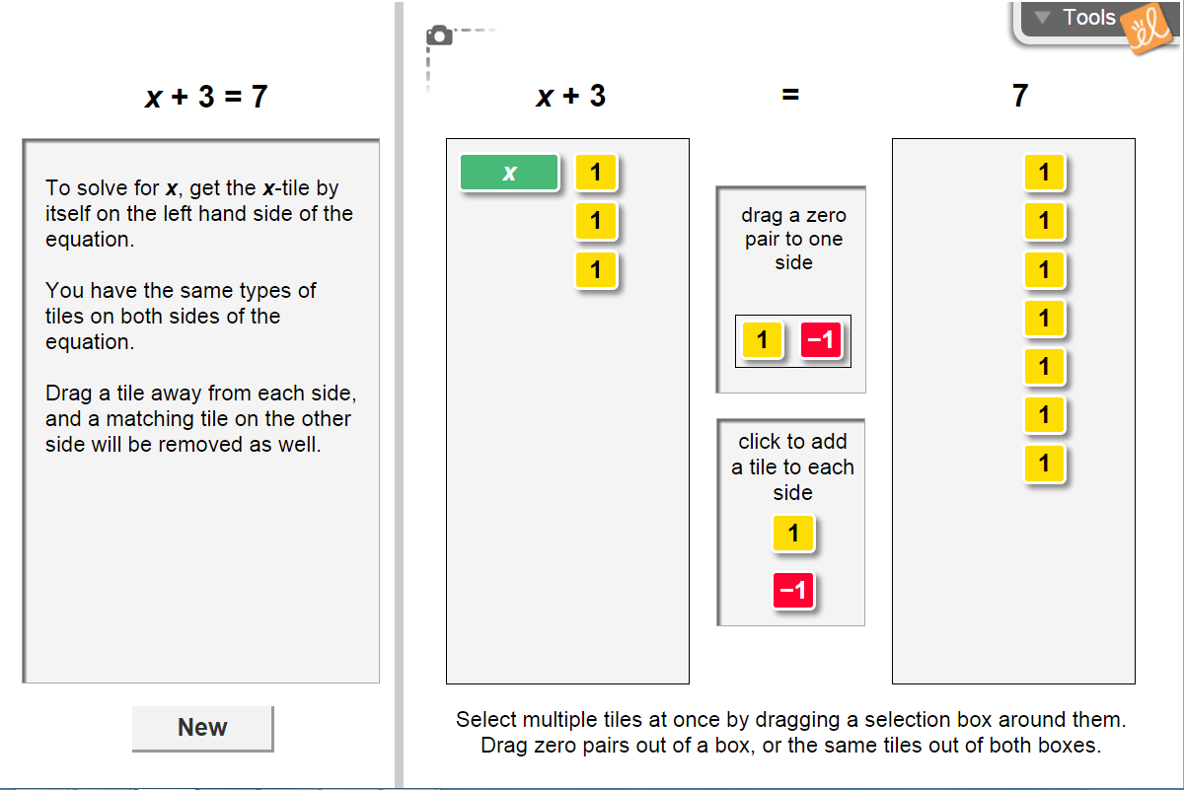
Read your instructions in the Gizmo.

To add a zero pair to one side, drag the pair from here. A zero pair is a pair of values whose sum is zero.

To add a 1-tile or a –1-tile to each side, click on the tile here.

Click New for a new equation to solve.

Activity:  Solving an equation | Get the Gizmo ready:  - You should see the equation x + 3 = 7 at the top left corner. If not, click Refresh in your browser. | 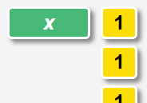

- Notice that the Gizmo has already modeled the equation x + 3 = 7 with tiles for you.

- How many tiles are used to model “x + 3”? x-tiles: 1-tiles:

- How many tiles are used to model “7”? x-tiles: 1-tiles:

- In order to solve the equation, you must isolate the variable, or get x by itself. In this case, you need to remove three 1-tiles to isolate the x. Drag the three 1-tiles out of the left-hand bin. (You can either remove them one at a time, or you can drag a box around all three and remove them together.)

- When you remove a tile from the left side, a tile is also removed from the right side. Why do you think this is?

- When the x-tile is by itself, how many 1-tiles remain on the right?

- What is the solution to the equation x + 3 = 7?

- Substitute the solution into the given equation. What do you get?

- Click New. The next equation you should see is x – 4 = 5.

- To solve the equation, you need to isolate x. Why can you not remove four –1-tiles from both sides?
- Add four 1-tiles to both sides of the equation. You now have four zero pairs on the left side. Drag a box around them and remove them.

- Why do you think you can remove these tiles from the left side without removing any from the right side?
- What is the solution to the equation x – 4 = 5?

- Click New and work through more problems in the Gizmo.

(Activity continued on next page)
Activity (continued from previous page)

- Solve each equation below, by hand. Just as with tiles, be sure to isolate the x, and whatever you do to one side of the equation, be sure to do it to the other side also.

- x + 5 = 12

- x + 6 = 2

- x – 3 = –8

- x – 4 = –2

- x – 7 = 10

- x + 5 = –3

- If you were solving the six problems above in the Gizmo, which ones would have required zero pairs? Why?

