Name: Date:

Student Exploration: Order of Operations

Vocabulary: expression, order of operations

Prior Knowledge Questions (Do these BEFORE using the Gizmo.)

- On a typical two-way street, which side of the road do drivers drive on?

- What do you think would happen if drivers could pick either side of the road to drive on?

Like driving, math has a set of rules. For example, when doing a multi-step calculation, such as 4 + 5 • 6, it’s important that everyone does it the same way, so everyone gets the same answer.

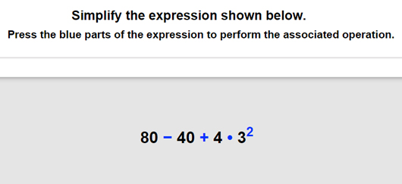
Gizmo Warm-up
In the Order of Operations Gizmo, you’ll evaluate expressions like
80 – 40 + 4 • 3².

In order to evaluate these expressions correctly, you’ll need to use the order of operations. The acronym PEMDAS (Parentheses, Exponents, Multiply/Divide, Add/Subtract) will help you remember the correct order.

- In the Gizmo, mouseover the blue subtraction sign.

- What happens?
- Should you do this step first? Explain.

- Click on the blue multiplication sign.

- What happens?

- Why does this happen?

Activity:  Evaluating expressions | Get the Gizmo ready:  - Click Refresh in your browser. | 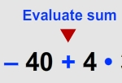

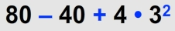
- When you begin, you should see the expression shown at the right in the bottom window of the Gizmo.

- What should you do first to evaluate this expression?

Click on the blue number or sign that corresponds to this step. (Click Undo anytime you want to go back a step.)

- The expression should now be 80 – 40 + 4 • 9. What operation should you perform next? Click on the blue sign for this step.
- The expression should now be 80 – 40 + 36. The only operations left are addition and subtraction. How do you know which to do first?
- Complete the last two steps. What is the value of this expression?
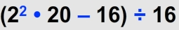
- Click New. You should see the expression shown at the right in the Gizmo.

- Since there are parentheses, start with the expression inside the parentheses. What should you do first to simplify 2² • 20 – 16?
- Finish simplifying (2² • 20 – 16) ÷ 16. What is its value?

- The original expression from above written without parentheses is 2² • 20 – 16 ÷ 16.

- Use the order of operations to simplify the expression. What is the result?

- How are the steps different without parentheses?

- Click New. Work through more problems in the Gizmo. Be sure to read the feedback in the Gizmo along the way.

(Activity continued on next page)
Activity (continued from previous page)

- Use the order of operations to simplify each expression below. Write all your steps in the space below each problem.

- 2 • 3 – 1 + 4

- 12 ÷ 4 • 3 + 3²

- 5² ÷ 5 + (4² • 2) – 36 ÷ 9
- (4 • 3 – 3²) • 7 + 8 ÷ 2

- (9 • 4 + 2 • 6) ÷ (6 – 2²)

- 24 – (2³ + 1) ÷ (3³ – 12 • 2)

