Vocabulary: Parallel, Intersecting, and Skew Lines

dictionary2

**Vocabulary**

***N***

***Q***

***M***

***P***

***O***

* Intersecting lines – lines that have exactly one point in common.
* For example, in the figure shown to the right,  and  intersect at point *O*.
* Line – a straight path that extends forever in both directions.
* Parallel lines – lines that lie in the same plane and never intersect.

***A***

***B***

***D***

***C***

* Parallel lines are always the same distance apart.
* The symbol || means “is parallel to.”
* For example, in the figure shown to the right,  and  lie in the same plane and never intersect, so  || .
* 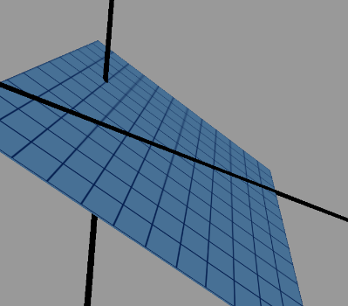Plane – a flat surface that extends forever in all directions.
* Point – a specific location in space.
  + For example, the lines shown in the figure to the right are skew.