Name: Date:

Student Exploration: Parabolas

Vocabulary: axis of symmetry, conic section, directrix, focus of a parabola, parabola,
vertex of a parabola

Prior Knowledge Questions (Do these BEFORE using the Gizmo.)
Flashlights contain a bulb in front of a curved mirror. The light reflects off the mirror and sends a bright beam of light forward. The mirror is called a parabolic mirror, because a cross section forms a parabola.

- Draw a point inside the parabola to the right to estimate location of the bulb. (The bulb is actually placed at the focus of the parabola. This is important, so the light reflects off the mirror in parallel rays.)

Cross section of parabolic mirror
- Draw a point on the parabola showing where the very back (in this case leftmost point) of the mirror is. This is the vertex of the parabola.

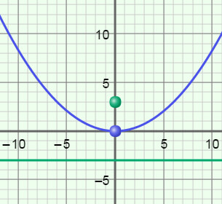
Gizmo Warm-up
A parabola is an example of a conic section, a shape formed when a plane intersects a cone. In the Parabolas Gizmo, you can explore parabolas in the coordinate plane and their equations in two different forms.

In the Gizmo, set p to 3, h to 0, and k to 0. (Change the values by dragging the sliders, or by clicking in the text box, typing in a value, and hitting Enter.)

- Be sure Vertical is selected. With the values above, you should have x² = 12y graphed.

- The vertex of this parabola is its lowest point. Mouseover the vertex.

What are the coordinates of the vertex?

- Vary the value of h. How does the parabola change?

- Vary the value of k. How does the parabola change?

- Reset h and k to 0. Select Horizontal.

  - How is the equation different?

  - How is the parabola different?

Activity A:  Graphs of parabolas | Get the Gizmo ready:  - Select Vertical.  - Set p to 2, h to 0, and k to 0. | 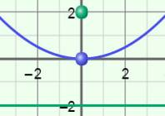

- A parabola is a curve defined by a fixed point called the focus, and a fixed line called the directrix. In the Gizmo, the focus is the green point, and the directrix is the green line.

- Vary the value of p for positive values only. How does the parabola change?

- What is true about the parabola when p is negative?

- Keep varying p. What distances does p seem to represent?

- Select Horizontal and vary p. How does the parabola change?

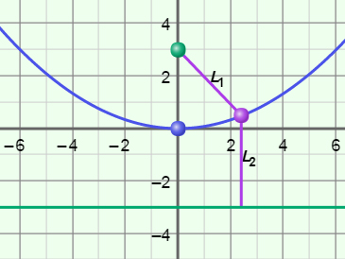
- Select Vertical. Click on Explore geometric definition. The purple point can be any (x, y) point on the parabola.

- Drag the purple point around the parabola. What distances do L₁ and L₂ represent?

- Now drag the purple point onto the vertex. Compare L₁ and L₂ to the value of p. Based on this, what does p tell you about the parabola?

- Drag the purple point. What is true about the values of L₁ and L₂?

- Select Horizontal and repeat. Is this always true about L₁ and L₂?

- Based on what you found above, fill in the blanks to write the definition of a parabola.

Definition: A parabola is the set of all (x, y) points that are

(Activity A continued on next page)
Activity A (continued from previous page)

- The equation of a parabola that has its vertex at the origin and opens vertically is x² = 4py. If the parabola opens horizontally, the equation is y² = 4px.

- Suppose a parabola opens vertically, has a vertex at (0, 0), and the value of p is –2. State the equation of the parabola, coordinates of the focus, and equation of the directrix. Then graph the equation in the Gizmo to check.

Equation: Focus: Directrix:

- Suppose a parabola opens horizontally, has a vertex at (0, 0), and p = 3. State its equation, coordinates of the focus, and equation of the directrix. Then graph the equation in the Gizmo to check.

Equation: Focus: Directrix:

- Select Vertical. Turn off Explore geometric definition. Set p to 3, h to 1, and k to –4 to graph (x – 1)² = 12(y + 4).

- Find the coordinates of the vertex, the coordinates of the focus, and the equation of the directrix of this parabola.

Vertex: Focus: Directrix:

- The vertex form of the equation of a parabola that opens vertically is y = a(x – h)² + k. Write (x – 1)² = 12(y + 4) in vertex form. Show your work to the right. Select Show vertex form to check your answer.

- How is a in the vertex form related to p?

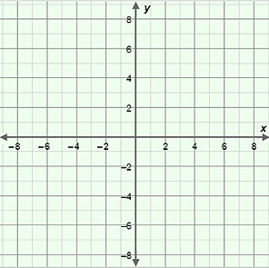
- The graph of (y + 2)² = 20(x – 3) is a parabola that opens horizontally with vertex (3, –2).

- Find the value of p, the coordinates of the focus, and the equation of the directrix of this parabola.

p = Focus:

Directrix:

- Sketch the graph of (y + 2)² = 20(x – 3) on the grid to the right.

Then check your graph in the Gizmo.

Activity B:  Equations of parabolas | Get the Gizmo ready:  - Turn off Explore geometric definition. | 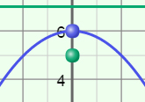

- A parabola that opens vertically has a vertex at (0, 6) and a focus at (0, 5).

  - Find the value of p for this parabola. Show your work to the right.

  - Find the equation of this parabola. Show your work to the right. Then graph the equation in the Gizmo to check.

- A parabola that opens horizontally has a vertex at (2, 4) and a directrix at x = –1.

- Find the value of p for this parabola. Show your work to the right.

- Find the equation of this parabola. Show your work to the right. Then graph the equation in the Gizmo to check.

- For each equation given below, state the coordinates of the vertex and focus, and the equation of the directrix. Then graph each equation in the Gizmo to check your answers.

- (x + 4)² = –12(y – 7) Vertex: Focus: Directrix:

- (y – 5)² = 2(x + 6) Vertex: Focus: Directrix:

- y² = –8(x – 2) Vertex: Focus: Directrix:

- Write the equation of the parabola shown in each graph. Check your equation in the Gizmo.

