Vocabulary: Parallelogram Conditions

dictionary2

**Vocabulary**

* 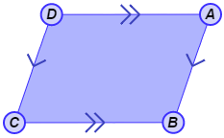Parallelogram – a quadrilateral with two pairs of parallel sides.
* In the quadrilateral shown to the right,  is parallel to , and  is parallel to , so *ABCD* is a parallelogram.
* Trapezoid – a quadrilateral with exactly one pair of parallel sides.
* 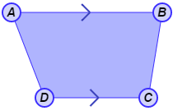In the quadrilateral shown to the right,  is parallel to , so *ABCD* is a trapezoid.
* The parallel sides are the *bases* of the trapezoid.
* The non-parallel sides are the *legs* of the trapezoid.
* A trapezoid whose non-parallel sides are congruent is an *isosceles trapezoid*.