Name: ______________________________________ Date: ________________________

Student Exploration: Pendulum Clock

Vocabulary: bob, calibrate, controlled experiment, gravity, mass, pendulum, period, variable

Prior Knowledge Questions (Do these BEFORE using the Gizmo.)

- A pendulum is a bob, or weight, hung from a fixed point so that it can swing back and forth. What are some objects that swing like a pendulum? (List as many as you can.)

_________________________________________________________________________

_________________________________________________________________________

- The period of a pendulum is the amount of time that it takes a pendulum to complete one full back-and-forth swing. How do you think you could make the period longer or shorter?

_________________________________________________________________________

_________________________________________________________________________

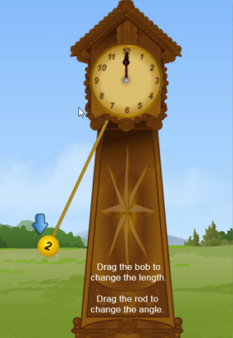
Gizmo Warm-up: Tick, Tock, Click

- On the Pendulum Clock Gizmo, a pendulum swings back and forth. The second hand of the clock moves forward one tick every time the pendulum swings across.
  - Open the Tools palette. Drag an arrow next to the pendulum bob as shown in the image at right.
  - Click Play () and watch as the bob swings away from the arrow then back to it.
  - Click Mark time every time the bob touches the arrow. The numbers tell you how many seconds are between each click, the period of the pendulum.

- Estimate the period of this pendulum. _________________

- Something is wrong with this clock! To keep the proper time, the pendulum period should be exactly 2 seconds. Will this clock run too fast or too slow?

_________________________________________________________________________
Activity A:  Length | Get the Gizmo ready:  - Click Reset (). | 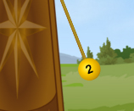

Question: How does the length of a pendulum affect its period?

- Observe: Drag the pendulum bob to change the length of the pendulum. Click Play and observe. Try several different lengths.

- Form hypothesis: How do you think the pendulum’s length affects its period? ____________

_________________________________________________________________________

- Experiment: Set up a controlled experiment to test your hypothesis. Everything but the Length should be kept the same in all tests. (The factor that changes is the variable you are testing.)

Choose 5 lengths to test, and measure the pendulum period for each length.

Test | Length (cm) | Starting angle | Mass (kg) | Pendulum period (seconds)
1
2
3
4
5

- Draw conclusions: What did you discover? _______________________________________

Was your hypothesis correct? _________________________________________________

- Extend your thinking: Measure the pendulum period for the following pairs of lengths:

Length | 50 cm | 200 cm | 60 cm | 240 cm
Pendulum period

- Find a pattern: Compare the 50 cm and 200 cm pendulums. Then compare the 60 cm and 240 cm pendulums. Complete the sentence:

If you multiply the length by __________, the pendulum period is multiplied by __________.

Activity B:  Mass, angle, and gravity | Get the Gizmo ready:  - Click Reset. | 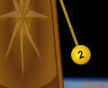

Question: How do mass, angle, and gravity affect the period of a pendulum?

- Observe: Experiment with the different variables available in the Gizmo.
- Drag a new bob to the pendulum to change its mass. (Mass is the amount of matter in an object.)
- Drag the rod of the pendulum left or right to change the starting angle.
- Change the Location to Jupiter to increase the gravity, or force, on the pendulum.

- Form hypotheses: How will each factor affect the period of the pendulum?

    - Mass: ______________________________________________________________

    - Starting angle: _______________________________________________________

    - Gravity: ____________________________________________________________

- Experiment: Use the Gizmo to find the effect of each variable on the pendulum. Make sure that each experiment is controlled—only the variable you are testing should be changed. If the variable is mass, then the length and starting angle should be the same in each test.

Record all results on separate sheets of paper or in your science notebook.

- Summarize: Describe your results below. How does each variable affect the period?

    - Mass: ______________________________________________________________

___________________________________________________________________

    - Starting angle: _______________________________________________________

___________________________________________________________________

    - Gravity: ____________________________________________________________

___________________________________________________________________

- Draw conclusions: Which factor had the biggest effect on the pendulum period? Explain.

_________________________________________________________________________
Activity C:  Calibrate the clock! | Get the Gizmo ready:  - Click Reset.  - Under Location, select Earth. | 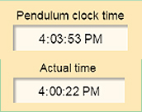

Goal: Build a clock that will keep accurate time.

- Calibrate: To calibrate a clock means to make changes until the clock is accurate. Using what you have learned so far, calibrate the clock so that its period is 2 seconds.

What settings are you using for your clock?

Mass: ___________ Starting angle: ___________ Length: ___________

- Test: Click Reset, and then click Play. The Actual time and the Pendulum clock time are displayed in the upper left corner. Wait for about five minutes, and then click Pause ().

What is the Actual time? ___________ What is the Pendulum clock time? ___________

- Revise and repeat: Based on your test, make further adjustments to your clock. What are your settings now?

Mass: ___________ Starting angle: ___________ Length: ___________

- Test: (Optional.) If possible, leave your clock running for an hour or two, and then click Pause. How accurate is your clock now? ________________________________________

- Predict: What settings do you think will result in an accurate clock on Jupiter?

Mass: ___________ Starting angle: ___________ Length: ___________

- Calibrate: Follow the same steps as above to calibrate the clock on Jupiter. What were the settings when your clock was calibrated?

Mass: ___________ Starting angle: ___________ Length: ___________

- Extend your thinking: If possible, compare the settings you used to those of other students. Is there more than one way to create an accurate clock? Explain.

_________________________________________________________________________

_________________________________________________________________________

