Name: ______________________________________ Date: ________________________

Student Exploration: Penumbra Effect

Vocabulary: eclipse, penumbra, point source, umbra

Prior Knowledge Questions (Do these BEFORE using the Gizmo.)
Try this experiment: Shine a flashlight (or a desk lamp) on your hand so that it casts a shadow on a sheet of white paper. Hold your hand about 15–30 cm (6–12 inches) above the paper.

- Look at the edges of the shadow. Are they sharp or fuzzy? __________________________

- Move your hand up and down. How does this affect the fuzziness of the shadow? ________

_________________________________________________________________________

- Why do you think the shadow has fuzzy edges? ___________________________________

_________________________________________________________________________

Gizmo Warm-up
The fuzzy edge of a shadow is the penumbra, a region where light is only partially blocked. The Penumbra Effect Gizmo demonstrates why penumbras form.

To begin, check that the Number of lights is 1. Click the light to turn it on. The gray block casts a shadow.

- The light is a point source, which means that all of the light rays emanate from a single point. Does the resulting shadow have sharp or fuzzy edges? ________________________

- Increase the Number of lights to 2. How does this affect the shadow? ________________

_________________________________________________________________________

- The central, dark part of the shadow is the umbra. Would you be able to see either of the lights if you were standing in the umbra? Explain. _________________________________
_________________________________________________________________________

Activity:  Light gradations | Get the Gizmo ready:  - Check that the Number of lights is 2.  - Be sure the Light intensity on front of detector checkbox is turned on.

Question: What causes a penumbra to form?

- Observe: The white rectangle behind the gray block is a detector that measures the intensity of light on its surface. Move the detector into the top part of the penumbra.

    - If you were standing where this detector was located, which light(s) would you be able to see? _________________________________________________________
    - Turn off the top light. Is the detector now in the light or in the dark? ______________

    - Turn on the top light and turn off the bottom light. Is the detector in the light or the dark now? ______________
    - Turn on the bottom light and Show ray trace. How does the ray trace of each light help you determine which light can be seen from the detector? _________________
___________________________________________________________________

- Summarize: Based on what you have observed so far, what causes a penumbra to form?

_________________________________________________________________________

_________________________________________________________________________

- Predict: In the two-light example, there were three possible light intensity values on the detector: two lights, one light, or no lights.

How many possible light intensity values do you expect if there were four lights? _________

- Test: Set the Number of lights to 4.

    - Describe the resulting penumbra. ________________________________________

___________________________________________________________________

    - How many different light intensity values result from four light sources? __________

(Activity continued on next page)
Activity (continued from previous page)

- Apply: The diagram below shows the situation with five lights. The lights are labeled A–E. In each part of the penumbra, list the lights that are visible from that location. Use the Gizmo for help as you do this.

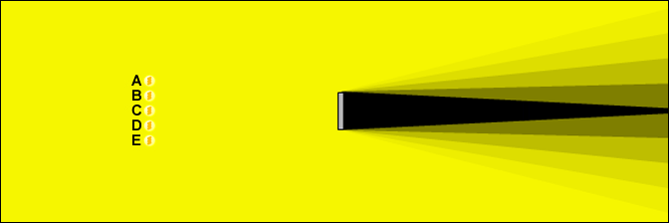

- Explore: Change the Number of lights to 2, the Light spacing to 8, the Shadow block width to 5, and the Distance to light(s) to 25. Then use the Gizmo to explore each of the following changes.

    - How does increasing the Light spacing change the shape of the umbra and penumbra? __________________________________________________________
___________________________________________________________________

    - How does increasing the Shadow block width change the shape of the umbra and penumbra? __________________________________________________________
___________________________________________________________________

    - How does increasing the Distance to light(s) change the shape of the umbra and penumbra? __________________________________________________________
___________________________________________________________________

- Make a connection: During an eclipse, one body moves into the shadow of another. What do you think you would see during a lunar eclipse, when the Moon moves into Earth’s shadow? (Hint: The Sun is a wide source of light, not a point source.)

_________________________________________________________________________

_________________________________________________________________________

_________________________________________________________________________

