Name: ______________________________________ Date: ________________________

Student Exploration: Phased Array

Vocabulary: constructive interference, phased array, phase shift, wave front

Prior Knowledge Questions (Do these BEFORE using the Gizmo.)
You shout out your name in a cave. In one room, you hear the echo right away. In the second room, it takes a little while before you hear the echo.

- Which room has a wall that’s closer to you? ______________________________________

- Based on what you hear, is there any way to tell where the nearest wall is located?
_________________________________________________________________________

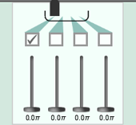
Gizmo Warm-up
While an echoed signal such as a sound wave or radio wave can tell you how far away an object is, it does not tell you about its direction. Many technologies, such as radar and ultrasound, use a device called a phased array to determine direction.

In the Phased Array Gizmo there are four wave sources. As shown at right, deselect all but one checkbox for the four wave sources. Turn on Show detector.

- Click Play (). Drag the detector around and watch the signal strength.

    - How does the appearance of the detector and signal strength change as a wave front passes by? _____________________________________________________
    - How does the signal strength change when the detector gets closer to the source?

___________________________________________________________________

    - How does the signal strength change when the detector stays the same distance from the source but moves from one side of the source to the other?

___________________________________________________________________

- Based on signal at the detector alone, can you determine the detector's location? ________
Explain: __________________________________________________________________
Activity A:  Creating a focused beam | 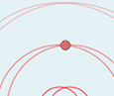  Get the Gizmo ready:  - Click Reset (). Make sure d_{separation} is set to 0.5 and v_{wave} is set to 1,000.  - Turn on the signal for a second wave source.

Question: How can you use a focused beam to determine the location of an object?

- Observe: Click Play. What do you notice about the waves directly above the wave sources?

_________________________________________________________________________

_________________________________________________________________________

- Compare: Place the detector towards the side of the screen so that the two wave fronts hit the detector at different times. Then, move the detector to a position above the two sources where both waves hit the detector at the same time. (The detector should be the same distance from the wave source.)

How does the signal strength compare at each detector location? _____________________

_________________________________________________________________________

- Predict: What do you expect will happen if you add additional wave sources? ____________

_________________________________________________________________________

Check your answer by adding additional sources one by one.
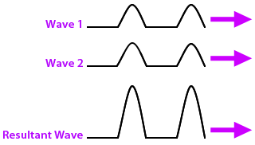

- Analyze: Wave pulses can combine to form a more intense wave. This is known as constructive interference.

The diagram at right depicts two wave pulses, seen from the side, which combine together to form a resultant wave.

    - On the diagram, how does the resultant wave compare to wave 1 and wave 2?

___________________________________________________________________

    - How does this relate to what is happening above the wave sources in the Gizmo?

___________________________________________________________________

___________________________________________________________________

(Activity A continued on next page)
Activity A (continued from previous page)

- Make connections: Move the detector to different areas to locate the path where the maximum signal strength is greatest. This is the beam of constructive interference. Draw a line on the diagram below to indicate the location of the beam of constructive interference.

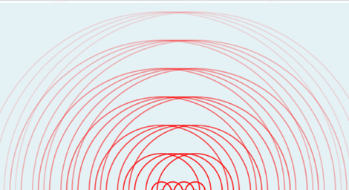

- Apply: A phased array emits a series of waves. Suppose the waves bounce off two objects (A and B) of similar size and composition. The reflected waves are detected by a detector on the phased array.

- The reflected signal from object A comes back sooner than the reflected signal from object B. Which object is closer? __________________
- The reflected signal from object B is stronger than the signal from object A. What does this tell you about the position of B in relation to the beam of constructive interference?

___________________________________________________________________

- Based on your answer to B, how does a phased array help determine the direction of an object? __________________________________________________________
___________________________________________________________________

___________________________________________________________________

___________________________________________________________________

In a phased array, emitted waves reflect off nearby objects. These reflected waves are sensed by a detector in or near the array. The time it takes for the waves to reflect back indicates how far away the object is. If the signal of the reflected waves is strong, this indicates the object is in the path of the beam of constructive interference. Thus, along with distance, you also can determine the direction of the object using a beam of constructive interference.

Activity B:  Scanning an area | Get the Gizmo ready:  - Make sure all the wave sources are on. | 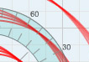

Introduction: In activity A, you saw how a focused beam of constructive interference can be used to locate an object along one line. However, ultrasound machines, weather radar, and other technologies need to sense objects not just in one location, but in a wide area.

Goal: How can you move a focused beam so that it can scan a wide area?

- Observe: Currently, each source is emitting waves with the same frequency, so they are in sync. However, the waves can be offset by delaying the release of the first wave from an emitter. The amount of delay is called the phase shift. You can adjust the phase shift of each emitter by moving the slider beneath it.

Set the left-most slider to 0.0 π, the second slider to 0.2 π, the third slider to 0.4 π, and the fourth slider to 0.6 π.

- What do you notice about the release of waves from the emitters now? ___________ ___________________________________________________________________
- How is the beam of constructive interference affected? _______________________

___________________________________________________________________

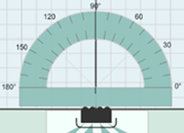
- Measure: Click Pause (). Turn on Show protractor and place it on the phased array as shown at right. Locate the beam of constructive interference, and measure the angle. Subtract this angle from 90° to determine how much the beam was deflected from its original direction.

How much was the beam deflected? _________________

- Predict: How do you think you could make the beam travel about 30° to the left of 90°?

_________________________________________________________________________

- Test: Try testing the prediction you made above. Did it work? If not, continue experimenting until you make the beam travel about 30° to the left of 90°. Explain how you did this.

_________________________________________________________________________

_________________________________________________________________________

(Activity B continued on next page)
Activity B (continued from previous page)

- Experiment: Now, try making the beam travel about 60° to the left of 90°. Explain how you did this. __________________________________________________________________
_________________________________________________________________________

- Observe: Weather radar and ultrasound machines send a beam of constructive interference from side to side or around in a circle. Turn off Show detector and Show protractor, and select the Automatic mode.

- What do you notice about how the beam of constructive interference changes over time? ______________________________________________________________
- What variable(s) change continuously over time in a phased array? _____________

- Explain: How does a phased array allow you to locate the exact position of an object?

_________________________________________________________________________

_________________________________________________________________________

_________________________________________________________________________

_________________________________________________________________________

- On your own: Explore how changing the separation distance (d_{separation}) and wave velocity (v_{wave}) affects the beam of constructive interference. Describe your findings below.

_________________________________________________________________________

_________________________________________________________________________

_________________________________________________________________________

_________________________________________________________________________

_________________________________________________________________________

_________________________________________________________________________

