Name: _____________________________ Date: ________________________

Student Exploration: Plants and Snails

Vocabulary: aerobic respiration, bromothymol blue (BTB), carbon dioxide-oxygen cycle, indicator, interdependence, photosynthesis

Prior Knowledge Questions (Do these BEFORE using the Gizmo.)

- What important gas do we take in when we breathe?

_________________________________________________________________________

- Why don’t we run out of the important gases that we need to stay alive?

_________________________________________________________________________

_________________________________________________________________________
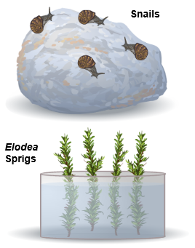

Gizmo Warm-up
In the Plants and Snails Gizmo, each of the test tubes contains water and a small amount of bromothymol blue (BTB). BTB is a chemical indicator. An indicator changes color when the chemicals in the water change.

- With the lights set to on, drag a snail into one test tube and a plant into another. Press Play (). After 24 hours, what is the color of each tube?

___________________________________________

___________________________________________

- Select Show oxygen and CO₂ values. Place the O₂/CO₂ probe in each tube. The probe shows the levels of two gases, oxygen (O₂) and carbon dioxide (CO₂), in the tubes. We call these amounts the gas levels.

  - When the water turns blue, which gas is most common? ______________________

  - When the water turns yellow, which gas is most common? _____________________

  - What does it tell you when the water is green? ______________________________

___________________________________________________________________

Activity A:  Gases in and gases out | Get the Gizmo ready:  - Click Reset ().  - Clear all of the test tubes.  - Turn on Show oxygen and CO₂ values. | 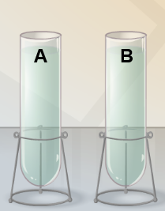

Question: What gases do plants and animals take in and what do they give off?

- Collect data: Use the Gizmo to learn what gases plants and animals take in and give off. Try it in both light and dark. Record your results below. If you do more than five experiments, write your extra results in your notebook or on separate sheets of paper.

What is in the tube | Lights: on/off | Results

- Analyze: Study your data on gases given off by plants.

  - What gas do plants give off in the light? ___________________________________

  - How about in the dark? ________________________________________________

- Analyze: Study your data on gases given off by animals.

  - What gas do animals give off in the light? __________________________________

  - How about in the dark? ________________________________________________

  - How do these results compare to your plant results? _________________________

___________________________________________________________________

- Infer: Describe the carbon dioxide-oxygen cycle by completing the sentences below:

Animals breathe in ________________ and breathe out ________________.

In sunlight, plants take in ________________ and release ________________.

Activity B:  Interdependence | Get the Gizmo ready:  - Click Reset.  - Clear all of the test tubes.  - Turn the light switch to on.  - Check Show oxygen and CO₂ values. | 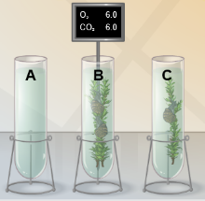

Question: How do plants and animals depend on each other?

- Observe: Put one sprig of Elodea and one snail in a test tube with the lights on. Click Play.

  - Does the color of the water in the tube change? _____________________________

  - What happens to the O₂ and CO₂ levels? __________________________________

___________________________________________________________________

- Predict: Without using the Gizmo, predict what you think will happen to the gas levels in each case listed below. (Leave the Actual result column blank for now.)

Tube | Prediction | Actual result
2 snails, 2 sprigs,
lights on
1 snail, 2 sprigs,
lights on
1 snail, 2 sprigs,
lights off

- Run Gizmo: Now run the Gizmo to test your predictions. Record your findings in the table.

- Generalize: Describe how plants and animals each contribute to the survival of the other. (This type of cooperative relationship is called interdependence.)

_________________________________________________________________________

_________________________________________________________________________

- Challenge: Simulate a 24-hour day (12 hours of light, 12 hours of dark). How many snails and plants do you need to keep a stable environment? Explain any discoveries you make.

_________________________________________________________________________

_________________________________________________________________________

Activity C:  The carbon-oxygen balance | Get the Gizmo ready:  - Click Reset.  - Clear all of the test tubes.  - Turn the light switch to on.  - Check Show oxygen and CO₂ values. | 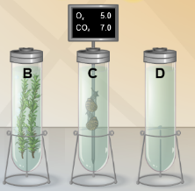

Question: How are the amounts of oxygen and carbon dioxide related to each other?

- Observe: Put two Elodea sprigs into a test tube. Put the O₂/CO₂ probe into the tube with the Elodea. Click Play. As the Gizmo runs, Pause () it a few times.

- How do the oxygen (O₂) and carbon dioxide (CO₂) levels change over time?

___________________________________________________________________

- What is always true about the total amount of O₂ and CO₂ in the test tube?

___________________________________________________________________

- What happens when the CO₂ reaches zero? _______________________________

- Revise and repeat: Click Reset and run the experiment again, this time with the lights off.

- How do the gas levels change? O₂ _________________ CO₂ _________________

- What is the total of O₂ and CO₂? _________________________________________

- Revise and repeat: Click Reset. Remove the plants. Repeat the experiment with two snails.

- How do the gas levels change? O₂ _________________ CO₂ _________________

- What is the total of O₂ and CO₂? _________________________________________

- Challenge: In the process of photosynthesis, plants use carbon dioxide (CO₂), water (H₂O), and light energy to produce a sugar (C₆H₁₂O₆) and oxygen (O₂). In the process of aerobic respiration, animals and plants release energy from sugar and oxygen and produce carbon dioxide and water. The chemical equations that describe these reactions look like this:

6CO₂ + 6H₂O + light C₆H₁₂O6 + 6O₂ C₆H₁₂O6 + 6O₂ 6CO₂ + 6H₂O + energy

How do these equations explain why the total amount of O₂ and CO₂ remains the same?

_________________________________________________________________________

_________________________________________________________________________

_________________________________________________________________________

