Name: ______________________________________ Date: ________________________

Student Exploration: Plate Tectonics

Vocabulary: asthenosphere, collision zone, convergent boundary, crust, divergent boundary, earthquake, lithosphere, mantle, plate, plate tectonics, subduction zone, transform boundary, volcano

Prior Knowledge Questions (Do these BEFORE using the Gizmo.)

- Volcanoes are openings in Earth’s crust where lava, gas, and ash can erupt. Where are active volcanoes located? ____________________________________________________
_________________________________________________________________________

- An earthquake is a violent shaking of Earth’s surface. Where are earthquakes common? _________________________________________________________________________
_________________________________________________________________________

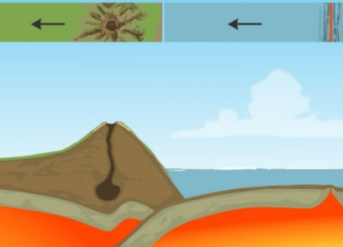
Gizmo Warm-up
Volcanoes, earthquakes, mountains, and other features of Earth’s surface owe their origin to the movements of plates: enormous, slowly-moving sections of Earth’s crust. At plate boundaries, plates collide, move apart, move under or over each other, or slide past one another. The theory of plate tectonics describes how the plates move, interact, and change the physical landscape.

The Plate Tectonics Gizmo shows a cross-section, or side view, of Earth. (Not to scale.) Above the cross section is a bird’s-eye view of the same location.

- Turn on Show labels. What are the layers of Earth that you can see? _________________

_________________________________________________________________________

The lithosphere is a layer of rigid rock that consists of the crust and the upper part of Earth’s mantle. The asthenosphere is a layer of the mantle that can deform like plastic.

- Turn on Boundary name, and click on each boundary. What four boundaries do you see? _________________________________________________________________________

Activity A:  Sliding plates | Get the Gizmo ready:  - Select BOUNDARY A. | 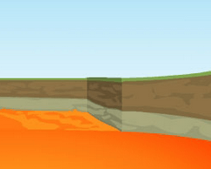

Question: What happens when plates slide past one another?

- Observe: Boundary A is a transform boundary. The arrows below the BOUNDARY A label will move the plates. Click the left arrow once to see how the plates move.

How would you describe the motion of plates in a transform boundary? ________________

_________________________________________________________________________

- Sketch: Draw a bird’s-eye view of the plate boundary before and after the plate motion. Draw an arrow to show which way the plate moved.

Before movement After movement

- Locate: Turn on Show location. Where on Earth can you find transform boundaries? (Note: You can refer to a world map or atlas for location names.)

_________________________________________________________________________

Highlight these locations on the map below.

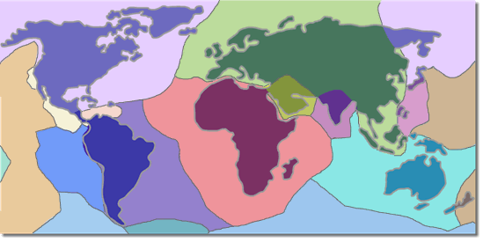

Activity B:  Colliding continents | Get the Gizmo ready:  - Turn off Boundary name and Show location.  - Select BOUNDARY B. | 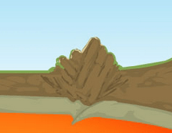

Question: What happens when two continents collide?

- Observe: Boundary B is an example of a convergent boundary, where two plates are moving toward one another. When the two converging plates both contain continental crust, it is called a collision zone. Click the left arrow four times to see how the plates move.

How would you describe the motion of plates in a collision zone? _____________________

_________________________________________________________________________

- Sketch: Draw a side view of the plate boundary before and after the plate motion. Draw an arrow to show which way the plate moved.

Before movement After movement

- Locate: Turn on Show location. Where on Earth can you find collision zones? (Note: You can refer to a world map or atlas for location names.)

_________________________________________________________________________

Highlight these locations on the map below.

Activity C:  Oceanic crust meets continental crust | Get the Gizmo ready:  - Turn off Boundary name and Show location.  - Select BOUNDARY C. | 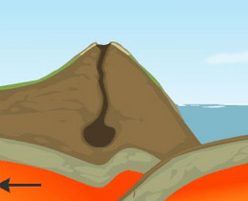

Question: What happens when ocean crust collides with continental crust?

- Observe: Boundary C is another type of convergent boundary called a subduction zone. Click the left arrow four times to see how the plates move.

How would you describe the motion of plates in a subduction zone? ___________________

_________________________________________________________________________

- Sketch: Draw a side view of the plate boundary before and after the plate motion. Draw an arrow to show which way the plate moved.

Before movement After movement

- Locate: Turn on Show location. Where on Earth can you find subduction zones? (Note: You can refer to a world map or atlas for location names.)

_________________________________________________________________________

Highlight these locations on the map below.

Activity D:  Spreading plates | Get the Gizmo ready:  - Turn off Boundary name and Show location.  - Select BOUNDARY D. | 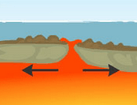

Question: How is new crust formed?

- Observe: Boundary D is a divergent boundary. Click the right arrow four times to see how the plates move.

How would you describe the motion of plates in a divergent boundary? ________________

_________________________________________________________________________

- Sketch: Draw a side view of the plate boundary before and after the plate motion. Draw an arrow to show which way the plate moved.

Before movement After movement

- Locate: Turn on Show location. Where on Earth can you find divergent boundaries? (Note: You can refer to a world map or atlas for location names.)

_________________________________________________________________________

Highlight these locations on the map below.

