Vocabulary: Point-Slope Form of a Line

dictionary2

**Vocabulary**

* Point-slope form – a linear equation of the form *y* – *y*1 = *m*(*x* – *x*1), where *m* is the slope and (*x*1, *y*1) is a point on the line.
* For example, the line with the equation *y* – 3 = (*x* + 5) has a slope of  and   
  (–5, 3) is a point on the line.
* Slope – a measure of the steepness of a line.
  + 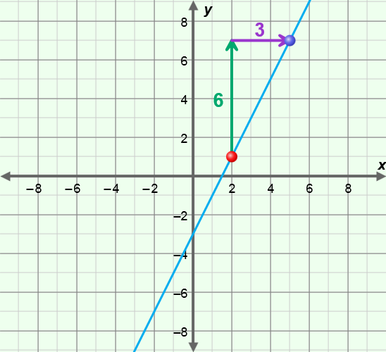For two points on a line, (*x*1, *y*1) and (*x*2, *y*2), slope is defined as:

slope =  =  = .

* + For example, the slope of the line through the points (2, 1) and (5, 7) as shown to the right is:

 =  = 2.

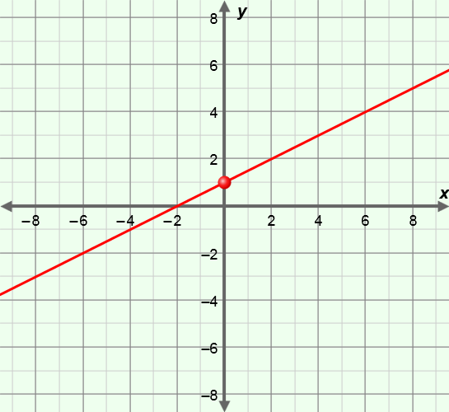

* Slope-intercept form – a linear equation of the form *y* = *mx* + *b*, where *m* is the slope and *b* is the *y*-intercept.
* For example, the line with the equation *y* = *x* + 1, shown to the right, has a slope of  and a *y*-intercept of 1.
* *y*-intercept – the *y*-coordinate where a graph intersects the *y*-axis.
  + In the equation *y* = *mx* + *b*, *b* is the *y*-intercept.