Name: Date:

**Student Exploration: Points, Lines, and Equations**

**Vocabulary:** coordinates, equation, input, ordered pair, output, *x*-intercept*, y*-intercept

**Prior Knowledge Questions** (Do these BEFORE using the Gizmo.)

You can use words or pictures to give directions.

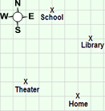

1. On the street map to the right, each square represents one block. To get from place to place, stay on the streets shown.
   1. Draw a path on the map to show how you could get from the theater to the library. (Stay on the street grid shown.)
   2. Use the compass points (north, south, east, and west) to describe the path you drew along the streets.

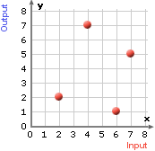

1. Points on a grid are another way to represent locations on a map. The location of a point is given by its **coordinates**, a pair of numbers written in the form (*x*, *y*) or (*input*, *output*).
2. What are the coordinates of the theater?
3. What are the coordinates of the library?

**Gizmo Warm-up**

**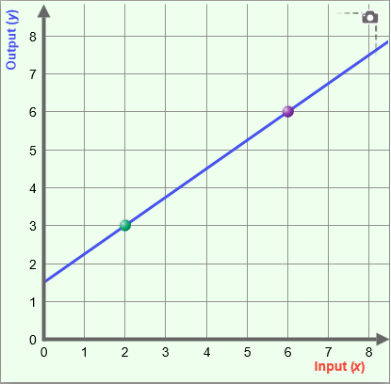**In the *Points, Lines, and Equations* Gizmo, you can plot two points and see the line through them and their coordinates.

1. Drag a point in the Gizmo and describe what happens.

1. Drag the points to (2, 3) and (6, 5). What is the equation of this line?
2. Select **Show Probe** and drag the red probe. What do the **Input** **(*x*)** and **Output** **(*y*)** mean?

|  |  |  |
| --- | --- | --- |
| **Activity A:**  **Points and lines** | Get the Gizmo ready:   * Turn off **Show Probe**. |  |

1. Plot the points (2, 2) and (4, 4).The Gizmo shows part of the line through the points.
2. What is the Input-Output equation for this line?
3. What is the *x*-and-*y* equation for this line?
4. Select **Show Probe**.
   1. Drag the probe and complete the table for the given values of *x* below.

|  |  |
| --- | --- |
| **Input (*x*)** | **Output (*y*)** |
| 0 |  |
| 1.5 |  |
| 3 |  |
| 4 |  |

* 1. Using the equation, what is the output if the input value is 125?

If the input value is ?

1. Click the **Table** tab and study the values in the input-output table.
2. What do you notice about the pairs of input-output values in the table?

1. Change the **Step** value under the table to 0.5 and press **Enter**. Use the equation of the line to explain why these also must be points on the line.

1. Click the **Probe** tab and plot (2, 3) and (4, 5). Select **Show** **Probe** and drag the probe over the line. Explain how the input-output values relate to the equation and the graph of the line.

|  |  |  |
| --- | --- | --- |
| **Activity B:**  **Points and equations** | Get the Gizmo ready:   * Select **Show Probe**. | 275SE3 |

1. In the Gizmo, plot the points (1, 3) and (4, 6).
2. What is the equation of this line?
3. Drag the probe so that it passes through the point (1, 3). Substitute the Input (*x*) and Output (*y*) values into the equation. Describe the result.

1. Drag the probe through the point (4, 6). What is the result when you substitute those coordinates into the equation?

1. Identify the coordinates of another point on the line and record it here.
2. What is the result when you substitute these coordinates into the equation?

1. With (1, 3) and (4, 6) still plotted in the grid, drag the probe across the grid.
   1. Record the (*x*, *y*) coordinates of a point that lies on the vertical line (the probe) but is not on the line containing (1, 3) and (4, 6).
   2. Substitute these coordinates into the equation of the line. Describe the result.

* 1. What appears to be true when you substitute the coordinates of a point not on a line into the equation of the line?
  2. Explain why the point (20, 22) lies on this line but the point (35, 33) does not.

\_\_\_\_\_\_\_\_\_\_\_\_\_\_\_\_\_\_\_\_\_\_\_\_\_\_\_\_\_\_\_\_\_\_\_\_\_\_\_\_\_\_\_\_\_\_\_\_\_\_\_\_\_\_\_\_\_\_\_\_\_\_\_\_\_\_\_

|  |  |  |
| --- | --- | --- |
| **Activity C:**  **The *y*-intercept** | Get the Gizmo ready:   * Select **Show Probe**. | 2015-07-29 21_40_24-Points, Lines, and Equations Gizmo _ ExploreLearning |

* 1. In the Gizmo, plot the points (8, 4) and (6, 2).

1. What is the equation of the line through these points?
2. Use the equation and complete the table below for each Input (*x*)*.* Then click the **Table** tab and check your answers.

|  |  |
| --- | --- |
| **Input (*x*)** | **Output (*y*)** |
| 0 |  |
| 1 |  |
| 2 |  |
| 3 |  |
| 4 |  |
| 5 |  |

1. What is the relationship between the *x*-and *y*-coordinates in the table?

1. Select the **Probe** tab and click **Show Probe**. Drag the probe to 5.5. What is the value of *y* when *x* = 5.5? \_\_\_\_\_\_\_\_\_\_ Click **Show *y*-value calculation***.* How is the value of *y* calculated?
   1. 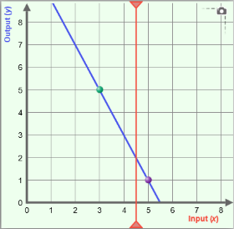Turn off **Show *y*-value calculation** and plot (3, 5) and (5, 1).
   2. The ***y*-intercept** is the *y*-value of the point where the line crosses the *y*-axis. What is the *y*-intercept of this line?

Drag the probe tocheck your answer.

* 1. The ***x*-intercept** of a line is the *x*-value of the point where the line crosses the *x*-axis. Drag the probe to identify the *x*-intercept of this line.
  2. Explain how you can use the equation of a line to calculate its *x*-and *y*-intercepts.