Vocabulary: Polling: City

Vocabulary

- Margin of error – a statistic that expresses the expected accuracy of the results of a poll.
  - For example, if a poll says that 46% of voters support Candidate A with a ±3% margin of error (with a confidence level of 95%), there is a 95% probability that the true percentage of voters supporting Candidate A is between 43% and 49%.
  - Margin of error is usually calculated for a 95% confidence level.
    - For a larger confidence level (like 99%), the margin of error is larger.
    - For a smaller confidence level (like 90%), the margin of error is smaller.
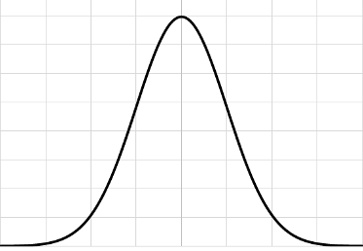

Normal distribution

- Normal distribution – a theoretical probability distribution that is bell-shaped and symmetric about its mean.
  - The normal distribution is also known as the Gaussian distribution.
  - The bell shape indicates that results near the mean are likely, while results farther from the mean are less likely (but not impossible).

- Poll – a survey of people to determine their information, opinions, or expected votes.

- Population – an entire group of objects or individuals.

- Sample – a part of a population selected to represent the entire population.

