Vocabulary: Polynomials and Linear Factors

Vocabulary

- Degree – the greatest exponent of all terms of a polynomial.
  - When a polynomial is written in standard form, the degree is the exponent of the first term.
  - For example, the degree of the polynomial 4x³ – 5x² + x – 3 is three.

- Linear factor – a first-degree factor of a polynomial.
  - For example, the polynomial x² – 2x – 35 = (x + 5)(x – 7), so the linear factors of
x² – 2x – 35 are (x + 5) and (x – 7).

- Multiplicity – the number of times the associated factor of a zero occurs in a polynomial.
  - For example, x³ + 16x² + 64x = x(x + 8)(x + 8), so this polynomial has two zeros:
    - x = 0 is a zero with multiplicity 1, because x is a factor one time.
    - x = –8 is a zero with multiplicity 2, because (x + 8) is a factor twice.

- Polynomial – a monomial or sum of monomials.
  - Each monomial is called a term of the polynomial.
    - For example, 2x³ – 5x² + 9x – 4 is a polynomial with four terms.
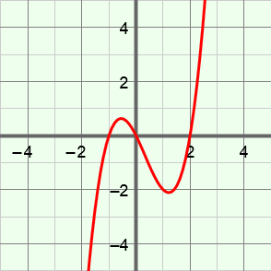
zeros
- Zero (of a polynomial) – an x-value for which the value of the polynomial is zero.
  - On a graph, each x-intercept represents a zero.
    - For example, the zeros of the polynomial
y = x³ – x² – 2x = x(x + 1)(x – 2), shown to the right, are the values where the graph has an x-intercept: x = –1, 0, and 2.

