Name: ______________________________________ Date: ________________________

Student Exploration: Pond Ecosystem

Vocabulary: abiotic factor, algal bloom, biotic factor, concentration, eutrophication, mean, oxygen, parts per million, photosynthesis

Prior Knowledge Questions (Do these BEFORE using the Gizmo.)

- All animals need oxygen. We get oxygen from the air we breathe. How do fish get theirs?

- Where does the “fizz” in soda come from?

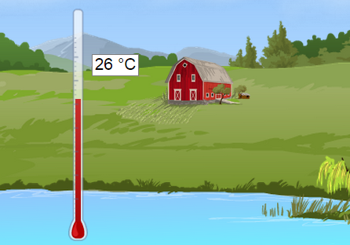

Gizmo Warm-up
The Pond Ecosystem Gizmo lets you study ponds as an ecologist would. Each of the tools can be dragged to the pond to take measurements.

- Drag the Thermometer to the pond at 6:00 am.
What is the water temperature? °C

- Click Fast-forward () until about 12:00 pm, and then click Pause ().

What is the water temperature now? °C

- Just as soda contains dissolved carbon dioxide, pond water contains dissolved oxygen. The unit for measuring the concentration (amount) of oxygen is parts per million (ppm).

Drag the Oxygen gauge to the pond. What is the concentration of oxygen?

- Drag the Fishing pole to the pond, and click Play (). Fish for about four hours.

How many catfish did you catch? How many trout?
Activity A:  A day in the life  of a pond | Get the Gizmo ready:  - Click Reset (). Remove the Fishing pole from the pond. | 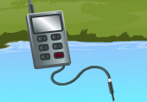

Introduction: The fish in a pond are affected by biotic factors such as other fish, aquatic plants, insects, and bacteria. They are also affected by abiotic factors, or nonliving factors such as temperature and the concentration of dissolved oxygen.

Question: How does the amount of dissolved oxygen in a pond change during one day?

- Observe: Use the Oxygen gauge to measure the concentration of dissolved oxygen at several different times. How does the oxygen concentration change over a single day?

- Predict: At what time should the amount of oxygen in a pond be lowest? (Circle one)

6:00 am 12:00 pm (noon) 6:00 pm 12:00 am (midnight)

- Test: Measure the dissolved oxygen at four times during the day: 6 am, 12 pm (noon), 6 pm, and 12 am (midnight). Then click New pond and repeat the test for two more ponds. Record your results in the table below.

 | 6:00 am | 12:00 pm | 6:00 pm | 12:00 am
Pond 1
Pond 2
Pond 3

- Analyze: Was your prediction correct for all three ponds? Explain.

- Draw conclusions: The dissolved oxygen in a pond is produced by pond plants and algae (small, plant-like organisms) in a process called photosynthesis.

    - At what time of day does photosynthesis take place?

    - What source of energy is present during this time?

    - Why does the level of dissolved oxygen go down after sunset?

Activity B:  Go fish! | Get the Gizmo ready:  - Click Reset. | 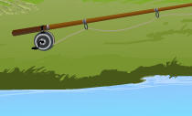

Question: How do concentrations of dissolved oxygen affect fish?

  - Explore: To investigate the question, measure the oxygen concentration and go fishing in several ponds. (To fish, drag the Fishing pole into the pond, click Play, and wait several hours.) Observe the oxygen concentration and the numbers and types of fish you catch.

  - Form hypothesis: How does oxygen concentration affect the fish that live in a pond?

  - Predict: If you fish in four ponds, will more fish be caught in the two ponds with the lowest oxygen concentrations, or the two ponds with the highest oxygen concentrations? Explain.

  - Test: Investigate four ponds. For each pond, measure the dissolved oxygen concentration at 6:00 am. Fish for six hours and record how many catfish and trout you catch in each pond. Hint: To find a pond with relatively high levels of dissolved oxygen (above 5 ppm), select No farms. To find a pond with low levels of oxygen (below 4 ppm), uncheck No farms.

 | Oxygen (6:00 am) | Number of catfish | Number of trout
Pond 1
Pond 2
Pond 3
Pond 4

  - Analyze: What does your data show?

  - Draw conclusions: Which type of fish can survive better in low-oxygen conditions? Explain.

Activity C:  Dissolved oxygen | Get the Gizmo ready:  - Select No farms.  - A calculator is recommended for this activity. | 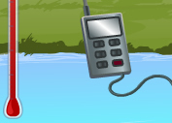

Question: How does temperature affect the concentration of dissolved oxygen?

- Explore: Measure the temperature and concentration of dissolved oxygen in several ponds.

- Form hypothesis: How does temperature affect oxygen concentrations?

- Predict: Which ponds will have a higher average oxygen concentration, ponds cooler than 20 °C or ponds hotter than 20 °C?

- Test: For each pond, measure the temperature and oxygen concentration at 6:00 am. If the temperature is below 20 °C, record your results in the left table. If the temperature is above 20 °C, record your results in the right table. Continue until each table is filled.

Ponds cooler than 20 °C
6:00 am Temp. | 6:00 am Oxygen

Ponds hotter than 20 °C
6:00 am Temp. | 6:00 am Oxygen

- Calculate: Find the mean (average) oxygen concentration for the cold ponds and for the hot ponds. To find the mean, add the three oxygen concentrations and then divide by three.

Mean oxygen level for cold ponds: Mean oxygen level for hot ponds:

- Draw conclusions: How does the temperature of water affect its ability to hold oxygen?

- Infer: Based on this data and what you learned in Activity B, do you think trout will be more common in warm or cool ponds? Explain.

(Activity C continued on next page)
Activity C (continued from previous page)

- Predict: How do you think the presence of farms will affect the oxygen concentration in the ponds? Explain why you think so.

- Test: Check that No farms is on and the thermometer and oxygen monitor are still in the pond. Click New pond until you find a pond with a starting temperature between 20 °C and 25 °C. Record the temperature and oxygen concentration for this no-farm pond.

Now, turn off the No farms checkbox. Click New pond until you get another pond with a starting temperature between 20 °C and 25 °C. Record the temperature, number of farms, and dissolved oxygen for this pond. Repeat until you have looked at five ponds.

 | Temp. (6:00 am) | Number of farms | Oxygen (6:00 am)
Pond 1 |  | 0
Pond 2
Pond 3
Pond 4
Pond 5

- Analyze: In the table, circle the pond with the lowest dissolved oxygen and the pond with the highest dissolved oxygen. What do you notice about the number of farms for these ponds?

- Draw conclusions: Based on your data, how do farms affect oxygen levels in the pond?

Farmers use fertilizers to increase crop growth. Many farms also produce large amounts of animal waste. When it rains, excess fertilizer and waste can run off into nearby ponds and streams. The nutrients in these substances can cause a rapid increase in algae known as an algal bloom.

When algae die, bacteria break down their remains, using up the dissolved oxygen in the water. The rapid loss of oxygen, or eutrophication, can kill fish and other wildlife living in the pond or stream.

