Vocabulary: Populations and Samples

Value | Frequency
1 | 3
2 | 1
3 | 1
4 | 3
5 | 2

Vocabulary

- Frequency distribution – a list, table, or graph that illustrates how many times each value occurs in a data set.
  - For example, the table at right shows the frequency distribution for the data set:
1, 1, 1, 2, 3, 4, 4, 4, 5, 5.
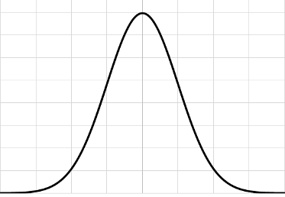

Normal distribution

- Normal distribution – a theoretical probability distribution that is bell-shaped and symmetric about its mean.
  - The normal distribution is also known as the Gaussian distribution.
  - The bell shape indicates that results near the mean are likely, while results farther from the mean are less likely (but not impossible).

- Population – an entire group of objects or individuals.

- Sample – a part of a population selected to represent the entire population.

