Name: ______________________________________ Date: ________________________

Student Exploration: Potential Energy on Shelves

Vocabulary: gravitational potential energy, kinetic energy, potential energy, weight, work

Prior Knowledge Questions (Do these BEFORE using the Gizmo.)
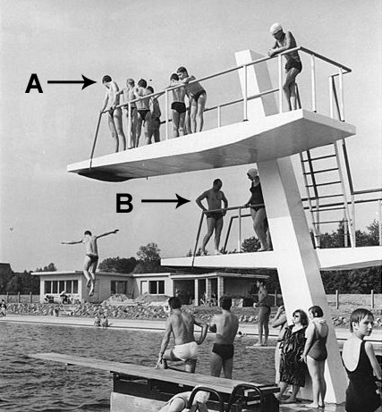
- Look at divers A and B in the picture at left. Which diver had to put the most effort into climbing to the top of his board? Explain.

_______________________________________

_______________________________________

- Which diver do you think will make the biggest splash? Explain. _________________________
_______________________________________

_______________________________________

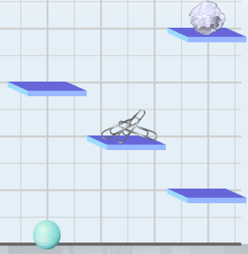
Gizmo Warm-up
It takes energy to climb up to the top of a diving board, and of course a diver that leaps off the board and makes a big splash in the water also has a lot of energy. But how much energy does a diver have while he is standing at the top of the diving board?

Even at the top of the board, the diver has energy—a type of energy called potential energy. Potential energy is the energy an object has because of its position or shape. Using the Potential Energy on Shelves Gizmo, you will discover how gravity gives objects potential energy because of their position above the floor.

- Which object on the SIMULATION pane most likely has the least potential energy? Why?

_________________________________________________________________________

- Click on the TABLE tab. The potential energy (PE) of each object is given in joules (J).
List the objects in order from lowest to highest potential energies.

_________________________________________________________________________

Activity A:  Factors affecting GPE | Get the Gizmo ready:  - Select the BAR CHART tab and turn on Show numerical values. | 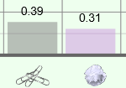

Introduction: Because gravity pulls objects down to Earth’s surface, objects lifted above Earth’s surface have a type of potential energy called gravitational potential energy, or GPE.

Question: What factors affect how much gravitational potential energy an object has?

- Identify: Circle the factors below that you think affect an object’s potential energy.

mass vertical position velocity horizontal position

- Observe: Drag the ball to the 1-m shelf on the SIMULATION pane.

- What is the ball’s potential energy (PE)? _______________
- Move the ball to the 2-m shelf. What is its potential energy now? _______________
- What do you think the ball’s potential energy will be on the 3-m shelf? The 4-m shelf?
PE on 3-m shelf: _______________ PE on 4-m shelf: _______________
Use the Gizmo to check your answers. (Click the control on the bar graph to zoom out.)

- Summarize: What is the relationship between an object’s height above the ground and its gravitational potential energy? _________________________________________________

- Describe: Move the ball from side to side (left to right) while trying to keep it at the same height. How does changing the horizontal position of the ball affect its potential energy?

_________________________________________________________________________

- Infer: Place the ball and the paper on the same shelf.

- Which object has more potential energy? __________________________________
- Why do you think their potential energies are different? _______________________

___________________________________________________________________

- Identify: What two factors affect how much gravitational potential energy an object has?

_________________________________________________________________________

Activity B:  Calculating GPE | Get the Gizmo ready:  - You will need a calculator to complete this activity. | 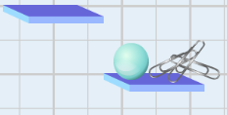

Introduction: An object’s gravitational potential energy depends on two factors: its height (h) and its weight (w). The equation for gravitational potential energy (GPE) is:

GPE = w × h

Goal: Use the gravitational potential energy equation to determine the weight, mass, and potential energy of various objects.

- Record: Position all three objects on the 1-m shelf and fill in the third column of the table.

Object | Height (m) | GPE (J or N•m) | Weight (N)
Ball | 1 m
Clips | 1 m
Paper | 1 m

- Calculate: For each object, substitute the values you know into the gravitational potential energy equation to solve for weight. Record each object’s weight in the fourth column.

- Predict: Suppose the clips were placed on the 5-m shelf. What would their gravitational potential energy be? (Show your work.) _________________________________________
Use the Gizmo to check your answer.

- Calculate: An object’s weight is determined by its mass (m) and the acceleration due to gravity (g) affecting that object: w = mg. On Earth, g = 9.8 m/s².

- What are the masses (in kilograms) of the three objects on the Gizmo? (Note: 1 N = 1 kg × m/s²)

Ball: _____________ Clips: _____________ Paper: _____________

- Suppose a 4,000-kg elephant is hoisted 20 m above Earth’s surface. What will the elephant’s gravitational potential energy be? (Show your work in the space below.)

___________________________________________________________________

Activity C:  Work and GPE | Get the Gizmo ready:  - Place the ball, clips, and paper at 0 m. | 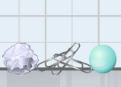

Introduction: Whenever you lift an object to place it on a shelf, you are doing work. Work occurs anytime a force causes an object to move.

Question: How much work is done to lift the ball, clips, and paper?

- Observe: How much potential energy do the ball, clips, and paper have now? ___________

- Calculate: The amount of work (W) done on an object is equal to the force (F) needed to lift the object (the object’s weight) multiplied by the distance (d) the object is lifted: W = F × d.

Use the weight of the ball that you calculated in activity B to determine how much work would be required to lift the ball 2 meters above the zero position:

_________________________________________________________________________

- Analyze: Move the ball to the 2-m shelf.

- How much potential energy does the ball have now? _________________________
- How does the ball’s potential energy relate to the amount of work needed to place the ball on the 2-m shelf? ______________________________________________
- How much work would be needed to lift the ball from the 2-m shelf to the 5-m shelf, and how much potential energy would it have on the 5-m shelf? ________________
___________________________________________________________________

- Predict: What do you think would happen to the ball’s potential energy if it is knocked off the shelf and falls to the floor? ____________________________________________________
_________________________________________________________________________

- Think and discuss: Objects in motion have kinetic energy. As objects fall, their potential energy is converted into kinetic energy. How much kinetic energy do you think the ball would have just before it hit the floor if it were dropped from a 2-m shelf? Explain your answer.

_________________________________________________________________________

_________________________________________________________________________

