Name: Date:

Student Exploration: Probability Simulations

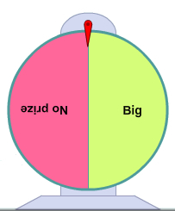
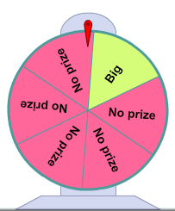
Wheel 2
Wheel 1
Vocabulary: experimental probability, fair game, outcome, probability, sample space, theoretical probability

Prior Knowledge Question (Do this BEFORE using the Gizmo.)
Walking though the fair, you see games where you can spin a wheel to win a prize. Two of these wheels are shown to the right.

If you had to pick one of these wheels, which one do you think gives better odds of winning a big prize? Explain.

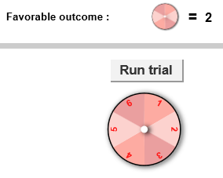
Gizmo Warm-up
With the Probability Simulations Gizmo, you can explore concept of probability, or how likely it is that something will happen. In the Gizmo, you can design a game with one or two spinners. With the one-spinner game, you choose the number of sections and what numbers will be winners. Because the sections are all the same size, the spinner has an equal chance of landing on any section.

- With the Number of spinners set to 1, check that Sections is set to 6, Number is set to 2, and is selected. This means you win if the spinner lands on 2, so 2 is a favorable outcome of this experiment. Click the Run trial button to spin the spinner once.

- What was the outcome? Was it a favorable outcome?

- Click Run trial 9 times. Of 10 trials, how many had favorable outcomes?

- Set Sections to 2. Leave the other settings unchanged. Click Run trial 10 times.

- How many favorable outcomes occurred this time?

- Which spinner seems more likely to have a favorable outcome?

Explain.

Activity A:  Exploring probability | Get the Gizmo ready:  - With Number of spinners set to 1, set Sections to 5, Number to 4, and the symbol to . | 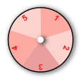

- The sample space is the set of all possible outcomes of a game or experiment.

- In the Gizmo, you will spin a spinner with five equal sections numbered 1–5. What is the sample space of one spin on this spinner?
- Which outcomes are favorable?

- What percentage of outcomes is favorable?

This is the theoretical probability of a favorable outcome. Probability is a value ranging from 0 to 1 (or from 0% to 100%), where 0 is impossible and 1 is certain.

- Suppose you were to spin the spinner 20 times. About how many favorable outcomes would you expect?
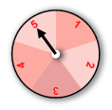
- Using the same settings, click Run trial 20 times.

- How many favorable outcomes occurred?

- What was the percentage of favorable outcomes?

Check your answer in the Gizmo. Because it is based on what happened in an experiment, this value is the experimental probability of the event.

- How did your experimental probability compare to the theoretical probability?

Note that the experimental probability does not always exactly match the theoretical probability. This is a natural result of randomness.

- Set the Sections to 10. Set up the game so you win if you spin a number less than 4.

- What is the sample space of this game?

- Which outcomes are favorable?

- What is the theoretical probability of a win, expressed as a fraction?

- What is the theoretical probability, expressed as a percent?
(Activity A continued on next page)
Activity A (continued from previous page)

- Using the settings from the previous question, click Run trial 20 times.

- How many favorable outcomes were there?

- What was the experimental probability of a favorable outcome?

- How close was the experimental probability to the theoretical probability?

- Suppose a spinner has 8 sections and the favorable outcomes are 1, 2, and 3.

- What are two different ways you can set up the Gizmo to create this game?

- Set up the spinner to match this game. What is the theoretical probability of a win, expressed as a fraction?
- What is the theoretical probability of a loss, expressed as a fraction?

- What is the sum of these two probabilities?

- Using the same settings, click Run trial 20 times.

- How many favorable outcomes were there?

- What was the experimental probability of a win? Express your answer as both a fraction and a percent.
- What was the experimental probability of a loss?

- What is the sum of the experimental probability of a win and a loss?

- In general, what can you say about the sum of the probability of an event happening and the probability of the event not happening?

Activity B:  Two-spinner games | Get the Gizmo ready:  - Set the Number of spinners to 2.  - Set each spinner’s Sections to 2.  - Set the symbol to . | 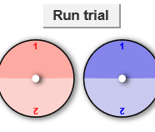

- In this game, two spinners are spun. If the red spinner has a higher number than the blue spinner, the outcome is favorable because red > blue. If not, the outcome is unfavorable.

- What is the sample space of this game? Express your answer as a list of ordered pairs. For example, (1, 2) means the red spinner is on 1 and the blue spinner is on 2.

- Which outcomes are favorable?

- What is the theoretical probability of a favorable outcome?
- Click Run trial 20 times. What percentage of outcomes were favorable?
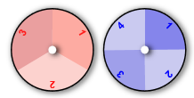
- How did this percentage compare to the theoretical probability of a favorable outcome?

- Set the Sections of the red spinner to 3 and the Sections of the blue spinner to 4. Set the symbol to . In this game, the outcome is favorable if the numbers on the spinners do not match.

- What is the sample space of this game?

- How many total outcomes are in the sample space?

- How does the total number of possible outcomes relate to the number of sections in the red spinner and the number of sections in the blue spinner?

- Which outcomes are favorable?

- What is the probability of a favorable outcome?

- Click Run trial 20 times. What percentage of outcomes were favorable?

(Activity B continued on next page)
Activity B (continued from previous page)

- In a fair game, the probability of a favorable outcome is equal to the probability of an unfavorable outcome. In other words, each probability is 50%.

- Set the Sections of each spinner back to 2 and the symbol back to , as it was in the first question of this activity.

Is this a fair game? Explain.

- Keeping two sections for each spinner, use the symbols to design a fair game. Explain how your game is set up and why it is fair.

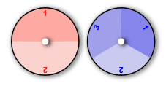
- Challenge: Design a fair game with two spinners in which one spinner has 2 sections and the other has 3 sections.

Describe your game below.

- Set each spinner to 3 sections.

- How many possible outcomes are there in a two-spinner game in which each spinner has three sections?
- Why is it impossible to design a fair game with two 3-section spinners?

