Name: Date:

Student Exploration: Proving Triangles Congruent

Vocabulary: congruent, corresponding angles (of a polygon), corresponding sides, similar

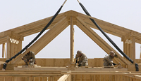
Prior Knowledge Questions (Do these BEFORE using the Gizmo.)
Buzz makes triangular trusses for home construction based on directions from his Uncle Pete. Unfortunately, Uncle Pete does not always provide him with enough information.

- Pete asks Buzz to make a triangular truss with sides that are 5 feet, 6 feet, and 9 feet.

Is this enough information for Buzz to make a truss with the correct size and shape?

Explain.

- Pete asks Buzz for a truss with angles of 60°, 90°, and 30°. (He does not give side lengths.)

Is this enough information for Buzz to make a truss with the correct size and shape?

Explain.

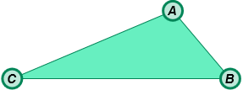
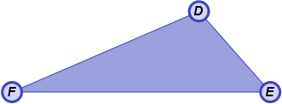
Gizmo Warm-up
Buzz wants to make a triangle that is congruent to, or identical to, the triangle described by his uncle. But how much information is needed to guarantee that one triangle is congruent to another? You can use the Proving Triangles Congruent Gizmo to find out.

- Under Conditions, check that None is selected. Drag each of the six vertices to form a variety of triangles.

- Is it possible to create two triangles that are not congruent?

- Draw a sketch in the space to the right to show what you found.

- Under Conditions, select S. Notice that one pair of sides is now congruent. Drag the vertices to form a variety of triangles.

- Can you make two triangles that are not congruent?

- Draw a sketch in the space to the right to illustrate your findings.

Activity A:  Congruent sides and angles | Get the Gizmo ready:  - Under Conditions, select A. | 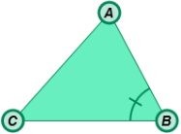

- Check that A is selected under Conditions. Notice that ∠B and ∠E are congruent. Do you think this condition guarantees that the two triangles are always congruent?
Explain.

- Drag the vertices until the triangles are clearly not congruent. (You can use the measurement tools below the triangles to check this.) Click the camera () icon at the upper right to create a snapshot. Open a blank word-processing document, and paste the image into it. Label the image “A”. You will turn in this document with this worksheet.

- For each condition listed below, write “yes” or “no” in the second column to tell whether you think the condition guarantees congruency.

Condition | Do you think this condition guarantees congruency? | Does this condition actually guarantee congruency?
AA
AAA
S
SS
SSS
SA
SSA
SAS
ASA
AAS

- In the Gizmo, choose each condition listed above, and try to create triangles that are not congruent. In the third column, write “yes” if you made all congruent triangles, or “no” if you were able to make non-congruent triangles. Paste a snapshot of any non-congruent triangles in your document, labeled with the condition.

(Activity A continued on next page)
Activity A (continued from previous page)

- Under Conditions, select AAA. Two congruent shapes are the same shape and size. Two similar shapes are the same shape, but not necessarily the same size. Drag vertices C and F to create a variety of triangles. What is true about the triangles when the condition is AAA?

- Under Conditions, select SSA. For some triangles, SSA guarantees congruence, while for others it does not. Create a variety of triangles. When the message, “For these triangles, SSA does not imply congruence,” appears, click Show counterexample. Paste an image of the triangles in your document. If necessary, modify your table on the previous page.

Challenge: What is true of triangles for which SSA does not imply congruence?

- Under Conditions, select AAS. Why is this condition equivalent to ASA? (Hint: If two pairs of corresponding angles are congruent, what can you say about the third pair?)

- Of all the conditions you have investigated, which ones guarantee congruency?

- Suppose you are sending instructions to a factory for a set of customized triangles. You are only allowed to give them three pieces of information about each triangle. Give three examples of the instructions you could provide.

Example 1:

Example 2:

Example 3:

Activity B:  Proving congruence | Get the Gizmo ready:  - Under Conditions, select None. | 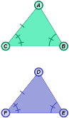

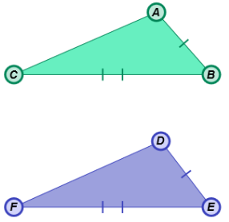
- In the triangles to the right, you know that ≅ and ≅ .

- What other information do you need to prove that the two triangles are congruent by SSS?
Check your answer in the Gizmo.
- What other information do you need to prove that the two triangles are congruent by SAS?
- Is ΔABC ≅ ΔDEF if ∠C ≅ ∠F? Explain.

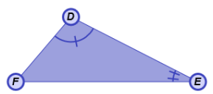
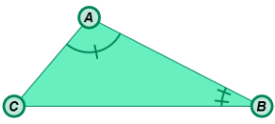
- In the triangles to the right, you know that ∠A ≅ ∠D and ∠B ≅ ∠E.

- What other information do you need to prove that the two triangles are congruent by ASA?
- What other information do you need to prove that the two
triangles are congruent by AAS?
- Can you prove that the two triangles are congruent if you also know that ∠C ≅ ∠F?

Explain.

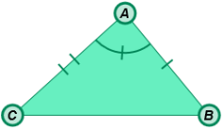
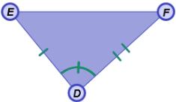
- The two triangles shown to the right have the congruent parts as marked.

- Are the triangles congruent?

Why or why not?

- What other pairs of corresponding sides and angles are congruent?

