Vocabulary: Proving Triangles Congruent

dictionary2

**Vocabulary**

* Congruent – having the same size and shape.

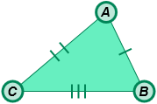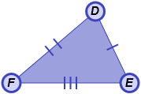

* + The symbol ≅ means “is congruent to.”
  + Two triangles are congruent when all of the corresponding angles and corresponding sides are congruent.
* For example, in the figure to the right, Δ*ABC* ≅ Δ*DEF*.
* Corresponding angles (of a polygon) – the matching pairs of angles of congruent or similar polygons.
  + For example, the corresponding angles in Δ*ABC* and Δ*DEF* are ∠*A* and ∠*D*, ∠*B* and ∠*E*, and ∠*C* and ∠*F*.
* Corresponding sides – the matching pairs of sides of congruent or similar polygons.
  + For example, the corresponding sides in Δ*ABC* and Δ*DEF* are  and , and , and  and .
* Similar – having the same shape, but not necessarily the same size.

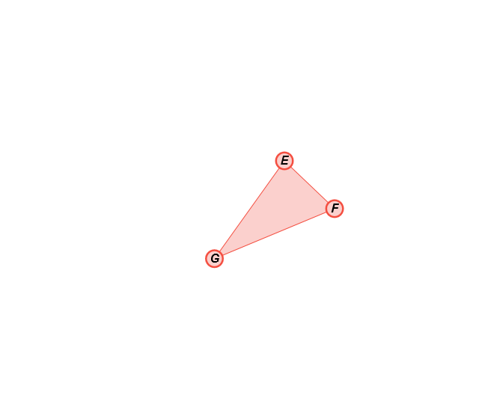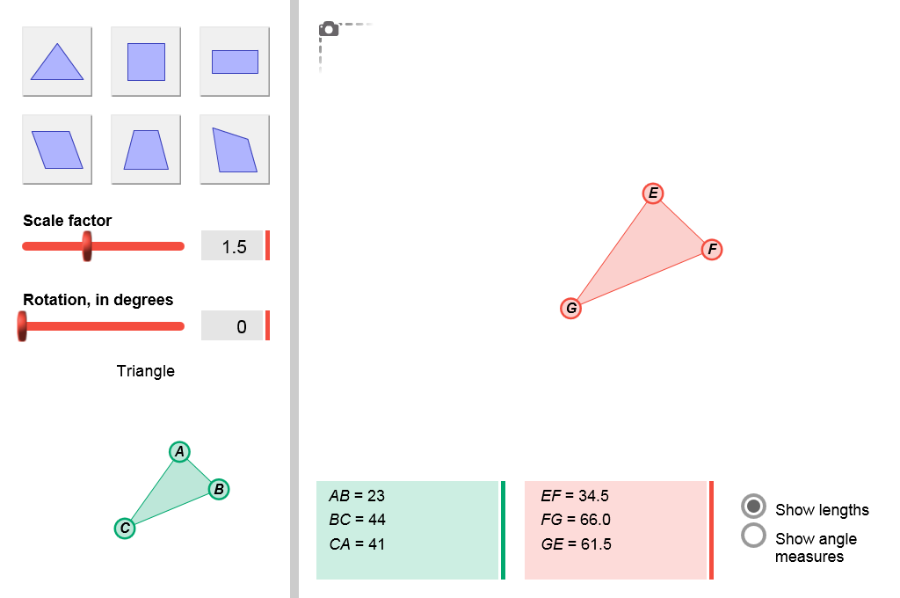

* + The symbol ∼ means “is similar to.”
  + Two polygons are similar when all corresponding angles are congruent.
* For example, in the figure to the right,   
  Δ*ABC* ∼ Δ*EFG*.