Vocabulary: Points in the Complex Plane

dictionary2

**Vocabulary**

* Additive inverse – a number that, when added to a given number, equals zero.
  + For example, the additive inverse of 4 is –4, because 4 + (–4) = 0.
* Complex conjugate – a complex number with the same real part as a given complex number and the opposite imaginary part.
  + For example, the complex conjugate () of (3 + 2*i*) is (3 – 2*i*).
* Complex number – a number written as *a* + *bi*, where *a* and *b* are *real numbers* and *i* is equal to .
* The value *a* is the real part of a complex number, and *bi* is the imaginary part.
* For example, the real part of 2 + 3*i* is 2, and the imaginary part is 3*i*.

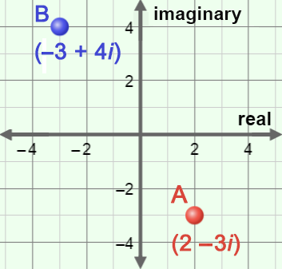

* Complex plane – a plane that represents the set of complex numbers.
  + Like the coordinate plane, the complex plane contains two perpendicular axes, the *real axis* and the *imaginary axis*.
  + In the complex plane to the right, point A represents the complex number (2 – 3*i*) and point B represents (–3 + 4*i*).
* Imaginary unit – the imaginary number, called *i*, that is defined to be equal to .
* Imaginary axis – the axis on the complex plane corresponding to the imaginary numbers.
* Imaginary number – any number that can be written in the form *bi*, where *b* is a real number not equal to zero and *i* is equal to .
* For example,  =  •  = 4*i*.
* Quadratic formula – a formula that can be used to find the roots of a quadratic equation of the form *ax*2 + *bx* + *c* = 0.
  + The quadratic formula is *x* = .
* Real axis – the axis on the complex plane corresponding to the real numbers.
* Real number – a number that represents a value along a continuous number line.
  + The real numbers include zero, all positives and negatives, integers, fractions, decimals, and irrational numbers, but do not include imaginary numbers.