Name: Date:

Student Exploration: Points in the Coordinate Plane

Vocabulary: coordinate plane, coordinates, ordered pair, origin, quadrant, reflect, x-axis, y-axis

Prior Knowledge Questions (Do these BEFORE using the Gizmo.)
A city has numbered streets that go east-west and numbered avenues that go north-south. Part of a map of the city is shown below.
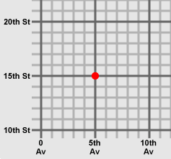
Corner store
- How would you describe the location of the corner store marked with a dot on the map?

- Jane lives at the corner of 2nd Av. and 14th St. Mark her location on the map with the letter “J.”

- Martin describes his location in code: (9, 18). If you can figure it out, mark his location with an “M.”

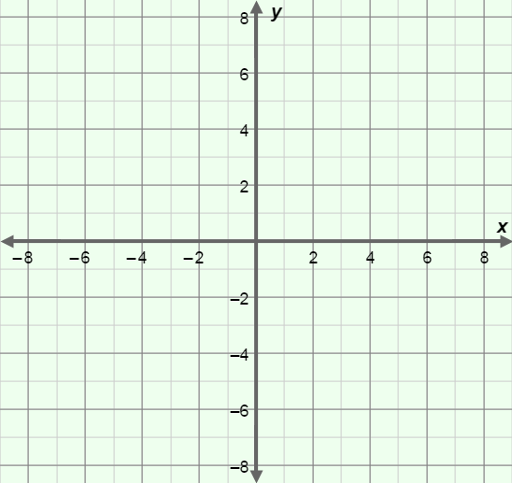
Gizmo Warm-up
Just as we use streets and avenues to describe city locations, mathematicians use coordinates to describe the locations of points on a graph. The Points in the Coordinate Plane Gizmo will help you understand how coordinates specify a point’s location.

Before you begin, familiarize yourself with the different parts of the coordinate plane. The x-axis is the horizontal number line, and the y-axis is the vertical number line. The point where the two axes cross is called the origin.

- Label the x-axis, y-axis, and origin on the blank grid to the right.

- In the Gizmo, drag the red point anywhere on the coordinate plane. Move the x slider back and forth. What happens to the point?

- Move the y slider back and forth. What happens?

Activity A:  Coordinates | Get the Gizmo ready:  - Check that the red point is on the grid.  - Set x to 4 and y to 2. (To quickly set a slider to a value, type the value into the text box to the right of the slider, and hit Enter.) | 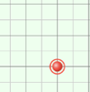

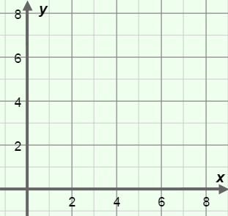
- Draw the position of the red point on the grid to the right.

- Draw a vertical dashed line from the point to the x-axis.

What is the value on the x-axis below the point?

- Draw a horizontal dashed line from the point to the y-axis.

What is the value on the y-axis left of the point?

- The (x, y) coordinates of a point are an ordered pair of numbers, written in parentheses. The coordinates of each point are displayed in the table on the left side of the Gizmo.

- What are the coordinates of the red point? ( , )

- What does the first coordinate indicate?

- What does the second coordinate indicate?

- Set the x slider to –3 and the y slider to –7.

- Where is the point relative to the x-axis?

- Where is the point relative to the y-axis?

- What are the coordinates? ( , )

- Drag the point to four different locations on the coordinate plane. For each location, sketch the location of the point on the blank grid to the right, and add dotted lines to show how the point lines up with the x- and y-axes.

Label the points A, B, C, and D. Write the coordinates of each point below.

- ( , )

- ( , )

- ( , )

- ( , )

(Activity A continued on next page)
Activity A (continued from previous page)
D
E
F

- Plot the following points on the grid to the right. Then write the coordinates of the three points illustrated on the grid.

- (–7, 6)

- (4, –3)

- (0, 8)
- ( , )

- ( , )

- ( , )

- Suppose point A has the coordinates (–7, 6). Point G is two units to the right of A and 8 units below A.

What are the coordinates of point G? ( , ) Draw and label this point on the grid.

- Drag all four points onto the grid, and position the points so they line up horizontally. What do the coordinates of all four points have in common?

- Next, position the four points so they line up vertically. What do the coordinates of the points have in common now?

- Suppose a rectangle has two opposite corners with the coordinates (3, –4) and (–2, 6). The top and bottom of the rectangle are horizontal and the sides are vertical.

What are the coordinates of the other two corners? ( , ) and ( , )

Confirm your answer with the Gizmo.

Activity B:  Quadrants | Get the Gizmo ready:  - If necessary, drag all four points onto the grid.  - Turn on Show quadrant labels.

- The coordinate plane can be divided into four quarters, or quadrants. The quadrants are numbered with Roman numerals: I, II, III, and IV.

- Place all four points in quadrant I. What is true about the signs of their coordinates?

- Try quadrant II. What do the coordinates of all points in quadrant II have in common?

- What is true about the coordinates of points in quadrant III?

- What is true about the coordinates of points in quadrant IV?

Check your answers in the Gizmo.

- Drag all four points to the x-axis.

- What do the coordinates of these points have in common?

- What is true of all points on the y-axis?

- List the quadrant of each point (or the axis on which it lies). Check answers in the Gizmo.

(5, –4) (–1, –5) (–2, 0) (5, 7) (0, –8)

- Remove the blue, green, and purple points. Move the red point to quadrant I.

- What do you think will happen to the point if you change the sign of the x-coordinate?

Try this in the Gizmo. The point is said to be reflected across the y-axis.
- What happens if you change the sign of the y-coordinate of a point?

Check your answer in the Gizmo.

