Vocabulary: Points in the Coordinate Plane

Vocabulary

- Coordinate plane – the plane defined by a pair of perpendicular number lines, or axes, that intersect at a point called the origin.

- Coordinates – a set of numbers that names the location of a point.
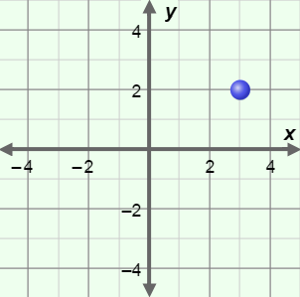
  - In the two-dimensional coordinate plane, it takes two numbers (x, y) to specify a location.
(3, 2)
    - The x-coordinate gives the location of the point left or right of the origin.
    - The y-coordinate gives the location of the point above or below the origin.
    - For example, the coordinates of the point shown to the right are (3, 2).

- Ordered pair – two numbers or variables written in a certain order.
  - (x, y) coordinates, such as (3, 2), are examples of ordered pairs.

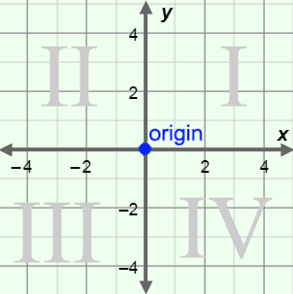
- Origin – the point in a coordinate plane where the x- and
y-axes intersect.
  - The coordinates of the origin are (0, 0).
  - The origin is the point labeled on the graph to the right.

- Quadrant – one of four regions defined by the x- and y-axes of the coordinate plane.
  - The four quadrants, labeled in the graph above, are numbered with Roman numerals: I, II, III, and IV.
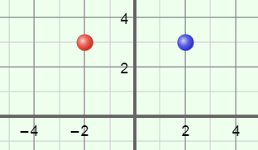
- Reflect – to form a “mirror image” by flipping a point or object across a line.
  - In the image to the right, the point on the left has been reflected over the y-axis to form the image on the right.

- x-axis – a horizontal number line that passes through the origin of the coordinate plane.
  - The x-axis measures position left or right of the origin.

- y-axis – a vertical number line that passes through the origin of the coordinate plane.
  - The y-axis measures position above or below the origin.

