Name: Date:

Student Exploration: Pythagorean Theorem with a Geoboard

Vocabulary: converse, hypotenuse, legs (of a rt. triangle), Pythagorean Theorem, right triangle

A
B
C
D
Prior Knowledge Questions (Do these BEFORE using the Gizmo.)
A television (TV) is shown to the right. The TV screen is a rectangle. One of its diagonals, , is shown. The diagonal divides the rectangle into two right triangles.

- In the diagram of the TV, consider right triangle ΔABC.

- What are the legs (sides that make up the right angle) of ΔABC?

- What is the hypotenuse (side opposite the right angle) of ΔABC?

- Normally, when TV manufacturers state the size of a TV, they use the length of its diagonal. Why do you think they might do this?

Gizmo Warm-up
In the Pythagorean Theorem with a Geoboard Gizmo, you can drag the colored points in the upper left hand corner to create different figures.

- Click and drag the green point. Drop the new point anywhere on the geoboard. Then, drag the original green point to a different spot. What figure did you make?
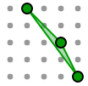
- Click between the points. Drag the new point away from the figure.

- What type of figure do you have now?

- Turn on Show right angles. Drag the points until you make a right angle. How do you know that you have a right angle?
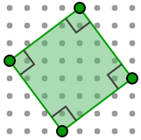
- Turn on Show side lengths. Click on one of the segments and drag the new point to make a square. How do you know that you made a square?

Activity A:  Understanding the Pythagorean Theorem | Get the Gizmo ready:  - Be sure Show side lengths and Show right angles are turned on. | 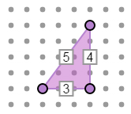

- In the Gizmo, click Build 3, 4, 5 to make a right triangle with side lengths 3, 4, and 5. Keep clicking if you want to change the orientation of the triangle. Then use the other three dots to create a square on each side of the triangle. Your figure should look like the one below.
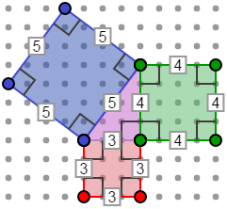
- Find the area of the square on the leg that is 3 units long.

- Find the area of the square on the leg that is 4 units long.

- What is the sum of the areas of the two squares built on the legs of the triangle?

+ =

- Find the area of the square on the hypotenuse.

- Compare the sum of the areas of the squares on the legs to the area of the square on the hypotenuse. What do you notice?
- Write two equations below to summarize what you found. In the first equation, fill in the side lengths of the 3-4-5 triangle. In the second equation, use a and b for the leg lengths, and c for the hypotenuse.

Equation with 3, 4, and 5: ² + ² = ²

Equation with a, b, and c: ² + ² = ²

The last equation you wrote is called the Pythagorean Theorem. (Check your work. You should have found that, in right triangles, a² + b² = c².)

- In the Gizmo, click Build 5, 12, 13. Be sure Show side lengths and Show right angles are still selected. Create a square on each side, as you did before. Fill in the table below to see if the Pythagorean Theorem is true for a 5-12-13 right triangle.

a | b | c | a² | b² | a² + b² | c²
5 | 12 | 13

(Activity A continued on next page)
Activity A (continued from previous page)

- Fill in the table below to see if the Pythagorean Theorem is true for other right triangles. First use the numbers given in the first two rows. Then try two right triangles of your own. (Note: The value of c in the Gizmo is rounded, so you may find small rounding errors.)

a | b | c | a² | b² | a² + b² | c²
3 | 10
7 | 7

- Find each missing side length in each right triangle below. If necessary, round your answer to the nearest hundredth. Show your work. Then check your answers in the Gizmo. (Note: Assume that any missing leg length is an integer, like in the Gizmo.)

6
8
c

5
3
c

8.94
4
b

7.07
a
a

Activity B:  The converse of the Pythagorean Theorem | Get the Gizmo ready:  - Be sure Show side lengths and Show right angles are turned on.  - Click Clear. | 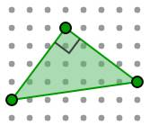
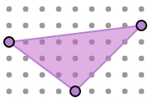
a
b
c
- Suppose c is the length of the longest side of a triangle, and a and b are the lengths of the two shorter sides.

- In the Gizmo, create two triangles in which a² + b² and c² are equal. Fill in the following table for each triangle.

a | b | c | a² | b² | a² + b² | c²

- Are the triangles you created, with a² + b² = c², right triangles?

- In the Gizmo, create two triangles in which a² + b² and c² are not equal. Fill in the following table for each triangle.

a | b | c | a² | b² | a² + b² | c²

- Are the triangles you created, with a² + b² ≠ c², right triangles?

- Create more triangles in the Gizmo to see if your observations above are always true. Then write an “if-then” statement to describe any triangle for which a² + b² = c².

This is the converse of the Pythagorean Theorem. (The converse is what results from reversing the hypothesis and conclusion of a conditional statement.)

- Determine if a triangle with the given side lengths is a right triangle. Show all of your work.

- a = 8, b = 15, c = 20
- a = 7, b = 24, c = 25

Activity C:  Using the Pythagorean Theorem | Get the Gizmo ready:  - Be sure Show side lengths and Show right angles are turned on.  - Click Clear. | 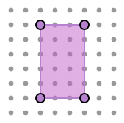

- Gary is pouring an 8-foot by 10-foot rectangular slab of concrete. First, he must create a rectangle with form boards to hold the concrete. After he puts the form boards in place, he stretches a string from one vertex to the opposite vertex (along a diagonal of the rectangle).

- In the Gizmo, build an 8-by-10 rectangle and create a diagonal. Sketch a labeled picture of the figure in the space to the right.

- How can Gary use the length of the string and the lengths of the boards to tell if he actually built a rectangle?
- How long should the string be if the boards form a rectangle? Show your work in the space to the right. Then check your answer in the Gizmo.

- Gary also wants to build a ramp from his 2-foot high porch out to the street. The street is 24 feet from the porch.

- What type of figure will the porch, ground, and ramp make?

- In the Gizmo, build a figure to show this situation. Sketch a labeled picture of the figure in the space to the right.

- Find the length of the ramp. Show your work in the space to the right. Then check your answer in the Gizmo.

