Vocabulary: Pythagorean Theorem with a Geoboard

Vocabulary

- Converse – a statement formed by switching the hypothesis and the conclusion of a conditional statement.
  - For example, the converse of the statement, “If it’s a school day, then I get up at 6:00 a.m.,” is, “If I get up at 6:00 a.m., then it’s a school day.”

- Hypotenuse – the side of a right triangle opposite the right angle.
leg
leg
hypotenuse
- The hypotenuse is the longest side of a right triangle.

- Legs (of a right triangle) – the two sides of a right triangle that form the right angle.
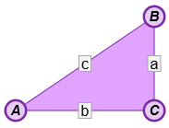
- Pythagorean Theorem – a theorem stating that, for any right triangle, a² + b² = c², where a and b are the lengths of the legs of the triangle and c is the length of the hypotenuse.

- Right triangle – a triangle that contains one right angle.

