Name: Date:

**Student Exploration: Quadratic Inequalities**

**Vocabulary:** boundary, inequality, solution

**Prior Knowledge Questions** (Do these BEFORE using the Gizmo.)

An **inequality** compares two quantities or expressions that are not equal. A **solution** to an inequality makes it true.

1. 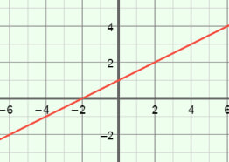The graph of *y* = 0.5*x* + 1 is shown to the right. Suppose *y* = 0.5*x* + 1 is changed to the inequality *y* < 0.5*x* + 1. Substitute 1 for *x* and 0 for *y* to see if (1, 0) makes   
   *y* < 0.5*x* + 1 true. Show your work in the space below.

Does (1, 0) make *y* < 0.5*x* + 1 true?

1. Plot (1, 0) on the graph. Where does (1, 0) lie in relationship to the graph of *y* = 0.5*x* + 1?

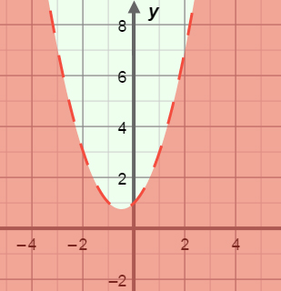**Gizmo Warm-up**

When you graph a quadratic inequality like *y* < *x*2 + *x* + 1, the **boundary** (graph of the related quadratic equation) will be a parabola instead of a line. In the *Quadratic Inequalities* Gizmo, you will graph quadratic inequalities to find their solutions.

3

With ***a***, ***b***, and ***c*** set to 1.0, select to graph *y* = *x*2 + *x* + 1. (Change the values of ***a****,* ***b***, and ***c*** by dragging the sliders, or by clicking in the text field, typing in a value, and hitting **Enter**.)

1

1. Select . How does the graph change?

5

1. Select . How does the graph change?

1

1. 5Why is the shaded part of the graph below the parabola when is selected, and above the parabola when is selected?

|  |  |  |
| --- | --- | --- |
| 4**Activity A:**  **Solutions of quadratic inequalities** | Get the Gizmo ready:   * Set ***a*** to 1.0, ***b*** to 0.0, and ***c*** to 0.0. * Select . | 149SE3 |

1. The graph shown in the Gizmo should be of *y* > *x*2. Sketch the graph of *y* > *x*2 on the grid to the right.
   1. Plot the points (1, 5) and (4, 7) on the graph.
   2. Substitute 1 for *x* and 5 for *y* to see if (1, 5) makes *y* > *x*2 true. Show your work below.

Does (1, 5) make *y* > *x*2 true?

* 1. Substitute 4 for *x* and 7 for *y* to see if (4, 7) makes *y* > *x*2 true. Show your work to the right.

Does (4, 7) make *y* > *x*2 true?

1. With *y* > *x*2 still graphed, select **Show solution test**. Drag the blue point to three places in the shaded area and three places outside the shaded area. Record the coordinates of each point and the values of *y* and *x*2 in the tables below.

|  |  |  |
| --- | --- | --- |
| **Points in the shaded area** | | |
| **Coordinates** | ***y*** | ***x*2** |
|  |  |  |
|  |  |  |
|  |  |  |

|  |  |  |
| --- | --- | --- |
| **Points outside the shaded area** | | |
| **Coordinates** | ***y*** | ***x*2** |
|  |  |  |
|  |  |  |
|  |  |  |

* 1. What is true about *y* and *x*2 for each point in the shaded area?

* 1. What is true about *y* and *x*2 for each point outside the shaded area?

* 1. What does the shaded area represent?

**(Activity A continued on next page)**

**Activity A (continued from previous page)**

1. With *y* > *x*2 still graphed and **Show solution test** selected, drag the blue point to (2, 4).
   1. Is (2, 4) a solution to *y* > *x*2? Explain.

5

* 1. Select . Is (2, 4) a solution to *y* ≥ *x*2? Explain.

1

* 1. Select . Is (2, 4) a solution to *y* ≤ *x*2?

2

* 1. Select . Is (2, 4) a solution to *y* < *x*2?
  2. When do you use a solid boundary?
  3. When do you use a dashed boundary?
  4. How do you know when to shade below the boundary?

1. Consider the graph of *y* < –3*x*2 – *x* + 1.
2. What is the equation of the boundary of the inequality?
3. Will the boundary be solid or dashed?
4. Which side of the boundary do you think will be shaded?

Check your answer in the Gizmo.

1. Determine if each (*x*, *y*) point given below is a solution to the inequality *y* ≥ 2*x*2 + *x* – 2. Show your work in the space below each problem. Then check your answers in the Gizmo.
2. (1, 6)
3. (–4, –2)

|  |  |  |
| --- | --- | --- |
| **Activity B:**  **Using quadratic inequalities** | Get the Gizmo ready:   * Be sure **Show solution test** is turned on. | 149SE6 |

1. Graph the following inequalities on the grids below. Then check your graphs in the Gizmo.
2. *y* ≤ *x*2 + 4*x* – 3

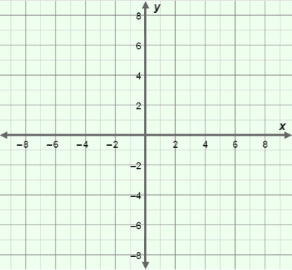

1. *y* > –4*x*2 + 2*x* + 5



1. For each item, write an inequality that contains the given point(s) in its solution and has the given boundary. Then graph the inequalities, and check your answers in the Gizmo.
2. The point (0, 4) and all points on the boundary *y* = *x*2 – 2*x* + 1.



1. The point (–3, 2) and no points on the boundary *y* = *x*2 – 4*x* – 3.

