Name: Date:

Student Exploration: Quadratics in Factored Form

Vocabulary: factored form of a quadratic function, linear factor, parabola, polynomial,
quadratic function, root of an equation, vertex of a parabola, x-intercept

Prior Knowledge Questions (Do these BEFORE using the Gizmo.)

- The sides of the large rectangle to the right measure (x + 2) and (x + 1).
x
1
x
2

- The rectangle has been divided into four regions. Label each region in the rectangle with its area.

- What is the total area of the large rectangle?

This polynomial is the product of the two linear factors, (x + 2) and (x + 1).

- The area of another rectangle is x² + 5x + 6. If one side measures (x + 2), what is the measure of the other side?
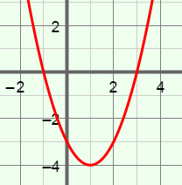
Gizmo Warm-up
A function in which y depends on the square of x is a quadratic function. The graph of a quadratic function is a parabola, as shown to the right.

A quadratic function can be written in factored form: y = a(x – r₁)(x – r₂). You will explore this type of quadratic function in the Quadratics in Factored Form Gizmo.

To begin, set a to 1. (Change the values of a, r₁, or r₂ by dragging the sliders, or by clicking in the text field, typing in a value, and hitting Enter.)

- Turn on Show x-intercepts. Drag the r₁ and r₂ sliders to vary the values. Watch the values of the x-intercepts (the x-coordinates where the graph intersects the x-axis) as you do.

How are r₁ and r₂ related to the x-intercepts?

- Set a to 0, and then slowly drag the a slider to the right. What happens as a increases?

- Set a to –1. What is true when a is less than zero?

Activity A:  The graph of  y = a(x – r₁)(x – r₂) | Get the Gizmo ready:  - Turn off Show x-intercepts.  - Turn on Show probe.  - Set a to 1, r₁ to –3, and r₂ to 2. | 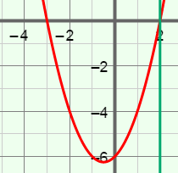

- The function graphed in the Gizmo should be y = (x + 3)(x – 2).

  - What are the values of r₁ and r₂ for this equation? r₁ = r₂ =

  - Drag the probe to r₁ and then r₂. What is the y value at each of these points?

  - Evaluate y = (x + 3)(x – 2) at x = r₁ and then at x = r₂. Show your work below.

  - Turn on Show x-intercepts. What happens when the function is evaluated at its
x-intercepts?
The x-intercepts are the roots, or solutions, of the related equation (x + 3)(x – 2) = 0.

  - If the product of (x – r₁) and (x – r₂) is zero, what must be true about at least one of these factors?
This is the zero product property.

- With a set to 1, vary the values of r₁ and r₂ to graph different functions of the form
y = (x – r₁)(x – r₂). What is the value of y = (x – r₁)(x – r₂) at r₁ and r₂?

- Graph y = 4(x – 1)(x + 5) in the Gizmo.

- What are the values of r₁ and r₂ for this function? r₁ = r₂ =

- Why are r₁ and r₂ roots of the equation 4(x – 1)(x + 5) = 0?

- Vary a to graph different functions of the form y = a(x – 1)(x + 5). Does a have any effect on the roots? Explain.

(Activity A continued on next page)
Activity A (continued from previous page)

- Set a to 1. Vary the values of r₁ and r₂ to find several parabolas with only one x-intercept.

- What is the relationship between r₁ and r₂ when the graph has only one x-intercept?

- The vertex of a parabola is the maximum or minimum point of the parabola.

When there is only one x-intercept, how are the vertex of a parabola and its
x-intercept related?
- When a = 1, what is the factored form of a quadratic function with its vertex at the origin? Check your answer in the Gizmo.
- While the vertex is on the x-axis, vary a. What happens to the vertex and x-intercept?

Experiment with a variety of functions to check that this is always true.

- Set a to 1. Vary the values of r₁ and r₂ to view a variety of parabolas with two
x-intercepts. Where is the vertex located in relationship to the two x-intercepts?

- Find the quadratic function in factored form for each parabola described or shown below. Check your answers in the Gizmo by graphing your functions.

- x-intercepts –4 and 0, a = 3

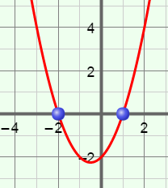
- a = 1

- x-intercepts –3 and 3, a = –1

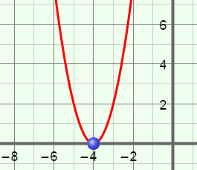
- a = 2

Activity B:  Factored form and polynomial form | Get the Gizmo ready:  - Be sure Show x-intercepts and Show probe are turned off.  - Set a to 1, r₁ to 3, and r₂ to 4. | 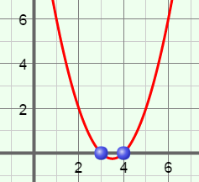

- The function graphed in the Gizmo should be y = (x – 3)(x – 4).

  - You can multiply the right side of y = a(x – r₁)(x – r₂) to write it in polynomial form, y = ax² + bx + c.

Multiply (x – 3)(x – 4) to write y = (x – 3)(x – 4) in polynomial form. Show your work to the right. Then select Show polynomial form to check your answer.

  - How can you combine r₁ and r₂ in the factored form to get b in the polynomial form?

  - How can you combine r₁ and r₂ to get c?

Experiment with other functions to check that this is always true.

  - Multiply (x – r₁)(x – r₂) to write y = (x – r₁)(x – r₂) in polynomial form. Show your work to the right.

  - How does the “multiplied-out” version of y = (x – r₁)(x – r₂) show how r₁ and r₂ can be used to find b and c in the polynomial form?

- With a still set to 1, vary the values of r₁ and r₂ to find several parabolas with one x-intercept.

- How can you use the value of r₁ to get the value of c in the polynomial form?

- How can you use the value of r₁ to get the value of b in the polynomial form?

- If a = 1, how can you tell if a function written in polynomial form has exactly one
x-intercept?
(Activity B continued on next page)
Activity B (continued from previous page)

- Be sure Show polynomial form is still turned on.

- Use the Gizmo to help you fill in the table for each of the functions in the first column.

Factored form | Polynomial form when a = 1 | Polynomial form when a = 2 | Polynomial form when a = –3
y = a(x – 2)(x – 4)
y = a(x + 1)(x – 2)
y = a(x – 5)(x + 2)

- How does a change the values of b and c in the polynomial form?

- Use r₁, r₂, and a in the blanks below to write equations that describe the relationships you discovered above.

b = c =

- Use the equations from above to fill the blanks below to write equations for the sum and product of the roots of a quadratic function.

r₁ + r₂ = r₁r₂ =

- One x-intercept of y = x² – 6x + c is 3.

- How you can find the value of c?

- What is the value of c?

- What is true about the x-intercepts of this function?

- One x-intercept of y = x² + bx + 10 is 5.

- How you can find the value of b?

- What is the value of b?

- What is the other x-intercept of this function?

