Vocabulary: Quadratics in Vertex Form

dictionary2

**Vocabulary**

* Axis of symmetry – a line that divides a shape into two parts that are mirror images of each other.

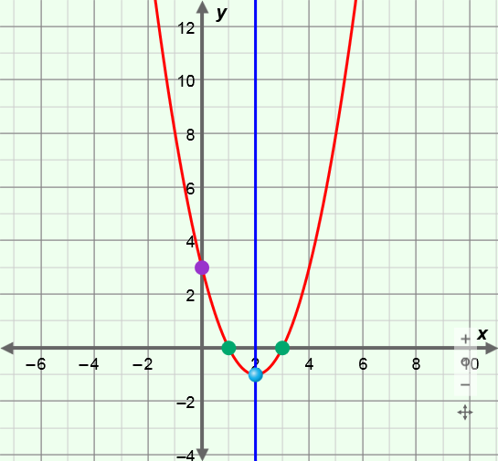

**axis of symmetry**

**vertex**

***y*-intercept**

***x*-intercepts**

* The axis of symmetry of a parabola goes through the vertex of the parabola.
* The equation of the axis of symmetry of the graph of *y* = *a*(*x* – *h*)2 + *k*, where *a* ≠ 0, is *x* = *h*.
* Parabola – the graph of a quadratic function.
* For example, the graph of *y* = (*x* – 2)2 – 1 is shown above.
* Quadratic function – a function in which *y* depends on the square of *x*.
* The polynomial form of a quadratic function is *y* = *ax*2 + *bx* + *c* and the vertex form is *y* = *a*(*x*2 – *h*)+ *k*, where *a* ≠ 0.
* The graph of a quadratic function is always a parabola.
* Vertex form of a quadratic function – a function of the form *y* = *a*(*x*2 – *h*)+ *k*, where *a* ≠ 0.
* Vertex of a parabola – the point that is the maximum or minimum of a parabola.
* The vertex is the *minimum* when the parabola opens up, and it is the *maximum* when the parabola opens down.
* The vertex always lies on the axis of symmetry.
* *x*-intercept – the *x*-coordinate where a graph intersects the *x*-axis.
* For example, the *x*-intercepts of the graph above are 1 and 3.
* *y*-intercept – the *y*-coordinate where a graph intersects the *y*-axis.
* For example, the *y*-intercept of the graph above is 3.