Vocabulary: Quilting Bee

Vocabulary

- Line of symmetry – a line that divides an image into two mirror images.
  - If you fold an image across a line of symmetry, each side will match perfectly.

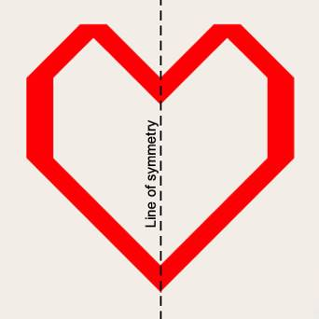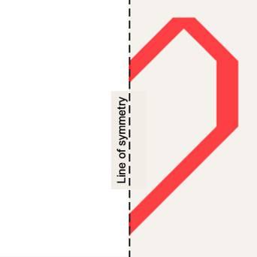

- Line symmetry – a type of symmetry in which one half of a figure is the reflection of the other half.
  - Line symmetry is sometimes called reflection symmetry.

- Quilt – a bedcover made of different pieces of fabric stitched together and stuffed with cotton batting.

- Reflection – a mirror image.

- Rotational symmetry – a type of symmetry that describes a figure that can be turned less than 360° and still look the same.
  - If a figure looks the same after being rotated 180° it has twofold symmetry.
  - If a figure looks the same after being rotated 90° it has fourfold symmetry.

- Symmetry – a property of a figure in which one part perfectly matches another when the figure is transformed in some way.
  - Two common kinds of symmetry are line symmetry and rotational symmetry.
