Vocabulary: Rabbit Population by Season

Vocabulary
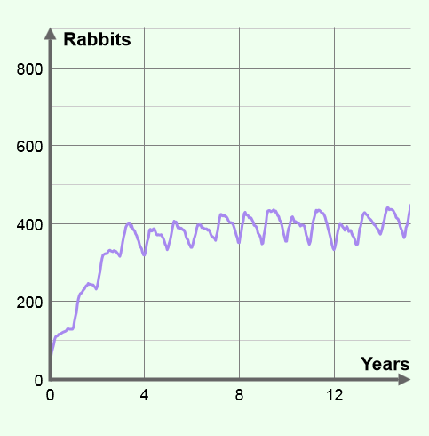

- Carrying capacity – the maximum number of individuals of a particular species that an environment can support.
  - Before a population reaches its carrying capacity, it grows rapidly. As the population nears its carrying capacity, growth slows. Once the population is at carrying capacity, overall growth stops as the population stabilizes. The population will remain at the carrying capacity until a limiting factor in the environment changes.

- Density-dependent limiting factor – a limiting factor that only affects a population when its density reaches a certain level.
  - The amount of available living space is one example of a density-dependent limiting factor.

- Density-independent limiting factor – a limiting factor that affects a population regardless of its size and density.
  - Unusual weather is one example of a density-independent limiting factor.

- Limiting factor – any factor that prevents a population from growing larger.
  - Examples of limiting factors include competition, disease, living space, natural disasters, predation, and unusual weather.

- Population – a group of individuals of the same species that live in the same area.
  - A population is one of the levels of organization of the biosphere, the parts of Earth where organisms live. The levels of biosphere organization from smallest to largest are:
    - Individual organism
    - Population
    - Community (all of the populations living in the same area)
    - Ecosystem (a community and its non-living environment)
    - Biome (a group of similar ecosystems)
    - Biosphere

- Population density – the number of individuals in a population per unit of area.
  - If 50 rabbits are living on a square kilometer of land, the population density would be expressed as 50 rabbits/km².

