Name: Date:

Student Exploration: Radians

Vocabulary: arc, central angle, circumference, radian, radius

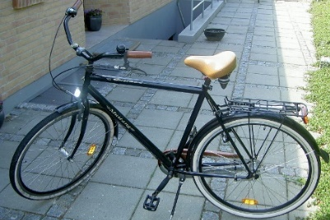
Prior Knowledge Questions (Do BEFORE using the Gizmo.)
Lia and Tia each have a splotch of paint on their front bicycle tires.

- As Lia rides her bike, her tire leaves paint marks on the ground about 6 feet apart. What does this tell you about Lia’s bike?

- Tia’s paint splotches are more like 6.5 feet apart. What does this tell you about her bike?

The distance around a tire, or around any circle, is called its circumference.

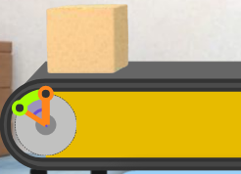
Gizmo Warm-up
Bicycles, cars, and many vehicles use the rotation of wheels to move forward (or backwards). Similarly, conveyor belts use wheels to move objects on the belt. In the Radians Gizmo™, you will use a conveyor belt to move boxes in a factory.

Click Get started, and you will be in the CLASSROOM. This is where you’ll learn to use the belt.

The belt has two controls, the radius and the rotation. (Recall that the radius is a line segment from the center to the edge of a circle.) In the Gizmo, the radii of the belt wheel are orange.

- Experiment with the Radius (r) and Rotation (θ) sliders. Try many different values, and click Go each time. How do r and θ affect how far the box goes?

- Two radii together form a central angle. A central angle defines an arc, or piece of a circle. Try a few values of r and θ, and click Unwrap arc. How does the arc relate to the box?

Activity A:  Factory training – belt operator | Get the Gizmo ready:  - Be sure the CLASSROOM tab is selected.

To become a conveyor belt operator at Gizmo Industries, you first need to pass a training class.

      - As belt operator, it’s up to you to make sure the boxes go the right distance to get stamped. But you only have 2 settings you can adjust – the wheel radius (r) and wheel rotation (θ).

- Set θ to 1 radian. Try various values of r and click Go. How far does the box go for a rotation of 1 radian?
- Turn on Arc length. Vary r and θ, to define different arcs. For each arc, click Go. What does the arc length tell you about the box?

r | θ | Arc length | Radii that  fit on arc
2 ft | 1 radian
 | 2 radians
 | 3 radians
2.5 ft | 1 radian
 | 2 radians
 | 3 radians
3 ft | 1 radian
 | 2 radians
 | 3 radians
      - Be sure Arc length is still turned on.

- Set r to 2, 2.5, and then 3 ft. For each value of r, set θ to 1 radian, 2 radians, 3 radians, and one other angle of your choice. Click Unwrap arc for each r and θ setting. Write each arc length in the table.

- How many radii do you think will fit on each arc? Write your answers in the table, and explain how you found your answers.

- After experimenting with various values of r and θ, fill in the blanks.

A central angle of θ radians defines an arc that is radius unit(s) long.

If the radius is r ft long, the intercepted arc length (s) is s = ft.

A radian is a unit of angle measure that expresses how many radii fit along the arc intercepted by the angle.

(Activity A continued on next page)
Activity A (continued from previous page)

      - For a rotation of 1 radian, explain how to find the wheel radius that will move the box 2.5 ft.

Test your answer in the Gizmo.

      - Click Enlarge wheel. Drag as many orange radii as you can onto the circle. Then click Close, and repeat for other values of r.

- How many radii fit on a circle?

- The circumference of a circle is C = 2πr. Explain why the number of radii that fit on any circle helps that formula make sense.

      - Suppose one belt in the factory is stuck on θ = 3 radians and another can only do θ = 180º. In the Gizmo, try to move a box 4.5 feet using each rotation, θ = 3 radians and θ = 180º.

- Is it easier to use radians or degrees to move a box 4.5 ft?

Explain why.

- What values will move the box 4.5 ft? r = θ =

 | Radius | Rotation | Distance
1 | 1.5 ft |  | 9 ft
2 |  | 4 radians | 11.6 ft
3 |  |  | 6 ft
      - Turn on Show challenge.

- Complete the first challenge, and fill in the first row of the table. Then click Next and complete challenges 2 and 3.

- Explain how you found the answers to the first two challenges.

- Why are there multiple settings that will move a box 6 feet?

      - Click Next. Work through more challenges in the classroom.

Activity B:  In the factory | Get the Gizmo ready:  - Select the FACTORY tab.  - Read the intro text and click Get started.

You’ve been hired as a Belt Operator! Your job is to get 20 boxes (5 batches of 4 boxes each) stamped for delivery. For each batch, the red laser lights show the location of the label machine.

- Set r to 2 ft and θ to 3 radians. Click Go once, and notice how far the box moves. Repeat for various values of r and θ. In general, how far does a box move, in terms of r and θ?

- The whiteboard shows the location of the label machine for the first batch of boxes. Choose your belt settings to get the boxes labeled. Click Go once to test, or Run to run the batch.

- Get all boxes in the batch labeled. Write the wheel rotation you used in the blank.

r = 2.5 ft θ = radians distance = 15 ft

- Explain how you found the wheel rotation.

- Click Continue. For your second batch, the belt is set to a rotation of θ = 5 radians.

- Finish labeling this batch, and write the wheel radius you used in the blank.

r = ft θ = 3.5 radians distance = 7 ft

- Explain why you chose that wheel radius.

- Click Continue. In this case, both the wheel radius and rotation are adjustable.

- Label the 4 boxes in this batch, and fill in your belt settings here.

r = ft θ = radians distance = 12 ft

- Explain why this challenge has more than one correct answer.

(Activity B continued on next page)
Activity B (continued from previous page)

 | Radius | Rotation | Distance
4
5
- Click Continue. You’ve now labeled 3 batches (12 boxes). After you complete 2 more batches (8 boxes), the truck will be loaded for delivery. Fill in the table for your last 2 batches.

After the truck drives off, click OK boss!

- Now it’s time to get more trucks loaded! For every 20 boxes labeled, another truck will be ready to go. Fill in the tables for your next two trucks.

Truck 2 Truck 3
 | Radius | Rotation | Distance
1
2
3
4
5
 | Radius | Rotation | Distance
1
2
3
4
5

- Suppose there is another belt in the factory. It is longer than the one in the Gizmo. Currently, it is functioning correctly, but its “rotation” display is broken.

  - This belt wheel has a radius of 4 feet, and the boxes are being delivered 30 feet to the stamp machine. What rotation is being used?
Explain how you know that.

  - Is the wheel making more or less than one full rotation, for each box?

Explain your answer.

Extension:  Radian measure | Get the Gizmo ready:  - Select the CLASSROOM tab.  - Be sure Show challenge is turned off. | 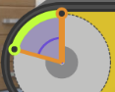

In a circle, a central angle defines an arc (e.g., if you cut a piece of pizza, the arc is the crust). This activity explores how a central angle (or a wheel rotation) relates to the length of that arc.

- In the classroom, click Reset, and set the belt wheel’s Rotation (θ) to 2 radians. The arc that this defines shows how far the conveyor belt will move the box when the wheel rotates.

  - Set r to the values given in the table. For each value of r, click Go and record the arc length, s. Check your work by clicking on the table clipboard in the Gizmo.
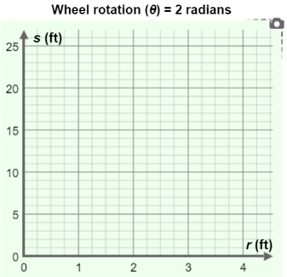
Wheel rotation (θ) = 2 radians
Radius (r) | Arc length (s)
1 ft
1.5 ft
2 ft
2.5 ft
3 ft

  - Plot these five (r, s) points on the grid. Click the graph clipboard to check your work.

  - Do the points you graphed appear to fall along a line?

  - Connect the points. When θ = 2 radians, what is the slope of the line?

- Close both clipboards, and repeat the same process for other values of θ. (Try θ = 1 radian, θ = 3 radians, etc.) Use several different radius lengths and click Go for each. Then check out the table and graph in the Gizmo.

- When θ = 3 radians, what is the slope of the line the (r, s) points lie on?

- In general, for a rotation of θ, what is the slope of the line the points lie on?

- Fill in the blank: A central angle of θ radians defines an arc with a length of radius lengths.

- What is the general equation of the line shown on each graph? s =

- Solve that equation for θ, the central angle (or wheel rotation). θ =

